SIOP Fall Newsletter
Nursing Steering Committee Updates

The SIOP Nurse Steering Committee is anticipating the SIOP Virtual Congress 2020 with great excitement. With almost 160 nurses from 39 countries across the globe registered, we are confident that the nursing sessions will be vibrant and informative. We are thrilled to announce that 22.5 continuing education credits will be available to nursing participants this year.

In September we celebrated Childhood Cancer Awareness Month – and on September 8th, recognized Pediatric Oncology Nurses Day. Given the disruption from COVID-19 and during the Year of the Nurse and Midwife 2020, this day to recognize the critical role of pediatric oncology nurses across the globe was especially meaningful. The image below depicts a young cancer survivor aspiring to be a pediatric oncology nurse, drawn by Tina Bouffet.

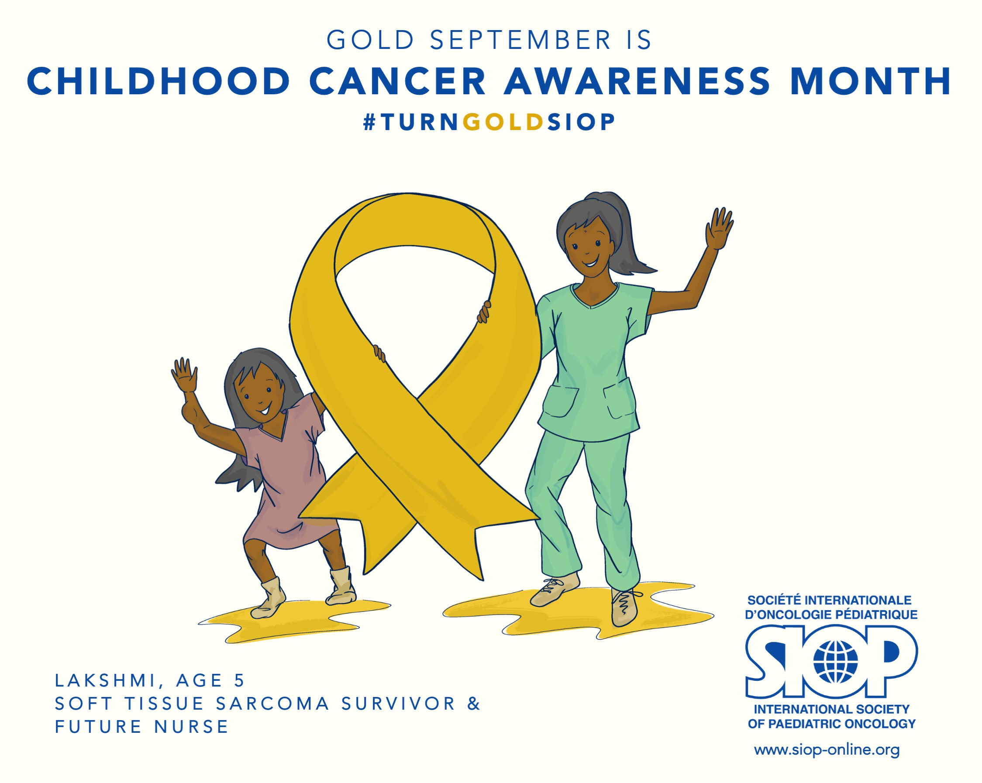

Liz Sniderman and Linda Abramovitz from the PODC Nursing Workgroup are leading the production of a video series entitled “20 Stories for 2020: Pediatric Oncology Nurses in the Year of the Nurse and the Midwife”. The videos highlight pediatric oncology nurses from around the world who work diligently to provide the best care possible for patients and families, especially during the COVID19 disruption. The videos are available via the PODC Nursing website: https://siop-online.org/nursing-working-group/, Take a moment to watch!

The nursing fact sheets on the Global COVID-19 Observatory and Resource Center have recently been updated and has been translated to Spanish, French, Arabic, Russian and Portuguese. These fact sheets, along with many other resources, are available to guide nursing care during the COVID19 pandemic.

The SIOP Nursing Committee will experience transitions this year. Frieda Clinton, a pediatric advanced nurse practitioner from Dublin, Ireland, will be completing her term. Frieda has over 25 years of experience in pediatric cancer care, and has been an engaged contributor to the work of the nursing committee. This year, she co-led the planning the SIOP Pre-Conference Education Day on October 14, which has a robust agenda covering diverse topics relevant to pediatric oncology nurses. We are deeply grateful to Frieda for her contributions to SIOP nursing and appreciative of her expertise and warm collegiality. Thank you Frieda!

Starting a new term is Yan Yin Lam, RN, MSc, AdvDip, BSN from Singapore, who was elected this spring. Yan Yin is Nurse Manager for the Paediatric Oncology and Haematopoietic Stem Cell Transplantation inpatient unit in KK Women’s and Children’s Hospital. We look forward to welcoming Yan Yin to the Nurse Steering Committee.

“See” you all soon at the Virtual Congress!

Best wishes,

Lisa Morrissey
On behalf of the SIOP Nurse Steering Committee

