LETTER OF INTENT

We, as local organizing committee, hereby confirm that we are ready, willing and able to organize the SIOP Asia 2021 Congress in Yerevan, ARMENIA.

We take the whole responsibility and have the complete understanding, knowledge and experience to host and organize the SIOP 2021 Congress in Yerevan, ARMENIA.

We assure the compliance of all main criteria necessary for the organization of the event, i.e:

1. Infrastructure to host 1500-2500 delegates

Armenia and Yerevan are ideal for organizing corporate events, conferences, congresses and teambuilding. First class hotels of leading international chains such as the Marriott, Hyatt, Radisson, Hilton, Royal Tulip, Ramada Hotels, Holiday Inn and Best Western are at the disposal of the capital’s guests. The hotels neighbor each other, which provide an opportunity to simultaneously host more than 2500 people. Availability of different hotel categories allows to have a wide range of accommodation prices for all categories of participants.

A wide selection of conference halls and comfortable venues with modern equipment and high speed internet connection facilitate conducting effective presentations and meetings, and the wide choice of restaurants and event halls offer fabulous gala-dinner or banquet opportunities.

Not only Armenian conference centers and hotels meet business tourism requirements, the country itself also manages to be the treasure of it all. The biggest benefit is visiting Armenia itself. Both groups and individual business travelers have the chance to explore the beautiful Armenian landscapes, Christian traditions, ancient architectural heritage listed by UNESCO and the traditional mouthwatering cuisine of delicious and ecologically fresh and organic food.

2. Infrastructure for a conference of 1500-2500 delegates

Karen Demirchyan Sport and Music Complex serve as a main venue for organization of large scale international or governmental conferences. It can host up to 2500 people in its big sport venue. The Complex has a concert hall also for 2500 seats, as well as a large hall for big banquets and receptions.

In 2018 it hosted the XVII Summit of Francophonie in Yerevan, attended by Emmanuel Macron and Justin Trudeau, together with other heads of member states, foreign affairs ministers, ambassadors, etc. This summit brought to Armenia more than 2000 participants and more than 10000 tourists.

Accessibility of Conference center - the conference venue has a huge private parking zone, and is comfortable for bus transfer of delegates from different hotels.

Taxis are very cheap; around 2 USD within the city and 10 USD from/to the airport.

There is a big variety of different category hotels 5 min walking distance from each other.
3. A core local organizing committee (LOC)

Under the patronage of the First Lady of Armenia H.E. Mrs. Anna Hakobyan
President of the City of Smile Charitable Foundation

- Gevorg Tamamyan
Head of the Pediatric Cancer and Blood Disorders Center of Armenia, Hematology Center after Prof. R.H.Yeoloyan
Chairman of the Department of Pediatric Oncology and Hematology, Yerevan State Medical University
Co-chair of the SIOP PODC working group, Chairman of the Organizing Committee of the POEM 2nd Scientific Meeting
- Samvel Danielyan
Director of the Hematology Center after Prof. R.H.Yeolyan
Chairman of the Board and Honorary President of the Armenian Association of Hematology and Oncology
- Armen Muradyan
Rector of the Yerevan State Medical University
Professor of Medicine, Yerevan State Medical University
- Armen Tananyan
Chairman of the Department of Oncology and Professor of Medicine
Yerevan State Medical University
- Ester Demirtshyan
Executive Director of the City of Smile Foundation
- Lilit Sargsyan
Chief of the Pediatric Oncology Department, Pediatric Cancer and Blood Disorders Center of Armenia
- Lala Vagharshakyan
Chief of the Pediatric Hematology Department, Pediatric Cancer and Blood Disorders Center of Armenia
- Tamara Sarkisian
Director of the Center of Medical Genetics
Chairman and Professor of the Department of Medical Genetics of YSMU
- Tatul Saghatelyan
Chief of the Radiation Oncology Department, National Oncology Center
Assistant Professor, Department of Oncology, Yerevan State Medical University
- Aleksandr Rumyantsev
President of the Dmitry Rogachev National Research Center of Pediatric Hematology, Oncology and Immunology
Professor of Medicine, Academician of the National Academy of Sciences, Russia
Honorary Doctor of Yerevan State Medical University
- Raya Saab
Acting Director of the Children’s Cancer Center of Lebanon, American University of Beirut, Lebanon
Honorary Doctor and Visiting Professor of Yerevan State Medical University
- Tezer Kutluk
Past-President of the Union for International Cancer Control
Professor of Medicine, Hacettepe University, Turkey
- Muhammad Saghir Khan
Pediatric Hematologist/Oncologist, Tawam Hospital, UAE
Co-chairman of SIOP PODC, Chair of the POEM Training WG
- Nino Totogashvili
Chief of the Department of Pediatric Oncology and Professor of Medicine, Iashvili Children’s Hospital, Georgia
- Dinesh Pendharkar
President of the Indian Society of Oncology, Delhi, India
Past-chairman of the International Affairs Committee of ASCO
Visiting Professor, Yerevan State Medical University
- Shant Shekerdimian
Assistant Professor, Department of Pediatric Surgery, UCLA, USA
Visiting Professor, Yerevan State Medical University
- Avo Artinyan
President of the Armenian Association of Hematology and Oncology
Associate Professor, Baylor College of Medicine
Visiting Professor, Yerevan State Medical University
- Dikran Kazanjian
Medical Officer, FDA and Hematologist/Oncologist at the National Institute of Health, USA
Visiting Professor, Yerevan State Medical University
- Saro Armenian
Director of Survivorship Clinic, Director of Division of Outcomes Research, City of Hope, USA
Visiting Professor, Yerevan State Medical University
- Norayr Torgomyan
Head of the Department of Development and Marketing, Yerevan State Medical University
- Naira Tovmasyan
Director of the “Just Travel” LLC

4. Backing organization
The backing organization which will be fully involved in the organization process of SIOP 2022 in Armenia is chosen to be JUST TRAVEL LLC. Just Travel LLC is one of the leading DMC and event management companies in Armenia with a large portfolio of the most important events and meetings held in Armenia, such as:
- 2019, February, POEM 2019, Pediatric Oncology East Mediterranean (POEM) Group Second Scientific Meeting, 250 participants (180 pediatric oncologists from 40 countries of East, Mediterranean and Eurasian regions; see some photos below)
- 2018, November, 17th ESO-ASCO Masterclass in Clinical Oncology in Armenia ESO ASCO, 80 participants
- 2017, July, Outgoing conference and teambuilding for the employees of Yerevan Brandy Company (member of the Group PERNOD RICARD) in Tbilisi, Georgia, 60 participants
- 2017, December, New Year Corporate party for the team of Yerevan Brandy Company (member of the Group PERNOD RICARD) in Yerevan, Armenia, 450 participants
- 2016, June, General Meeting and Workshop of Association of National Numbering Agencies, with participation of representative from Depositories worldwide, 200 participants
- 2016, October, FEMTEC (Worldwide Federation of Hydrotherapy and Climatotherapy) Congress in Jermuk, Armenia, 80 participants
- 2015, October, VII outgoing conference of Russian network of travel agents “HOT TOURS”, 140 participants
- 2015, June, “Armenia Country of Honor” cultural days of Armenia organized in the MIDEM music festival in Cannes, France. 200 musicians from Armenia, 4000 visitors, presidential dinners and concerts during the 5 days of the festival.
- 2015, April, Official Ceremony dedicated to the centennial of the Armenian Genocide, participated by the Presidents of Armenia, Russian Federation, France, Serbia
- 2014, May, Charles Aznavour concert in Yerevan dedicated to his 90th anniversary
- 2012, April, Andrea Bocelli open-air concert in Armenia
- 2011, September, events of 20th anniversary of Independence of Armenia, 350 involved employees, 50.000 participants
- 2007, Grand opening of Musical Fountains in the Republic Square of Yerevan, 2000 VIP guests
- 2006, September, Organization of Charles Aznavour open-air concert dedicated to the visit of President Jacques Chirac to Armenia, 2500 participants

Pediatric Oncology East and Mediterranean Group Scientific Meeting
(180 delegates from 40 countries)
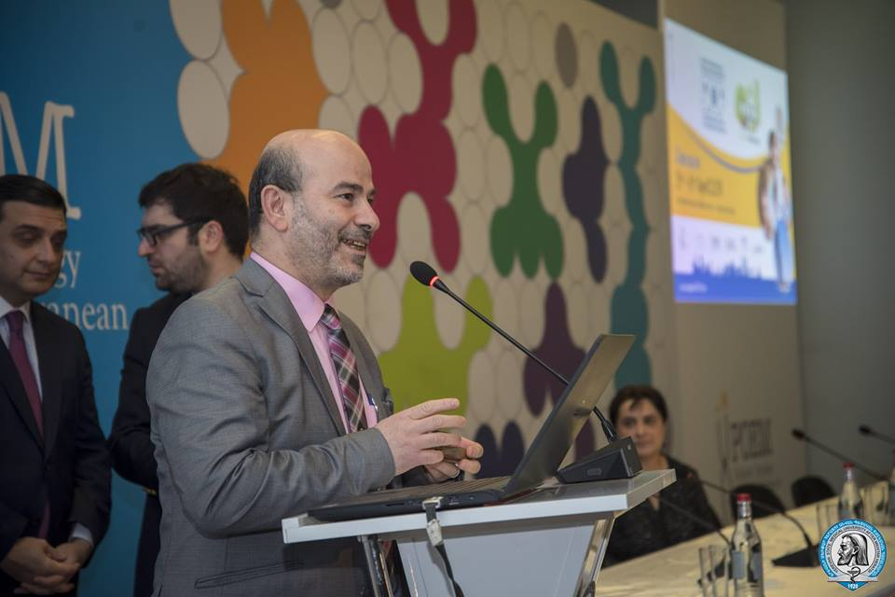

Dates of the meeting
- March or April 2021 (4 days). Dates are open to discussion.
Housing of delegates
- Just Travel LLC being one of the biggest tour-operators and MICE organizers in Armenia has obtained a reputation of a reliable partner and has signed contracts with lowest rates with the hotels all over Yerevan, which means that the provision of housing of delegates can be arranged in the necessary price range.

Accessibility of Yerevan as the city of Conference
Yerevan is the capital of Armenia, and one of the oldest but meanwhile most of the modern cities of the world. When historians talk about Yerevan, they usually mention the fact that this city is older than Rome. That is in fact a reality. Yerevan emerged as a city around the fortress Erebuni, which was founded in 782 BC by the Urartian King Argishti the First. Today it is a modern city which is 2800 years old, and it can be a very interesting and meanwhile an ideologically new venue for the Conference.
It is easily accessed by air. The following direct flights are operating to Yerevan:
- Austrian Airlines – Vienna – Yerevan flights operating 5 times per week
- Air Germany – Berlin – Yerevan flights 2 times per week
- Aeroflot – Moscow – Yerevan – 7 times per week , several times during a day
- Ukraine International Airlines – Kiev – Yerevan – 7 times per week
- LOT Polish Airlines – Warsaw – Yerevan - 7 times per week
- Fly Dubai – Dubai – Yerevan – 6 times per week
- Qatar Airways – Doha – Yerevan - 6 times per week
- Air France – Paris – Yerevan – 3 times per week
- Georgian Airways – Tbilisi – Yerevan – 4 times per week
- Mahan Air – Tehran – Yerevan – 3 times per week

From 2020 low – coster airlines (RyanAir) are going to operate in Armenia.
It worth to mention the ease of getting Armenian visa; with the support from the Armenian Government majority of delegates from different countries are able to get the visa upon arrival or electronically.
Cost of attendance at the CONGRESS
100 - 150 USD
We are envisioning to provide 5-6 scholarships to the young investigators with the highest scored abstracts.

