SIOP ASIA: ANNUAL REPORT, OCTOBER 2020

Greetings from SIOP Asia!
Gold September has just drawn to a close with many childhood cancer awareness promotional activities, Covid-19 notwithstanding. The year of the pandemic 2020 has brought in its wake numerous challenges to the pediatric oncology fraternity and caregivers, as well as the children and adolescents needing treatment; arising from both risks of infection and Covid19-induced restrictions. It has changed communicabilities and redefined academic interactions. Hope all of you stay well and safe.
The SIOP Asia Annual meeting originally scheduled for March 2020, has been twice postponed and will now be held from March 19-21, 2021, in a virtual format since travel safety concerns may still prevail. The revised format will soon be notified and we hope many more colleagues from Asia will be able to join in. Updates will be available on the conference website www.siopasia2020.com and please do follow the meeting on Twitter@SiopAsia2020 . The next SIOP Asia meeting after this will be held at Guangzhou, China in 2022, under the leadership of Dr Yizhou Zhang.
Following the Presidential elections for SIOP Asia, Dr Hiroki Hori from Japan will join us as President Elect from 2021; we warmly welcome him to the SIOP-Asia community and the SIOP Board.
Dr Maya Prasad has worked hard in bringing out our newsletters twice a year and has also compiled a list of COVID19 resources and partnered a Covid19 management survey across Asia.
After their successful work in Africa and Latin America, SIOP & POINTE in collaboration with grants from Sanofi Espoir Foundation, soon plan to extend the Global Mapping Project for Pediatric Oncology Services, in Asia.
SIOP Asia has engaged with the Rare Cancers ESMO-Asia group as a stakeholder, as well as with the Asian OncoFertility oup to bring out guidelines on Fertility preservation & related Survivorship Issues.
SIOP-PODC Nutritional Guidelines are also due to be released for implementation across LMICs in Asia to begin with, under the stewardship of Dr Elena Ladas, Dr Amita Trehan & Dr Maya Prasad.
In partnership with SIOP Asia and under the stewardship Dr Akira Nakagawara and Dr Godfrey Chan, the Asian Pediatric Hematology Oncology Group (APHOG) is in an early phase of development, as the clinical trials and research arm of SIOP Asia. It also has plans to develop models of clinical research in LMICs in alignment with the WHO-GICC.
The SIOP-St Jude collaboration WHO-GICC has had workshops in Myanmar and the Phillipines and several members from SIOP Asia & SIOP-PODC are involved in the development of technical packages this year.
Future plans for SIOP Asia include expansion of its Board to enhance regional and focus representation, develop Research Methodology Training modules for Pediatric Oncology, among many others. We urge you to come forward with ideas and proposals for activities in the region. Looking forward to ‘seeing’ many of you during SIOP 2020, there are over 450 registrants from Asia already!
We have periodic communications reaching out to SIOP members from Asia, who have the official voting rights, but also to other pediatric oncology colleagues from Asia to whom our database has been exposed to in earlier years or meetings. We encourage members of national societies across Asian countries to share contacts of pediatric oncologists so many more can be in the fold. We do encourage them to join and enjoy the benefits of SIOP membership, including LMICs which have a discounted rate. You can now follow updates for SIOP Asia, on Twitter @AsiaSiop. If you have any meeting announcements, important publications or achievements from your departments or country, please use the SIOP Asia Twitter site to disseminate the same. You can communicate with me or at rdphoc@gmail.com

Rashmi Dalvi
Continental President SIOP Asia (2018-2021)

CORONA IS TAKING OVER THE WORLD!
Artist: Avaneesh, 8 yrs, Bengaluru, India

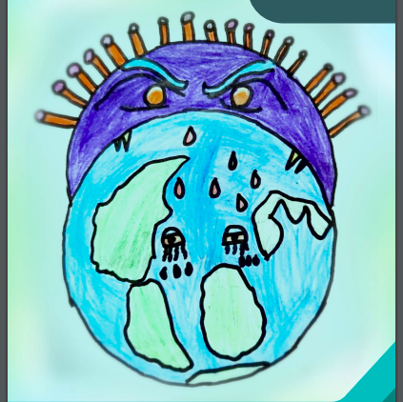
SEPTEMBER GOLD 2020
Tata Memorial Hospital, Mumbai

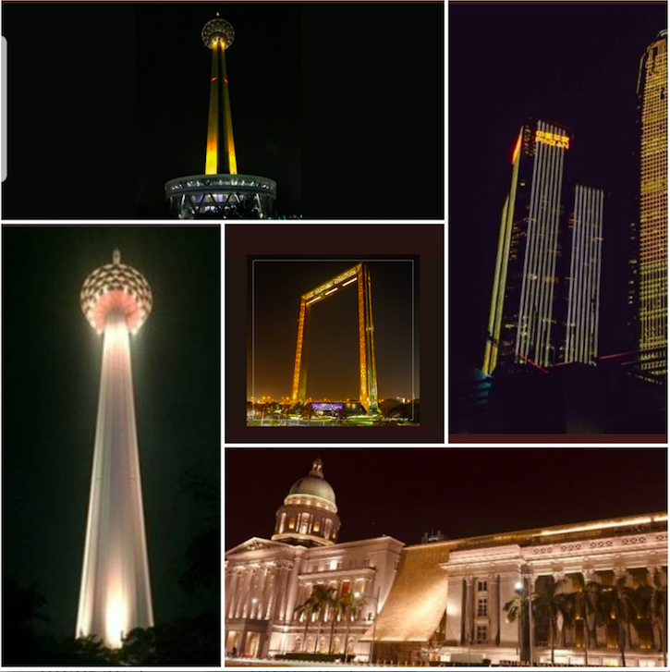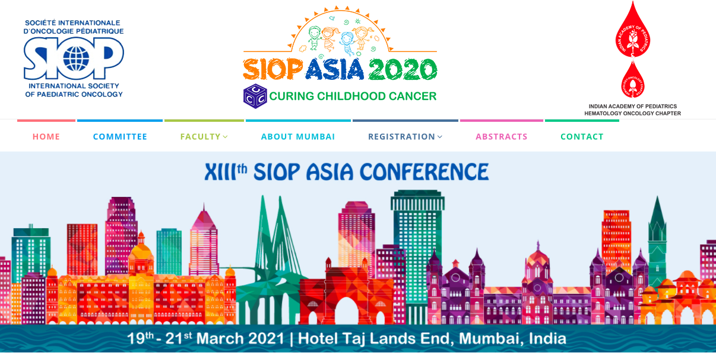
GOLD SEPTEMBER ASIA 2020
Tehran, Iran
Shenzhen, China
Singapore
Kuala Lumpur, Malaysia
Dubai, UAE

