SIOP Europe 2019 Annual Meeting and upcoming events

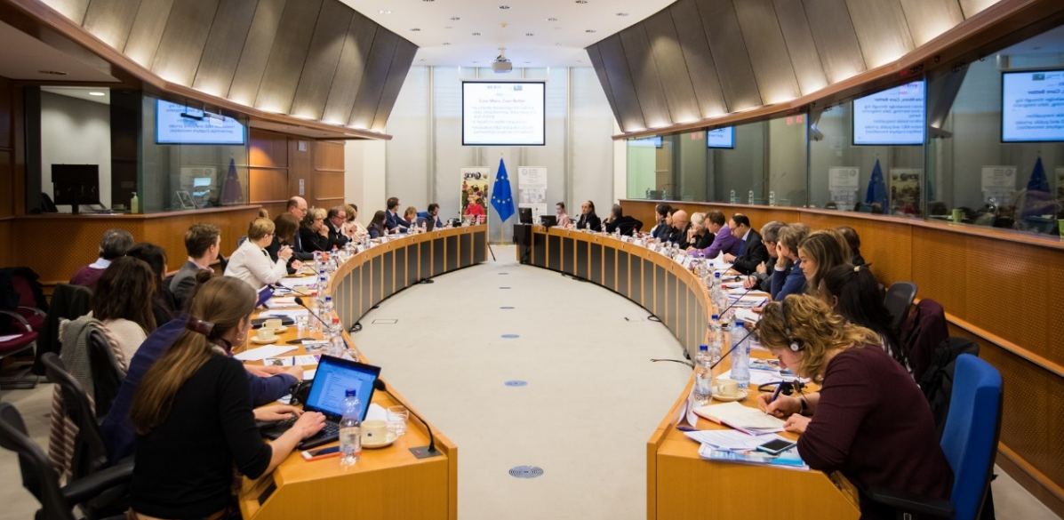

The past months at SIOPE have been very busy and productive with several events taking place starting with the SIOPE Clinical Research Council (CRC) meeting on 1st February 2018. This was followed by the ERN Paedcan General Assembly to ensure knowledge sharing and dissemination amongst partners, parents and survivor and other key stakeholders. In addition, the 6th ACCELERATE Paediatric Oncology Conference was also a success with 134 delegates attendance in Brussels on 8-9 February 2018. Likewise, the International Childhood Cancer Awareness Day (ICCD 2018) took place in February at the European Parliament enabling constructive exchanges between academics, survivors and European policy-makers. Another key milestone is the launch of the Survivorship Passport (a tool to provide all European childhood cancer survivors with optimal long-term care) in Italy on 13 February.

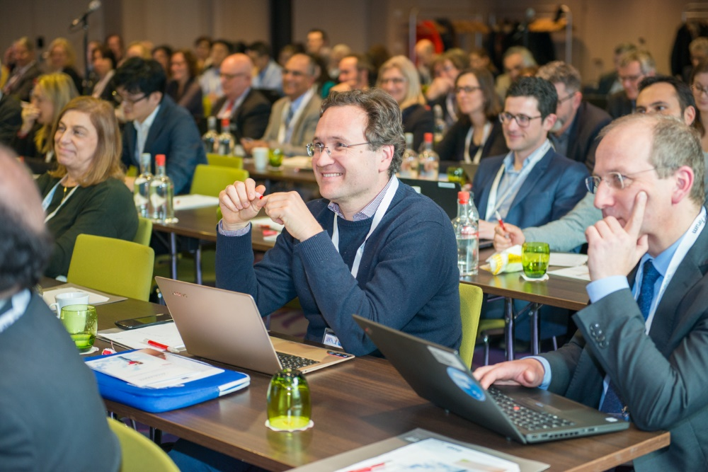

There are consequently many developments in the European paediatric haemato-oncology area as various professionals and stakeholders are committed to bringing a brighter future for children and adolescents with cancer. One of the latest advances in this area is the first edition of the SIOP Europe 2019 Annual Meeting scheduled to take place on 20-25 May 2019 in Prague, Czech Republic.

This multinational and multidisciplinary meeting is a distinct opportunity for professionals from various fields to share their knowledge and collaborate on cutting-edge research in paediatric haemato-oncology. It builds on the extensive experience accumulated in all types of disease entities by various tumour research groups within Europe. SIOPE aims to establish a platform that will improve cross-entity interaction and enhance the impact of modern insights in biology, pharmacology and genetics. By introducing a pioneering type of mentoring and training for young doctors and fellows in the field, sustainable career resources will be built up.
Firmly based on an all-encompassing vision of paediatric haemato-oncology, this meeting will gather researchers, scientists, clinicians, young experts, patients, parents, survivors, policymakers and healthcare professionals of diverse profiles to tackle key issues to increase the cure rate for children/adolescents and the quality of life for survivors.
All SIOP Europe and SIOP members, European tumour and clinical trial group members, parent groups, survivors, and relevant healthcare professionals with a common interest in paediatric haemato-oncology are invited to this meeting. Please kindly note that the SIOP Europe Annual Meeting is by invitation only. All SIOP members will receive an invitation with detailed information on how to register for SIOP Europe 2019 before the end of summer.
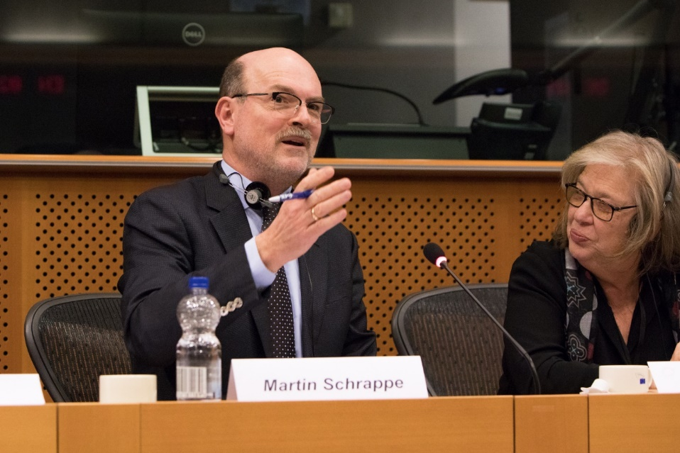
Another upcoming key milestone is the special SIOPE event in partnership with the MEPs Against Cancer (MAC) Group. The SIOPE – MAC 2018 Event ‘Celebrating 20 Years of Progress in the Paediatric Haemato-Oncology in Europe’ is scheduled to take place on 25 September 2018 (16:00 – 18:00), followed by a reception at the European Parliament in Brussels. This event will be hosted by Mr. Alojz-Peterle MEP, and President of the MAC Group.
In addition, the special SIOPE Awards Gala dinner will also take place on 25 September (19:45 onwards) in order to honour key personalities and their outstanding achievements in paediatric haemato-oncology.
Finally, next year, the International Childhood Cancer Awareness Day (ICCD 2019) will once again take place at the European Parliament in Brussels in February 2019. This event will bring together academics, policy-makers, advocates, parents and survivors to achieve more and better cure for children and adolescents with cancer across Europe.
To stay tuned about SIOP Europe 2019 Annual Meeting, please visit the website: www.siopeurope.eu
Further information on upcoming SIOPE events: www.siope.eu

