SUMMER 2020 UPDATE
During this period of COVID19 restricted activities, the SIOPE Team launched the Gold Ribbon Social Media Challenge to highlight the real heroes – the children and adolescents battling cancer with tremendous strength and courage. During the #StayHome order in many countries, #GoldRibbonHeroes brought further awareness and visibility to childhood cancer.
Speaking of heroes, we have all witnessed how healthcare professionals and frontline workers have selflessly and courageously looked after their patients during the COVID-19 health emergency and maintained essential services. We owe a profound debt of gratitude to all those who are working to save lives every day under such extreme circumstances. They continue putting themselves at risk doing their job every day. This is heroism with a capital H.
The SIOP Europe office looks forward to working with you all and encourage you to continue supporting our patients and their families in these difficult times.

COVID-19
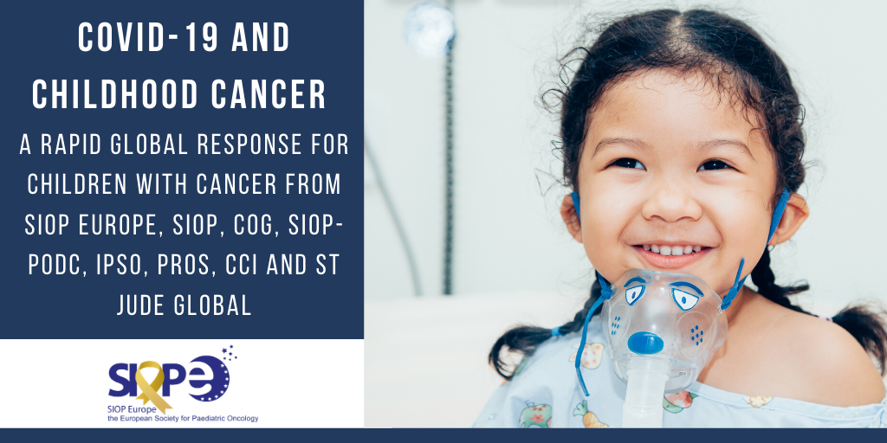

The consequences of the COVID-19 pandemic have implications for children and adolescents with cancer and how we can ensure the best possible diagnosis, treatment and follow up for children and adolescents with cancer. It is now more than ever important that we continue to monitor and share our experiences and expertise in managing our patients during this pandemic.
SIOP Europe worked in close collaboration with SIOP and the other key global Societies representing the needs of children and adolescents with cancer to generate the following publication in Pediatric Blood and Cancer:
The COVID-19 PANDEMIC: A Rapid Global response for Children with Cancer from SIOP, COG, SIOP Europe, SIOP-PODC, IPSO, PROS, CCI and St Jude Global
This Special Report gives a summary of the broad principles for continuing multidisciplinary care during SARS-CoV-2 (COVID-19) and articulates the framework for healthcare teams caring for children with cancer during the pandemic with contributions from the leadership of the International Society for Paediatric Oncology (SIOP), Children’s Oncology Group (COG), St Jude Global programme and Childhood Cancer International.

SIOPE RADIATION ONCOLOGY WORKING GROUP
A rapid review of evidence and recommendations from the SIOPE radiation oncology working group to help mitigate for reduced paediatric radiotherapy capacity during the COVID-19 pandemic or other crises
This article published in ‘Radiotherapy and Oncology’ (July 2020) provides evidence-based treatment recommendations during unexpected shortage of paediatric radiotherapy facilities. It has wider applications for the optimal utilisation of facilities, to improve clinical outcome in low- and middle-income countries, where limited resources continue to be a challenge.
The article makes a rapid review of published literature on the role of radiotherapy in the multimodality treatment of paediatric cancers governing the European practise of paediatric radiotherapy. The derived data has been discussed with expert paediatric radiation oncologists to derive a hierarchy of recommendations.
Highlights of the article:
- No guidelines for the optimal use of paediatric radiotherapy facilities during a shortage.
- Recommendations for the optimal use of paediatric radiotherapy facilities are presented.
- This guideline has applications in low-and-middle income countries with limited resources.

Read it here.

POSTPONED EVENTS
SIOP Europe 2021 Annual Meeting
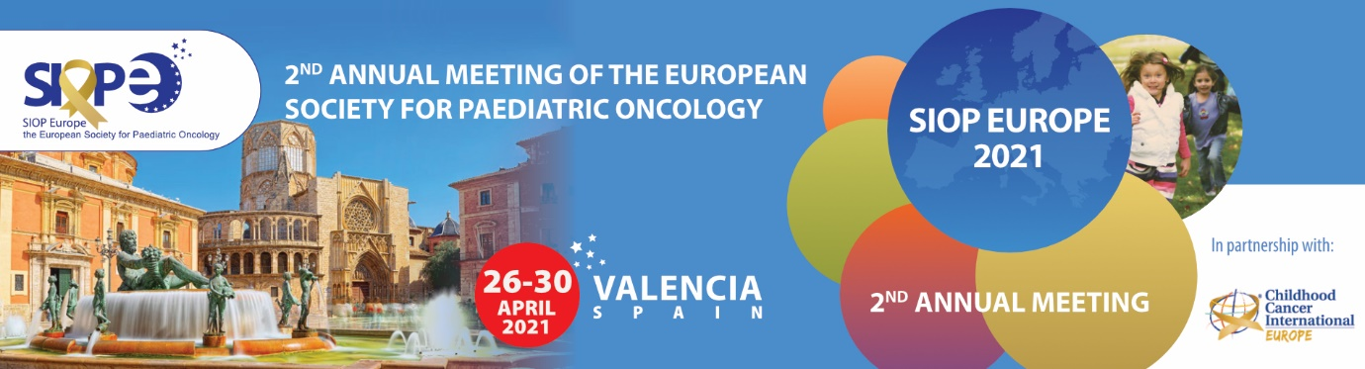
SIOP Europe, alongside CCI Europe, made the difficult decision to postpone the 2nd SIOP Europe Annual Meeting, which was scheduled to take place on 4-8 May 2020 (Valencia, Spain) due to the Coronavirus (COVID-19) pandemic.
The new dates: 26-30 April 2021 (Valencia, Spain)!
The Annual Meeting will once again be held in partnership with CCI Europe, who will be holding their 11th CCI Europe Conference. This ensures the representation and participation of childhood cancer parents and survivors and provides exceptional possibilities for collaboration across all stakeholders within the paediatric oncology community.
This is a very challenging situation but the health and safety of everyone is our highest priority. Our thoughts and sympathies are with all those affected by COVID-19, their families and the professionals involved in their care.
More information: www.siopeurope.eu | Twitter: #SIOPEurope20

ESO – SIOPE Masterclass in Paediatric Oncology
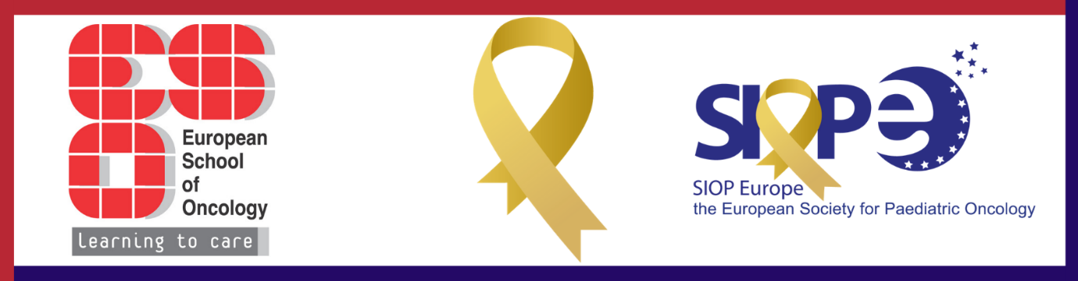
The 8th edition of the ESO – SIOPE Europe Masterclass in Paediatric Oncology was also postponed due to the COVID-19 pandemic.
The new dates: 28 November - 3 December 2020 (Bucharest, Romania).
This CME accredited clinically oriented educational program has been designed for advanced paediatric oncologists, who wish to improve their skills in clinical management of common childhood tumours and leukaemia and lymphoma. It is designed to offer a unique learning experience, providing practice-oriented training and the teaching sessions will focus on the application of the most recent research findings to clinical practice.
Application deadline: 18 September 2020.
More information here.

ONCOPOLICY
EU Consultations: Medicines and Health Data
The European Union (EU) launched two public consultations that are relevant for the paediatric oncology community:
1. Survey assessing the Member States’ rules on health data in the light of GDPR: The survey seeks stakeholder opinions on the areas where EU level action might facilitate health data processing across the EU. By answering this consultation, SIOP Europe was seeking to promote adequate data sharing rules that can advance research on paediatric cancers and support the ERN PaedCan.
2. Pharmaceutical Strategy for Europe: ‘Timely Patient Access to Affordable Medicines’: This initiative aims to collect feedback from organisations and individuals to inform future EU policies on these issues. This was an important opportunity to highlight the unmet needs of children and adolescents with cancer in relation to access to innovative therapies, shortages, and financial accessibility including pricing and reimbursement.
Besides responding to these consultations, SIOP Europe also informed and guided members to submit their individual responses.

EDUCATION
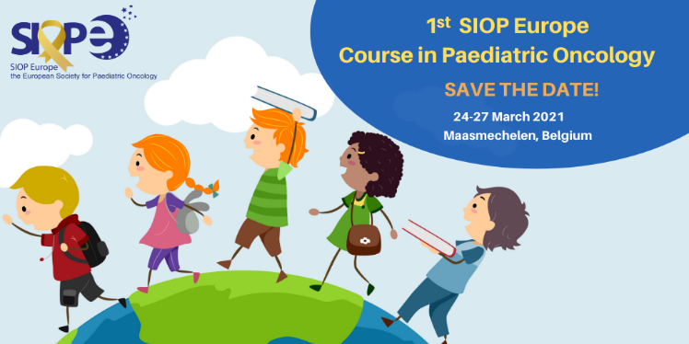
NEW: SIOP Europe Course in Paediatric Oncology

The first module of the SIOP Europe Course in Paediatric Oncology will take place 24-28 March 2021 in Maasmechelen, Belgium.
This new initiative is designed to support young and promising paediatric oncologists in developing their careers in paediatric oncology. The course will cover clinical aspects of childhood cancer, clinical research methods, research collaborations, statistical analysis, presentation skills and leadership. Real-life cases and situations will be discussed, as well as patient management and how to perform clinical studies.
The Course is planned to be held over 3 years, consisting of an annual module of 4 days, to stimulate long-term educational impact and group development. Attendees will obtain the skills and expertise to become leading physicians, performing high-quality patient management and research. The Course is open to fellows in paediatric haematology and oncology and junior faculty at academic medical centres across Europe.
Course application submission opens: 1 May 2020
Application submission closes: 15 September 2020
More information here.

SIOP Europe: www.siope.eu

