SLAOP AC: On February 15, 2018 in Mexico City the constitutive act of the Latin American Society of Pediatric Oncology AC was signed. The minutes were signed by President Dr. Arturo Moreno of Mexico and by delegates from Latin American countries. In this way, SLAOP AC has a legal representation and may have a current account and collect fees through transbank.

This process fills us with pride because it took many years to transform it into a reality.

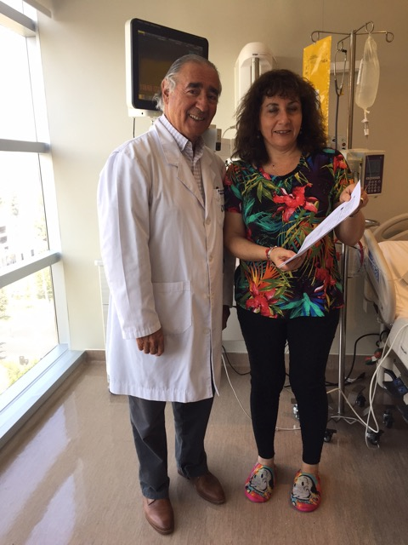

In Chile from February 1, 2018 it is possible to issue a medical license to mothers of children with cancer so that they can take care of it and be remunerated without attending their work. This License can last up to 6 months.

This achievement has been the subject of much praise from other Latin American countries and will be discussed at the next Assembly of SLAOP AC in Sao Paulo in March 2018 to present it as one of the goals of SLAOP for Latin America.

We intend to obtain the sponsorship of SLAOP / SIOP so that child oncologists in conjunction with parent organizations can present this project to the authorities of the Ministry of Health and Ministry of Labor of their respective countries in order to obtain this benefit for mothers. parents of children with cancer in our continent.

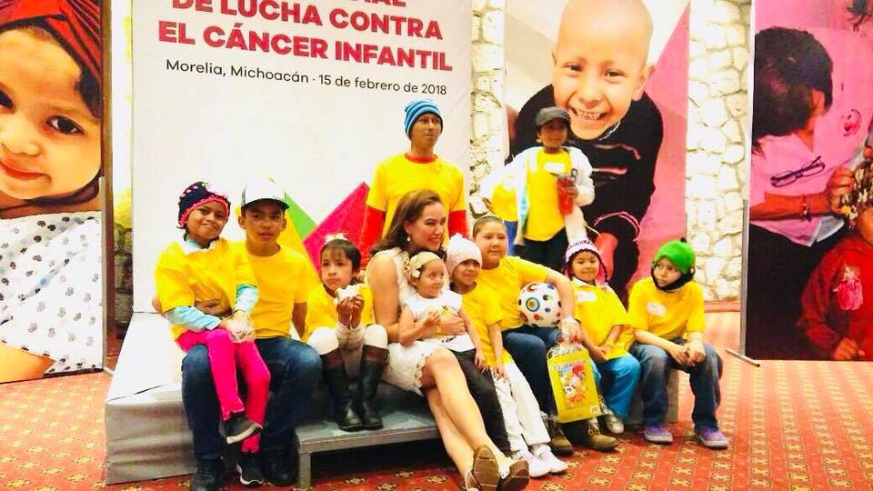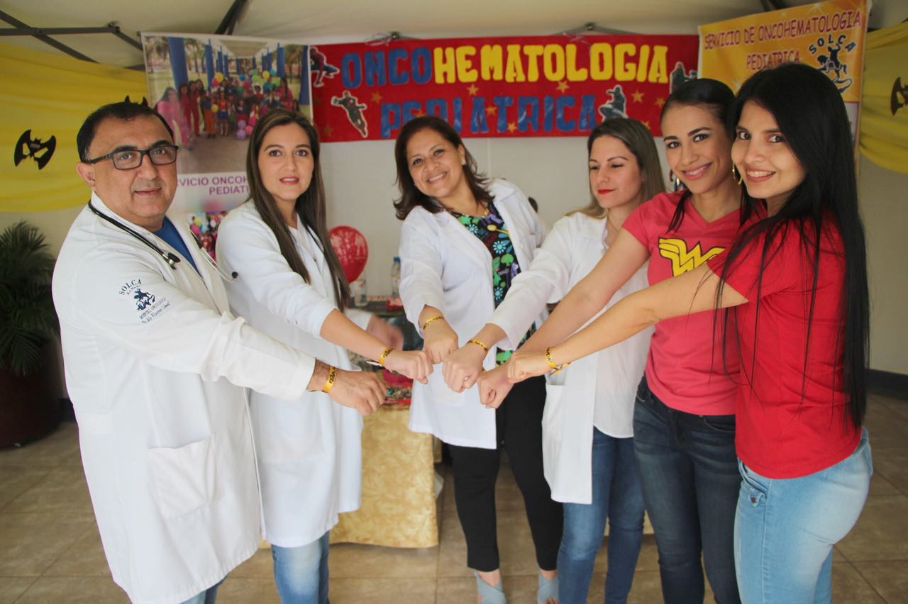Impressions from the Children's Cancer Day this year in Chile, Argentina, Peru, Mexico and Ecuador

