From SIOP LATINAMERICA

Dear Friends

I tell you that the XXX SIOP-SLAOP Congress was held in Quito, Ecuador, on April 3-6 of this year, with very good results. There was a change of the SLAOP board: President; Guillermo Chantada (Argentina), President-Elect; Liliana Vasquez (Peru), Treasurer; Essy Madariegue (Peru), Secretary; Claudia Sampor (Argentina), Vocal Education; Mercedes Garcia (Argentina), Vocal Social Relations; Wendy Garcia (Dominican Republic).

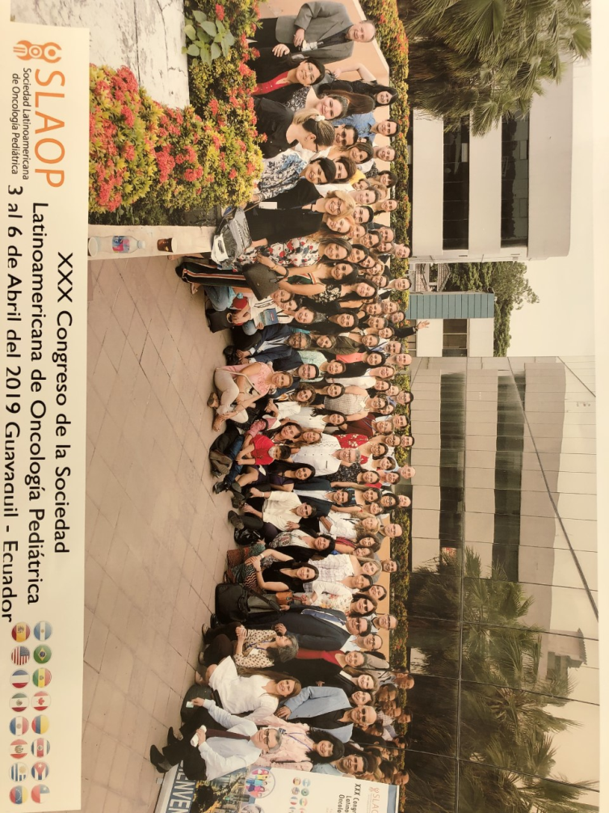
XXXI SIOP/SLAOP 2020 in Asuncion, Paraguay. The meeting will take place from April 1-4, Dr. Eva Lescano the Congress President and her team is working very hardly and efficiently to make this a memorable meeting. The venue is already selected and they have already committed a number of international speakers such as Carlos Rodriguez-Galindo, Jaume Mora, Monika Metzger, Alvaro Lassaletta, Susana Rives, among others. We are preparing a nursing course lead y Oscar Barbona and Julia Challinor with a committee of many nurses from many countries that is going to be supported by the My Child Matters grant and the Leo Messi Foundation, so up to 50 nurses will go for training. There will be also a psychosocial and a surgery parallel meeting as well as a young investigators session. This time, our cooperative groups GALOP and CLEHOP will have their annual meetings in parallel to SIOP/SLAOP so we will have a greater interaction. We will give a recognition award to Antonio Wachtel for his lifetime achievements and service to SLAOP during the meeting in Asunción.
Please plan to attend, the meeting will be great, the local team is doing a great job to make it a wonderful meeting. For more information please visit the website and start planning your next trip to Paraguay. http://www.slaop.org/
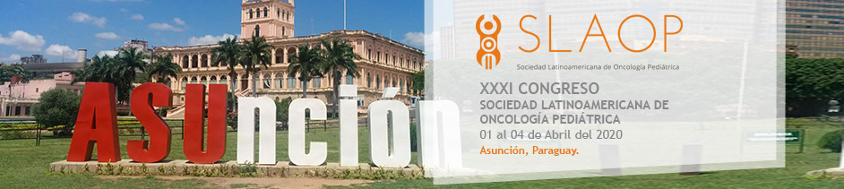
SLAOP nominated Andrea Cappellano as a member of the SIOP Scientific Committee and she has just been elected for that position.
SIOP awarded 2 papers presented at SLAOP Guayaquil as the Best of SLAOP papers and their authors were awarded a scholarship to attend to SIOP meeting in Lyon and awarded them with free SLAOP membership for 2 years.

We are working SIOP/SLAOP to participate in a global mapping of oncological facilities.

SLAOP will sign an agreement with the SEHOP (Spanish Society of Pediatric Hematology-Oncology) to have a common strategy for training and other educational opportunities.

SLAOP interacted with regional national groups and are envisioning activities with AMHOP (Mexican National Group), AHOPCA (Central American Group) and ACHOP (Colombian Group).
Peru was chosen as a focal country in the Region of the Americas for the WHO Global Initiative against Childhood Cancer, which was launched on June 7, 2019 in the city of Lima. A grant obtained from My Child Matters will provide educational opportunities for Peruvian professionals who contribute to the program. Our relationship with St Jude Global Alliance is very strong in this and other SLAOP activities.
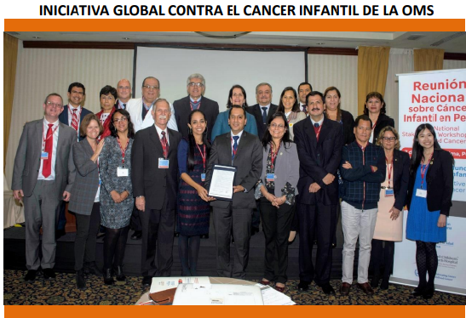
SLAOP participate in the online activities of the WHO Global Initiative.
SLAOP supported the EPEC 2019 course on palliative care and awarded 1 half scholarship to attend to the course.
DR. ARTURO MORENO RAMIREZ
Continental President of Latinamerica SIOP

