**SIOP Africa Report, March 2018.**

There have been various activities across the continent of Africa. Starting with the GFAOP group, the Francophone African countries held a palliative care workshop in Abidjan. This forms part of a My Child Matters supported project integrating palliative care into the GFAOP Paediatric Oncology programme. The project lead is Christine Edan. During the first phase, 65 health workers from Francophone African countries were trained in paediatric palliative care. The second phase is currently underway.

**Attendees at the GFAOP palliative care workshop held in Abidjan.**

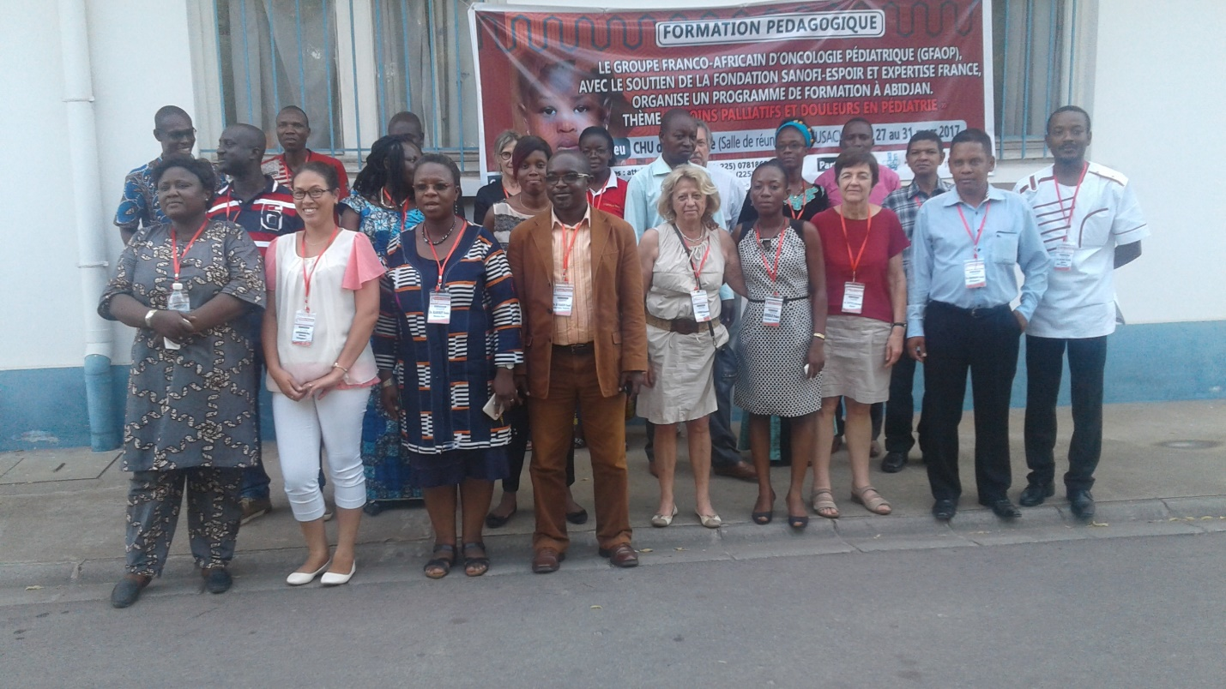

February 15th marked International Childhood Cancer Day. Members of SIOP in several African countries organized events on the day. In Cameroon, the Cameroon Baptist Convention Health Services printed and distributed ten thousand flyers in both English and French on the early warning signs of Childhood cancer and services available for such children in their hospitals. Several activities were held under the leadership of Glen Mbah and Dr Francine Kouya. There were outreaches to Muea Market in Southwest Region and Jakiri market in the Northwest. There were special guests, visiting partners from Stellenbosch, South Africa and the UK at the celebrations in Mbingo.

**Cameroon - market outreach**



**Activities at Mbingo, Cameroon**



Botswana marked the day with members of Botswana Global HOPE Team, visitors from Texas Children’s Cancer and Haematology Centre, HOPE team partners from Princess Marina Hospital together with some children and parents coming together to make a banner of handprints, signifying that they are all working together to combat cancer. The hope in the middle of the banner signified the hope they have that their shared work would improve disparities in childhood cancer survival.

**Botswana Banner of Hope**

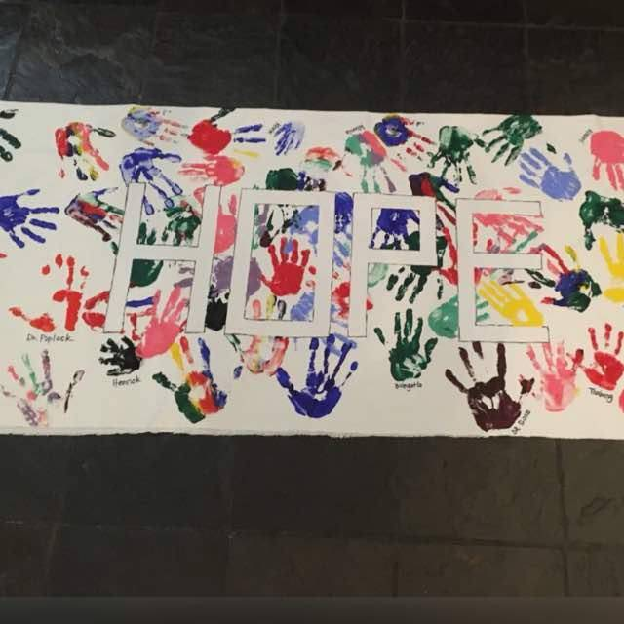

In South Africa, CHOC ran a “Have a heart for children with cancer” campaign, which generated great awareness for childhood cancer and fundraising for CHOC. Thousands of specially designed badges, heart pins and heart-shaped chocolates were sold to schools, corporates, religious groups and individuals. The ICCD Press Release received great print exposure to a total of 57 newspapers. Media interviews were also conducted. The regions hosted various awareness activities nationwide reaching schools, corporates, hospitals, clinics and Malls.

**South Africa ICCD celebration in a school**

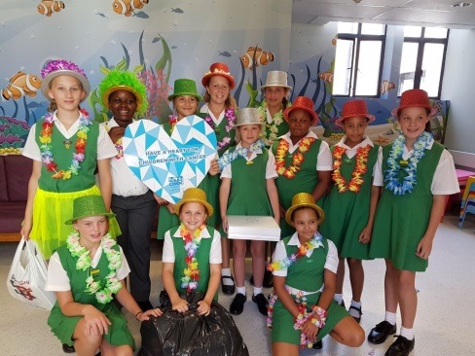

Still on South Africa, CCI together with CHOC and the American Childhood Cancer Organization will be organizing a two-day Africa Strategy Workshop in Johannesburg in May. The aim is to strengthen the work of CCI and its affiliates in Africa so as to build awareness of childhood cancer in Africa.

In Ghana, parents, doctors, nurses and the local World Child Cancer representative walked to Parliament House on ICCD, February 15th. A petition was handed to the chairperson of the parliamentary select committee on health by Dr Ahenkorah, an executive of the Ghana Parents’ Association for Childhood Cancer, advocating for the speedy inclusion of at least some selected childhood cancers such as lymphomas, retinoblastoma and Wilms tumour on the list of conditions covered by the National Health Insurance Scheme.

**Ghana – Petitioning Parliamentarians on NHIS cover**

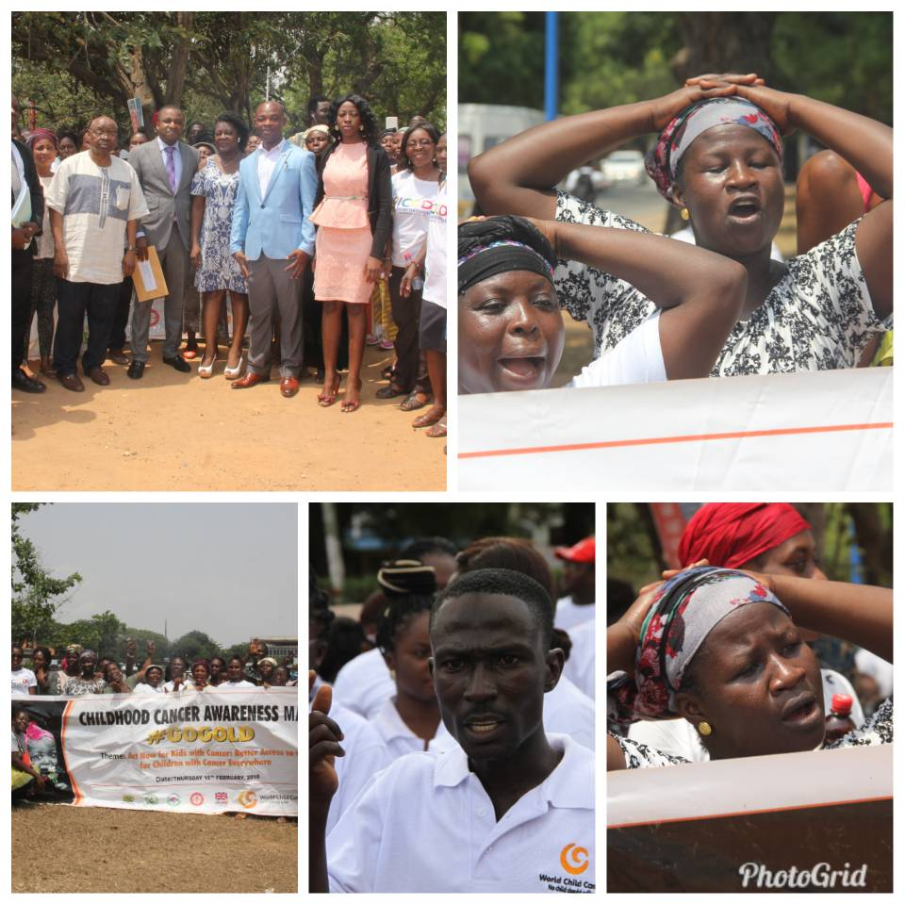

The SIOP Africa Wilms Tumour collaboration will be organizing an ultrasound training workshop in Blantye, Malawi in May 2018. This will enhance the skills of clinicians and others who will be trained so as to improve their diagnostic capacity of abdominal masses.