International Society of Pediatric Oncology (SIOP) AFRICA newsletter March 2019

SHORT REPORT ON SIOP CAIRO
The recent congress of SIOP in Africa was held in Cairo. We congratulate Elhamy Rifky and his stellar organising team for a stimulating, inclusive programme which included local research and international experts. The kindness and generosity of our Egyptian hosts will be remembered for a long time. The presenters who earned awards and special mentions include:
- Amr Abdalla Salem - Egypt : Prognostic Factors and Outcome of Patients with Relapsed and Refractory Hodgkin Lymphoma After High-dose Chemotherapy and Autologous Stem Cell Transplantation.
- Emad Moussa – Egypt : Burkitt's lymphoma in Children: Is a Second Cycle Pre-Induction Chemotherapy Effective in Critically ill Children?
- Fayçal Oubich – Tunisia: Bilateral Wilm’s Tumor Ten Year Experience
- Sara Ibrahim – Ethiopia: Reducing Treatment Abandonment at Pediatric Oncology Unit of Tikur Anbessa Specialized Hospital, Addis Ababa, Ethiopia through Psychosocial and Financial Support
- Joan Nakabiri - Uganda - Continuing nurse’s education at the Uganda Cancer Institute: a baseline assessment
- Hany Eskander Egypt - Assessment of Intensive Care Nurse’s Knowledge & Practices Regarding utilization of infection control standards at Children’s Cancer Hospital – Egypt
- Vera Njamnshi Cameroon - Nurses role in the long-term follow up of female survivors of Burkett lymphoma to assess their fertility
- Elizabeth W. Ng'ang'a- Kabuthi- Kenya : child life practice in the care of children with cancer: the experince in a lowincome setting
- Samar ElBahy - Egyptian Working in UK: Outcomes of umbilical cord transplant in high risk relapsed or refractory acute myeloid leukemia
We congratulate them for the high standard of their research.

The winners of the free registration to the 51st Annual SIOP Congress in Lyon, France is
- Njodzeka Bernard Wirndzem – Cameroon : HIV Prevalence and Disease Outcome among Patients Diagnosed with Childhood Cancer in Cameroon (Best Poster )
- Jeremie Hassan- Tanzania: Increasing Safety and Consistency of Chemotherapy Treatment in Resource-limited Countries via Excel-based Prescription Automation (Best Oral)
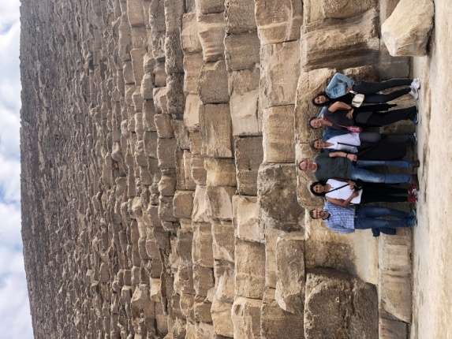 | 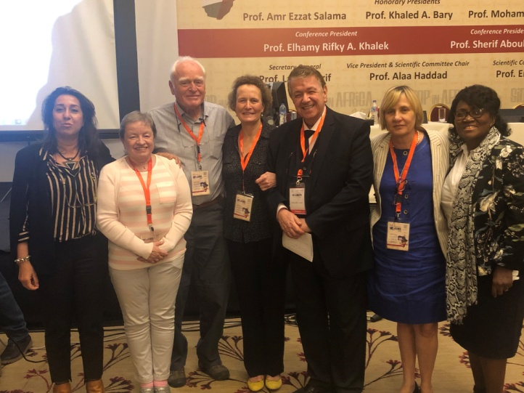
Visit to pyramids | SIOP Africa and SIOP presidents (from right to left : L Renner, M Kruger, E Rifky Khalek, K Pritchard-Jones, P Hesseling, J Poole and L Hessissen)

NEW SIOP AFRICA BOARD
We are delighted to announce that we have expanded the SIOP Africa board to ensure full geographic representation. Our representative of Francophone Africa is Jamila Elhoudzi from Marrakech, Morocco. We are confident that our conscious effort to include Francophone members will contribute to greater collaboration and inclusivity.
Alan Davidson continues as an ex-officio member to ensure strong links with the board of SIOP International. Joyce Balagadde is the new representative of East Africa, while Elhamy Rifky, John Ahenkorah and Jennifer Geel continue to represent Northern, Western and Southern Africa respectively. Glenn Mbah from Cameroon represents the nursing group. Jennifer Geel also agreed to take on the role of Secretary General while Jeanette Parkes continues to represent PROS.
In an effort to consolidate relationships with the greater childhood cancer community, the chair of Childhood Cancer International Africa Division, Carl Quieros, was co-opted onto the board. We have every hope that this new formalized collaboration will benefit our oncology community, especially our patients and their communities.
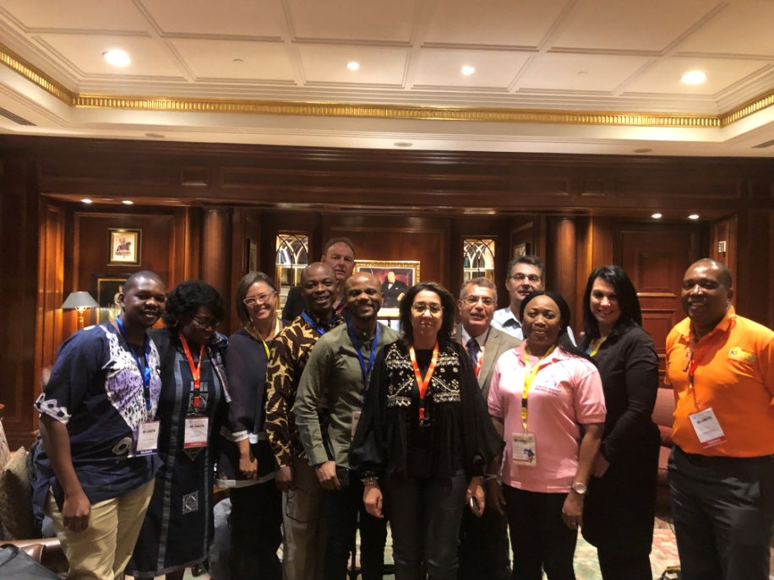
Meeting CCI and SIOP Africa board

INCREASING RESEARCH OUTPUT AND PUBLISHING OF AFRICAN STUDIES

One of the questions that was posed at the Annual Business Meeting was whether SIOP Africa would consider starting a journal. As this is something that we cannot at this time consider, due to both time and financial constraints, we thought it might be a good idea to suggest some journals which are peer reviewed and of sufficient quality for our research. Here are some suggestions:

- South African Journal of Oncology.The SA Journal of Oncology (SAJO)
- Journal Africain du Cancer / African Journal of Cancer
- Cancer in Africa Online (CIAO®) Journal is a publication of the Society of Oncology and Cancer Research of Nigeria (SOCRON).
- AORTIC is affiliated with Infectious Agents and Cancer, an open access, peer-reviewed, online journal published by BMC.

ACTIVITIES ACROSS THE CONTINENT OF AFRICA
TUMAINI LA MAISHA TANZANIA/their live matter
Over the last 10 years TLM has supported medical and non-medical services for kids undergoing treatment. Most recently TLM’s sights have been directed nationally to try to bring the quality available in Dar es Salaam across the country. Currently TLM have established and support a network of 6 paediatric oncology sites across the country at no costs to the kids or their families.
In 2019 the TLM efforts included the provision free of charge of all chemotherapy used for children in the country; the creation of a Paediatric Intensive Care Unit (PICU) and a Neonatal Intensive Care Unit (NICU) at Muhimbili National Hospital; haematology and pathology laboratory strengthening including the provision of flow cytometry, immunohistochemistry and minimal residual disease analysis. TLM would very much like to publicly thank the staff of Crumlin Children’s hospital in Dublin for their support particularly in the field of pathology and haematology.
An other important initiative in the area of data management. is the creation of a programme for automating the prescribing of chemotherapy. This can remove 90% of common prescription errors. TLM hope to merge this with their soon to be launch paediatric database and once the beta testing phase is complete to offer these programmes to the resource limited colleagues.
TLM is also hoping to run the 10 week intensive paediatric oncology clinical nursing course again this year. The course was a huge success last year and transformed the type of care the children receive.
Caring for children with cancer in tanzania www.wearetlm.org
https://www.facebook.com/tumainilamaishaTZ/
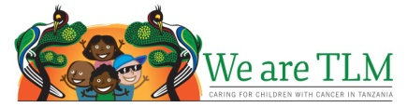

Abidjan 14 March 2019 - inaugural ceremony of the AKWABA parent house a new house for Children with cancer and their families in Ivory Coast
The NGO Soleterre, in partnership with the Lalla Salma Foundation Cancer Prevention and Treatment and the Franco-African Group of Pediatric Oncology (GFAOP) www.gfaop.org , continues its commitment for children with cancer by creating a new parent house
The new parent house will accommodate about twice as many families as in previous years. It will help improve the care of patients and their families and will help reduce treatment abandonment and better management of hospital beds.

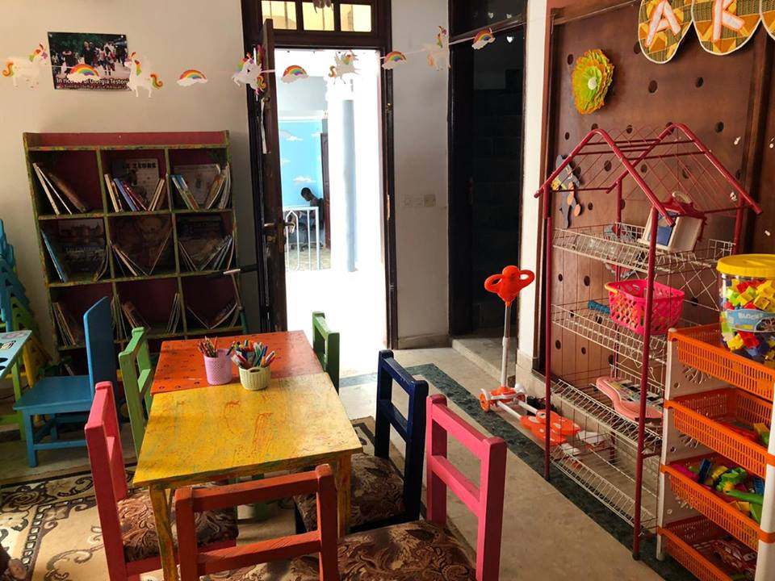 | 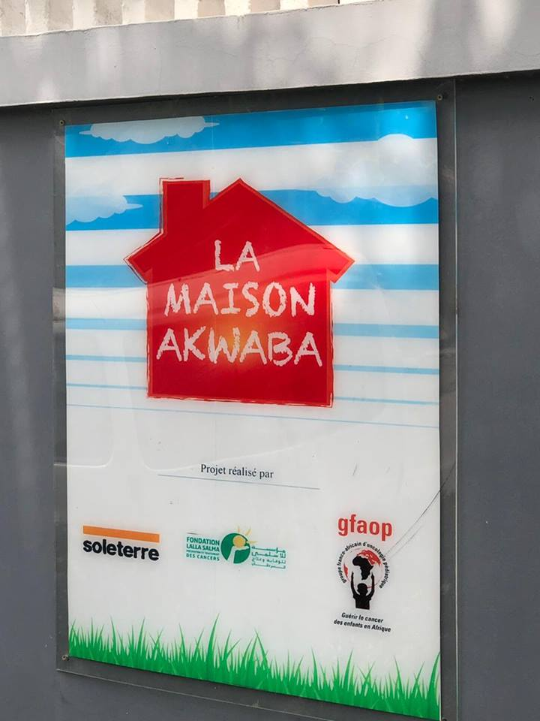
Uganda Cancer Institute receives international recognition for cost-effective paediatric treatment. This is contained in an article published by the Journal of the American Cancer Society, 2019 which featured a study that was done on building a financial case for treating childhood cancer in resource-limited settings. http://www.pmldaily.com/news/2019/03/uganda-cancer-institute-receives-international-recognition-for-cost-effective-pediatric-treatment.html
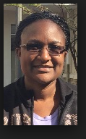 Congratulations JOYCE!
The SIOP Africa / PODC Collaborative Wilms Tumour Project
‘Improved outcome – preparing phase II – new centres welcome to join”

The Aims of this project are to improve care and survival, establish a regional network and contribute to local multi-disciplinary capacity building. A regional ultrasonography course was organised in Malawi in 2018 and will be repeated every two years.
Funding from SIOP and World Child Cancer is used to pay for treatment and associated costs such as transport to enable parents to complete treatment. In the first two years, abandonment of treatment decreased significantly from 23% to 13% and treatment related deaths from 21% to 13%. The aim is to reduce both to below 10%. To achieve this, the group continues to seek funds to enable parents to complete treatment and is developing a project to improve supportive care (SUCCOUR).
The group is currently analysing the data of the first four years of the project and, based on these, preparing the start of phase II with modifications to the treatment guideline. Phase II will start January 2020. Centres in Africa wishing to join are most welcome.

SUCCOUR – Supportive Care for Children with Cancer in Africa

Improved supportive care has the potential to benefit children with all types of cancer as well as children in general paediatric care. SUCCOUR is a comprehensive and inclusive project led jointly by doctors and nurses to promote improvements in supportive care. The aim of SUCCOUR project is to find feasible and sustainable solutions to shared local challenges, based on local expertise and evidence.
The project will start with a careful and prospective baseline documentation of current practice and outcome in several areas of supportive care such as febrile neutropenia, nutrition and abandonment. Other activities will include educational workshops, advocacy, developing localappropriate supportive care guidelines and development of specific interventions based on the collected local evidence. Centres in Africa wishing to join are most welcome.

For more information about the Collaborative Wilms Tumour Africa project or SUCCOUR, please contactafrica@siop-online.org (Chair SIOP Africa, Laila Hesissen), t.israels-3@prinsesmaximacentrum.nl(Trijn Israels, coordinator), mbahlos@gmail.com (Glenn Mbah, co-coordinator SUCCOUR, nursing component)

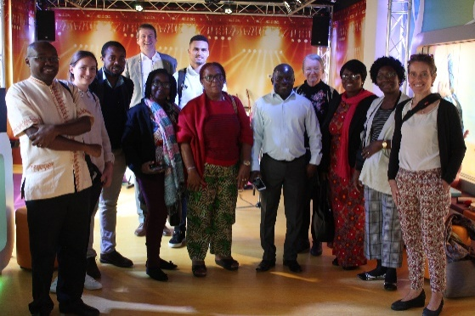 | 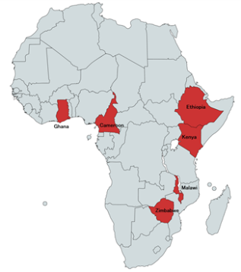
Work meeting October 2018 | Countries (centres) participating in the Collaborative Wilms Tumour Africa Project

The SIOP Africa Nursing Group
The nurses of SIOP members have been engaged in several activities aimed at capacity building, quality improvement, research, advocacy, as well as regional and global collaboration.
African nurses joined colleagues from other regions to produce a poster which was distributed widely via the SIOP website and social media outlets, to celebrate the international paediatric day on September 8th. With mentorship of senior colleagues within the PODC community, two African nurses received the Sanofi Espoir My Child Matters Award for nurses at the 50th International SIOP congress in Kyoto, Japan. ElianethKiteni of Tanzania is currently executing her project on “Childhood and adolescents cancer fight in southern highland zone of Tanzania: nurses, role players.” While Lomtunzi Chidziwa from Zimbabwe is empowering trainer of trainers with skills in chemotherapy administration, provision of palliative care services and general management of children with cancer and their families.
Several nursing training initiatives have been conducted within the continent with the support of twinning partners. Local training programme have been effected in Cameroon, Ghana, Malawi, Tanzania, Botswana, Uganda, Malawi, some of which are ongoing, with impressive impact assessment reports. Discussions have begun for the harmonization of training curricular for various tiers of nurses involved in paediatric oncology care, with sharing of training materials, as well as competencies and policies developed. Additionally, attendance of African nurses at online SIOP PODC education meetings has increased.
Prof. Hoda Zaki led the organization of a nursing program at the 13th African SIOP Conference in Cairo, Egypt in March 2019. The nursing programme included a workshop on research, three keynote lectures on pain management, effective communication and the baseline nursing standards. There were eleven good quality free papers from nurses around the continent. At this conference, the African nurses decided to maintain constant communication and collaboration by establishing whatsApp and facebook groups. As of date, an interactive whatsApp group has been established with Nurse Mariam Ndagire from Uganda leading the social media platforms.
At the conference in Cairo, a new African collaborative project on supportive care was presented to begin later in the year. Nursing is a prime focus of this project as participating sites will have designated lead nurses for supportive care and several nursing and multidisciplinary training sessions are earmarked to take place within the project.

JOIN SIOP

The representation of Africans in the greater SIOP community is low-key, and needs to be increased. Over the last five years, the attendance by Africans at global SIOP meetings has been between 1 and 4%, although Africa is the world's second largest and second most-populous continent, being behind Asia in both categories. We urge our SIOP Africa community to join SIOP International: https://siop.multiregistration.com/membership/step1

The SIOP Africa Board and the Paediatric Oncology in Developing Countries (PODC) leadership have lobbied hard for reduced membership fees for low and middle income countries. This option is now available at €20 for low and lower-middle income country members. The more representation we have from our beautiful continent, the more our patients will benefit!

The many benefits of SIOP membership include opportunities to learn from and collaborate with highly respected colleagues, access to articles in Pediatric Blood and Cancer, access to recordings of keynote lectures at past congresses and more.

DATES TO DIARIES
- 20-23 June 2019, Up to SPAED conference in Johannesburg, South Africa. This refresher course will include a full day multidisciplinary team workshop and a half day paediatric oncology conference. http://witsuptospaed.co.za/ The rest of the even includes adolescent medicine, mental health, nephrology, neonatology, ethics and more.
- 7-8 August 2019. Society for Neuro-oncology in Sub-Saharan Africa Paediatric Brain Tumour Workshop. in Cape Town, South Africa. http://btw.brainchild.org.za/
- 12th International Conference on Cancer in Africa. The conference, themed Cancer in Africa: Innovation, Strategies, Implementation, will be held in Maputo, Mozambique from 5 to 8 November 2019. http://aorticconference.org/about-aortic/
- 16-18 March 2021. The 14th Congress of SIOP in Africa Congress, Kampala, Uganda

SIOP AFRICA IN SOCIAL MEDIA
SIOP Africa has recently started a Facebook page: https://www.facebook.com/profile.php?id=100015960223807

If you are on Facebook, please go the page and “like” it and you will receive regular updates.

If you have conferences, training programmes or any other opportunities you would like us to publicize, please email us africa@siop-online.org and also email the SIOP PODC Education and Training Working Group co-chairs on jennifer.geel@wits.ac.za and neil.ranasinghe@refinitiv.com

We wish you a fruitful year ahead and hope to see many new and old friends in Lyon!

Laila Hessissen, Jennifer Geel,
SIOP Africa President SIOP Africa Secretary General

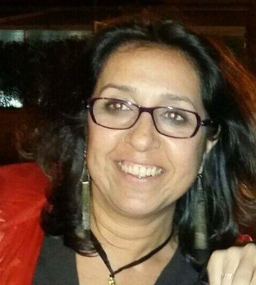 | 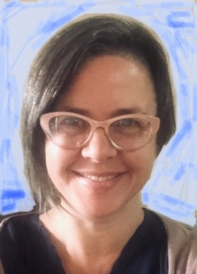
On behalf of the SIOP Africa Board

