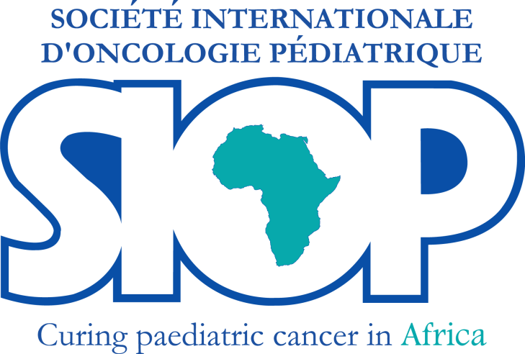

**SPRING NEWS LETTER**

**December 2019**

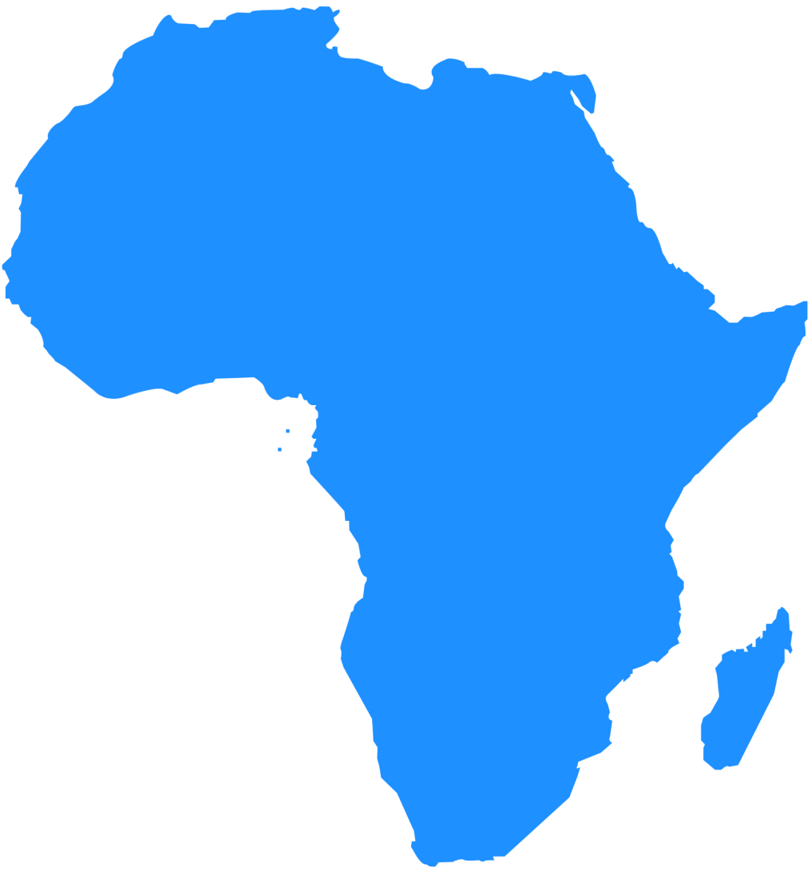

**Bests wishes and happy New Year**

**2020**

**National Stakeholder Meeting on the WHO Global Initiative for Childhood Cancer in Ghana**

Ghana was selected as one of the pilot countries of the WHO Global Initiative for Childhood Cancer. The stakeholder’s workshop was organized to mobilize key stakeholders in Ghana in order to start developing an action plan for the country to achieve at least 60% survival rates by 2030, establishing priorities and responsibilities.

A national stakeholders meeting was held in Accra, Ghana on 18th and 19th November 2019. Participants included CEOs and staff from the Teaching Hospitals, representatives from WHO (Head quarters and Ghana), World Child Cancer (UK and Ghana), SIOP President and a past President, Ministry of Health, Ghana Health Service including NCD Program Manager, Coalition of NGOs in Health, Survivor and representative from Ghana Parents’ Association for Childhood Cancer, Pharmaceutical Companies, NHIA, Food and Drugs Authority, representative from Lions Club, Ghana, Rector and vice-rector of Ghana College of Physicians and Surgeons, Rector and vice-rector of Ghana College of Nurses and Midwives.

This stakeholders meeting was the first focus country national workshop associated with the WHO Global Initiative for Childhood Cancer in the Africa Region. This workshop engaged key national, regional, and international stakeholders to maximize in-country implementation to achieve Ghana’s national priorities in childhood cancer and connecting national priorities to define commitments and global targets, including that of the overarching Global Initiative.

The objectives were to:

1. Summarize the landscape and priorities for cancer control in children and adolescents in Ghana;
2. Highlight the available resources and tools of WHO for the assessment, prioritization, development and scale-up of cancer control programs, particularly for childhood cancer;
3. Develop outcome measures as part of a national action strategy for children and adolescents with cancer in Ghana, in alignment with national, regional, and global priorities

At the end of the meeting, recommendations were made including: the formation of a National Childhood Cancer Steering Committee, improving early diagnosis using existing health care pathways, accelerated training of multi-disciplinary teams, strengthening of inter-sectoral collaboration on management of childhood cancer. Commitments to support the initiative in the country were made by stakeholders. The report will be made public soon.

**AORTIC 2019 meeting– 5th and 6thNovember 2019**

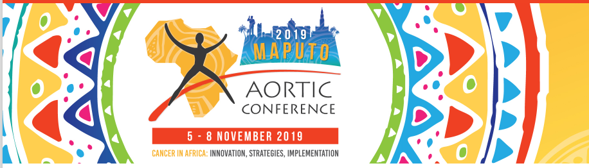

The 12th International Conference on Cancer in Africa, “Cancer in Africa”: Innovation, Strategies, Implementation, was held in Maputo, Mozambique from the 5 to 8 of November 2019.

The conference program, focused on the unique burden and opportunities for cancer control in Africa. The conference featured an in-depth scientific program with local, African, and internationally-renowned keynote speakers. Major areas of focus included cancers of the cervix, breast, prostate, and esophagus; hematological cancers; and hepatocellular carcinoma. In addition, the conference focused on the development of National Cancer Control Programs and addressed the issue of palliative care in Africa.

Pediatric and childhood cancer was very well represented with many stimulating discussion sessions conducted in association with the SIOP Africa:

1. **SIOP Africa / AORTIC sessions:**
   * KEYNOTE 5: Laila Hessissen (Morocco) SIOP Africa | Pediatric cancers: Are we bridging the gaps in terms of treatment and survival?
     + A TOOLKIT FOR MANAGING ADOLESCENTS IN CANCER
     + Chemotherapy: using relationships and protocols to bridge the adult/pediatric divide Z Mohamed (South Africa)
     + Radiotherapy: any special considerations?
     + Nursing considerations L Soanes (United Kingdom)
2. **Other pediatric presentations**
   * PAEDIATRIC ONCOLOGY; PALLIATIVE-CARE | PSYCHO-ONCOLOGY : Experience of parents with treatment of childhood cancer in southern Nigeria G Eke (Nigeria)

* HAEMATOLOGY
  + Lymphoma in East-African Children and Minors (EMBLEM): where we are, and where we gofrom here N Othieno-Abinya (Kenya)
  + Pattern of occurrence of adult acute leukaemias in Kenya and identifiable risk factors C Williams (United States)
  + Childhood acute lymphoblastic leukaemia in Nigeria: Evidence for a role for infection, and a comparison with global experience
    - ACCESS MODELS FOR IMPROVED PAEDIATRIC CANCER CARE IN AFRICA :
    - Discussion around access models for improved pediatric cancer care in Africa T Scanlon (Tanzania) TLM Tanzania model cancer care in Africa N Ozuah (Malawi)
    - Global HOPE model in Malawi, Uganda, and Botswana Tighe (United States)
    - NGO support to improve access to care for childhood cancer patients A Adler-Waxman (Israel)
    - Discussion around industry models to help ensure Rx access
    - ECONOMICS OF CANCER S Gupta (Canada) | Cost of childhood cancer in Africa

The next AORTIC meeting will be help in 2021 in SENEGAL

**The second meeting of the Franco-Congolese association of paediatric surgery**

|  |  |
| --- | --- |
|  | The second meeting of the Franco-Congolese association of paediatric surgery (AFCCP) was held in Kinshasa (DRC) from 26 to 28 November 2019 and was dedicated to cancer in children. This meeting was supported by Monkolé Hospital and training center and health support (CEFA Monkolé) from Kinshasa, Kinshasa University (UNIKIN), Lubumbashi University, the French African Paediatric Oncology Group (GFAOP) and the International Society for Paediatric Oncology SIOP Africa. |

The surgical management of solid tumours (nephroblastoma, neuroblastoma, germ cell tumours, lymphomas and bone tumours) was presented with a pediatric oncologist (Catherine Patte) and a pathologist (Aurore Coulomb) point of vue. Doctors and nurses were gathered during an afternoon to discuss pain relief, not only postoperative pain but also pain in patients in palliative care and pain in caregivers. Some problem cases were exposed and discussed in an open forum with the audience.

About 100 doctors and nurses participated to the meeting with a lot of exchanges between the speakers from France or Subsaharian countries (accepted communications) and the audience. This meeting was very successful with the participation of many surgeons from all parts of DRC (Bukavu, Goma, Lubumbashi, Kinshasa…), from 5 sub-Saharan countries (Congo Brazzaville, Guinea, Mauritania, Senegal and Central African Republic) and Tunisia, nurses from DRC and trainees. Trainees participated to the meeting and had a fourth educational day about hepatic, pancreatic and gonadal tumours. This training will be part of subspecialisation in pediatric surgery for surgeons from DRC.

|  |  |
| --- | --- |
|  |  |

**SIOP Africa nursing report for Newsletter**

At the SIOP Africa congress in Cairo in March 2019, the nurses decided to form a group with the objective of strengthening relationships between colleagues, sharing knowledge, information and opportunities with each other, ensuring that friendships and collaborations continue and are reinforced between continental conferences. A WhatsApp group was created to this effect. Membership to this group is open to every nurse working in paediatric oncology in any part of Africa. Communication within the group has so far been in English and French, with colleagues taking turns in volunteering to translate between the two languages. This group now has a membership of 93 and continues to rally paediatric oncology nurses from across Africa. Discussions on the group so far have ranged from clinical questions like management of extravasation, chemotherapy induced nausea and vomiting, through professional matters like counselling children on diagnosis and treatment and sharing of information and publications, to social matters like birthday celebrations. We invite nurses who are not yet part of this group to contact Mariam Ndagire from Uganda ([ndagimariam@gmail.com](mailto:ndagimariam@gmail.com)).

September 8th is celebrated as International Paediatric Oncology Nurses Day. This year, the SIOP PODC nursing group celebrated this day by producing a poster featuring paediatric oncology nurses from various regions of the world providing care to patients in the hospital and in the community. This poster was translated into eight international languages, posted on the SIOP website and distributed widely via social media. Two nurses from the SIOP Africa group contributed to the design of this poster.

Several capacity building initiatives are on-going for paediatric oncology nurses in the region with collaboration across countries. One of these is the Global Hope nursing programme in sub-Saharan Africa provided by the Texas Children’s Hospital provides an online educational training sessions for collaborating centres in Malawi, Botswana, and Uganda. For more information on this, please contact TadalaMulemba ([tadalamulemba@gmail.com](mailto:tadalamulemba@gmail.com))

Secondly, the Supportive Care for Children with Cancer in Africa (‘Succour’) project includes a nursing component which conducts monthly educational web meetings with nurses from Zimbabwe, Kenya, Malawi, Ghana and Cameroon, with the aim of empowering nurses who will be clinical role models in supportive care.

A network has been created between several partners supporting nurse training in Africa dubbed the SIOP Africa Sub Saharan paediatric oncology nursing network. The network aims atdevelopment of a proposed harmonized training package for paediatric oncology at foundation and specialist levels, including a psychosocial care training package, core competences and guidelines. A steering committee has been created for this network and a Delphi survey is being conducted to canvass opinion of colleagues on topics to be included in the foundation course. For more information about this project and for any interest in contributing to this project, please contact co-chairElianethKiteni of Tanzania ([elianeth.kiteni@gmail.com](mailto:elianeth.kiteni@gmail.com)).

The SIOP international conference in Lyon, France in October 2019 witnessed a strong attendance of 16 African nurses with as many oral presentations and posters on a variety of topics including clinical care, research, psychosocial support and community education – our congratulations to MarangGoratao from Botswana for her best poster presentation award. The nursing group is very grateful to SIOP and the Sanofi My Child Matters initiative for providing scholarships to nurses from Africa to attend this conference. Some SIOP Africa nurses were also present at the conference of the African Organization for Research and Training on Cancer (AORTIC) held in Maputo in November. These nurses are part of a working group working on the development of oncology competencies for Africa.

**Sanofi Espoir Foundation “My Child Matters” supported programs across Africa.**

The **My Child Matters** program is a unique initiative developed by the Foundation since 2006 to help children with cancer in low-income countries in Africa, Asia and Latin America to benefit from early diagnosis and better care.

The My Child Matters program fights childhood cancer via several actions.

1. Training health professionals :
   * Diploma courses for onco-pediatricians in Francophone Africa,
   * Lifelong training for nurses and paramedics.
2. Palliative care: establishing palliative care networks and training in pain treatment.
3. Retinoblastoma: improving early diagnosis, providing conservative treatment, and implementing prosthetic eyes after surgery.
4. Registers: introducing pediatric cancer surveillance systems by recording epidemiological data.

Sanofi Espoir Foundation is supporting many projects in Africa through the MCM initiative.

**1 - Poster presented at SIOP Annual meeting in Lyon, France, of work supported by Sanofi Espoir Foundation.**

**SIOP Maps Paediatric Oncology Services in Africa to Address Inequalities in Childhood Cancer Services.** Geel JA, Ranasinghe N, Davidson A, Challinor J, Howard S, Wollaert S, Myezo K, Renner L, Hessissen L, Bouffet E.

|  |  |
| --- | --- |
|  | **RESULTS:** 47/54 African countries responded with 243 surveys returned. 20 countries have no full-time pediatric oncologist. 168 responders work in a government hospital. Median number of patients seen each year 120 (range 45-300). 20% of responders had >20 full-time nurses caring for children with cancer.  The data serves as a baseline against which to measure efforts to improve comprehensive care for children with cancer and their families in the region. |

**African MCM projects presented at SIOP/CCI Lyon October, 2019**

|  |  |  |  |  |
| --- | --- | --- | --- | --- |
| **Poster number** |  | **Title** | **Presenter** | **Country** |
| [SIOP19-0300](https://urldefense.proofpoint.com/v2/url?u=https-3A__eur02.safelinks.protection.outlook.com_-3Furl-3Dhttps-253A-252F-252Furldefense.proofpoint.com-252Fv2-252Furl-253Fu-253Dhttps-2D3A-5F-5Fweb.kenes.com-5Fklead-5FSIOP19Final-5FSIOP19-2D2D0300.pdf-2526d-253DDwMGaQ-2526c-253DDbf9zoswcQ-2DCRvvI7VX5j3HvibIuT3ZiarcKl5qtMPo-2526r-253DhbYZyMjgIj4aGt-5Ffg27fd-2DhuDIKcm4FfbNi1qgDX0EwZrZWoIpd0bbYmVaB0iYyI-2526m-253DKI2UAuTsFzWtmQ1K0KTC2-5Fjrt1d0-2Da0J0tek-5FWhflWs-2526s-253Dreg3QguzcRDkHNrlSafYTJSuMYY8snKx-2DMXkZ8fMRY4-2526e-253D-26data-3D02-257C01-257Cbbenami-2540kenes.com-257Cb6f99a26831446b9e90d08d747302f08-257C3d30e618d92c4b12be882d9347423783-257C1-257C0-257C637056144611736769-26sdata-3DGvXoaWgB5M5ZzMjLmuqPRJ8w-252BBfYaM6gQ2VE3ZQN52Q-253D-26reserved-3D0&d=DwMGaQ&c=Dbf9zoswcQ-CRvvI7VX5j3HvibIuT3ZiarcKl5qtMPo&r=hbYZyMjgIj4aGt_fg27fd-huDIKcm4FfbNi1qgDX0EwZrZWoIpd0bbYmVaB0iYyI&m=wEwvtT7V_MOznUcGwCVgdcRDhDN0rzNAtMQqQwAS44Y&s=dHXxm-5DjfEakerUfZbsey3mmNv0dCJojGLHgKbchog&e=) | Treatment and Care - Nursing | The role of a training initiative of primary healthcare nurses on early detection and supportive care for children with cancer in Tanzania: improving referral | Elianeth Kiteni | Tanzania |
| [SIOP19-0882](https://urldefense.proofpoint.com/v2/url?u=https-3A__eur02.safelinks.protection.outlook.com_-3Furl-3Dhttps-253A-252F-252Furldefense.proofpoint.com-252Fv2-252Furl-253Fu-253Dhttps-2D3A-5F-5Fweb.kenes.com-5Fklead-5FSIOP19Final-5FSIOP19-2D2D0882.pdf-2526d-253DDwMGaQ-2526c-253DDbf9zoswcQ-2DCRvvI7VX5j3HvibIuT3ZiarcKl5qtMPo-2526r-253DhbYZyMjgIj4aGt-5Ffg27fd-2DhuDIKcm4FfbNi1qgDX0EwZrZWoIpd0bbYmVaB0iYyI-2526m-253DKI2UAuTsFzWtmQ1K0KTC2-5Fjrt1d0-2Da0J0tek-5FWhflWs-2526s-253DAPn-5F2NWP2DxLTvcS8t7coUVH7f4TarecVmn5ADlKaN4-2526e-253D-26data-3D02-257C01-257Cbbenami-2540kenes.com-257Cb6f99a26831446b9e90d08d747302f08-257C3d30e618d92c4b12be882d9347423783-257C1-257C0-257C637056144611706787-26sdata-3D6k-252FLzmeYWb7Qvka19u1fIsg82jqMxxb7ItwwCWQ4hao-253D-26reserved-3D0&d=DwMGaQ&c=Dbf9zoswcQ-CRvvI7VX5j3HvibIuT3ZiarcKl5qtMPo&r=hbYZyMjgIj4aGt_fg27fd-huDIKcm4FfbNi1qgDX0EwZrZWoIpd0bbYmVaB0iYyI&m=wEwvtT7V_MOznUcGwCVgdcRDhDN0rzNAtMQqQwAS44Y&s=8fA38popidywUMPG8EYoA5C65jgdihrRjcantMorGZI&e=) | Childhood Cancer International (CCI) | Twelve countries present their results of a hospital-based childhood cancer register in French speaking African. On behalf of the GFAOP | Brenda Mallon | France |
| [SIOP19-0437](https://urldefense.proofpoint.com/v2/url?u=https-3A__eur02.safelinks.protection.outlook.com_-3Furl-3Dhttps-253A-252F-252Furldefense.proofpoint.com-252Fv2-252Furl-253Fu-253Dhttps-2D3A-5F-5Fweb.kenes.com-5Fklead-5FSIOP19Final-5FSIOP19-2D2D0437.pdf-2526d-253DDwMGaQ-2526c-253DDbf9zoswcQ-2DCRvvI7VX5j3HvibIuT3ZiarcKl5qtMPo-2526r-253DhbYZyMjgIj4aGt-5Ffg27fd-2DhuDIKcm4FfbNi1qgDX0EwZrZWoIpd0bbYmVaB0iYyI-2526m-253DKI2UAuTsFzWtmQ1K0KTC2-5Fjrt1d0-2Da0J0tek-5FWhflWs-2526s-253DYrmZ963Vzu9FwYtIGkBsJ-5FTW4pOKY7u6bt-5F4-5F0HBUMw-2526e-253D-26data-3D02-257C01-257Cbbenami-2540kenes.com-257Cb6f99a26831446b9e90d08d747302f08-257C3d30e618d92c4b12be882d9347423783-257C1-257C0-257C637056144611696793-26sdata-3Dv86qpr688wrs8TG-252B-252FmewSdJ8JnoTVzETbWOh0JvMkKM-253D-26reserved-3D0&d=DwMGaQ&c=Dbf9zoswcQ-CRvvI7VX5j3HvibIuT3ZiarcKl5qtMPo&r=hbYZyMjgIj4aGt_fg27fd-huDIKcm4FfbNi1qgDX0EwZrZWoIpd0bbYmVaB0iYyI&m=wEwvtT7V_MOznUcGwCVgdcRDhDN0rzNAtMQqQwAS44Y&s=D8MgFd7bSgbgpCkBeZMnUyxMDWsk9cj-nX0gOp9LNgw&e=) | Treatment and Care - Palliative Care | Integrating Palliative Care in a Pediatric Oncology Approach. A project of the Franco-African Group of Pediatric Oncology (GFAOP) supported by the My Child Matters Program. | Christine Edan | France |

As part of its roadmap for the period 2019-2021, the Sanofi Espoir Foundation supported 6 new projects in Africa to fight childhood cancers by providing expertise and financial support. This announcement came on the occasion of the 51st World Congress of the International Society of Pediatric Oncology (SIOP), which is being held in Lyon until October 26.

**2 - Current 2019 African MCM projects**

|  |  |  |  |  |  |  |
| --- | --- | --- | --- | --- | --- | --- |
| Project title | Project manager | | |  | Country |  |
| Supporting the Cameroon Paediatric Oncology Group to strengthen services in Cameroon | Tchintseme |  | Francine |  | Cameroon |  |
| Establishing the pattern of childhood cancer in Kenya to optimize cancer control (EPICK) | Githanga |  | Jessie |  | Kenya |  |
| Towards zero percent abandonment in Blantyre, Malawi | Chagaluka |  | George |  | Malawi |  |
| African School of pediatric oncology | Hessissen |  | Laila |  | GFAOP |  |
| French African pediatric oncology registry | Mallon |  | Brenda |  | GFAOP |  |
| Implementing a navigator program to reduce care delays &abandonment in Wilms Treatment | Shyirambere |  | Cyprien |  | Rwanda |  |

**AMCC Retinoblastoma program 2019-2020**

Retinoblastome (RB) is the most frequent eye cancer in childhood. A disease which is curable with > 95% cure rate in high income countries because of:

* Early diagnosis
* Referral and rapid access to treatment by a trained multidisciplinary team.

Unfortunately, this is not the case in sub-Saharan Africa where there is still a high mortality rate for this curable disease.

AMCC retinoblastoma program 2019-28 in partnership with GFAOP and Curie institute helps for the development of referent implement treatment centres of retinoblastoma in each country in subsaharian Africa.

**Extension of the RB program 2019-2028**

**Early and late stage presentation of RB and child enucleated with prosthesis**.

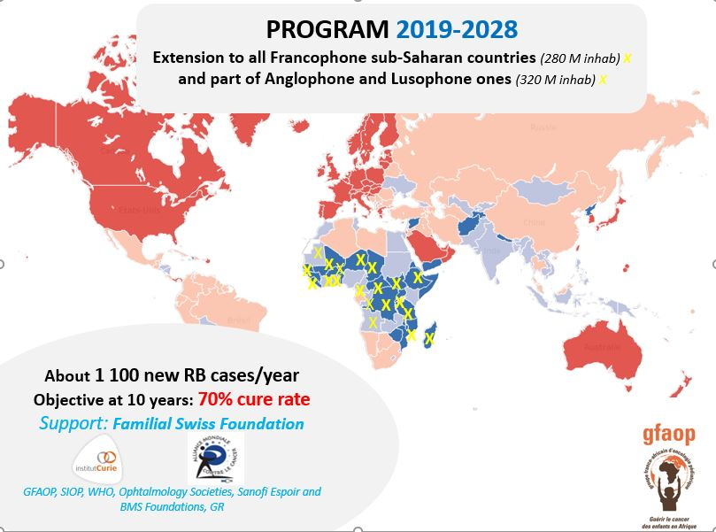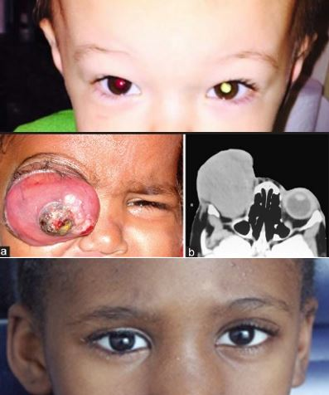

The aim of this program is to improve the cure rate of retinoblastoma to > 70 % in 10 years with the possibility to provide prothesis to each child enucleated and preservation of the eye with useful vision when possible.

**Tumaini La Maisha and Their Lives Matter**

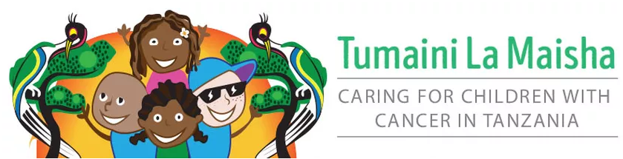

**Opening of the NICU &PICU**

“We Are TLM” is a collection of three NGOs all working for a single aim - to provide free and curative care for all children in Tanzania with cancer. The Tanzanian NGO goes by 'Tumaini la Maisha' meaning hope for life in Swahili. The UK and Irish NGOs, whose primary functions are advocacy and fundraising, go by Their Lives Matter.

## HRH the Queen of Sharjah, who visited the oncology program in 2014, has agreed to fund a paediatric intensive care unit which will service all critically ill children who require short term high intensity support including paediatric oncology patients.The civil works for the NICU portion of this plan began in 2017.

## On Friday November 29th, a representative from Friends of Cancer Patients, her Highness the Queen of Sharjah, the UAE Embassy, the Irish Embassy, the Muhimbili National Hospital team and TLM Board Chair celebrated together the opening of the new PICU & NICU wards at Muhimbili National Hospital . The plan and build of these pivotal resources at MNH was funded by a generous donation from Friends of Cancer Patients and implemented by TLM & MNH together.

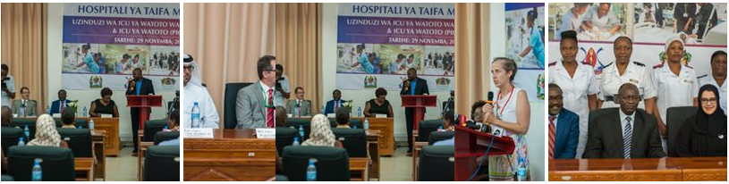

<https://www.facebook.com/tumainilamaishaTZ/>

**Upcoming events**

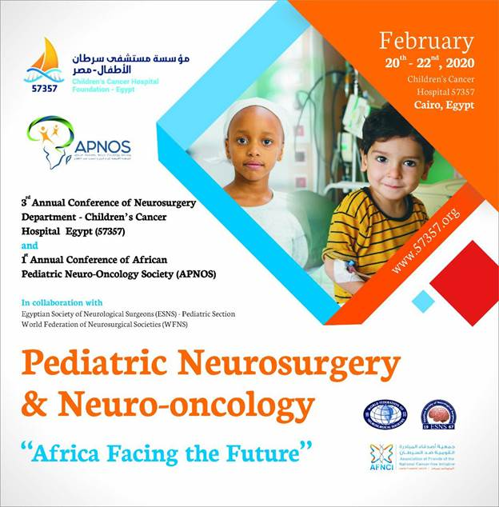



**Bests wishes**

**and**

**happy New Year**

**2020**