News from SIOP Africa
Registre Franco-Africain d’oncologie Pédiatrique (RFAOP)
As part of the GFAOP research program, 24 pediatric oncology units in 17 countries, all members of the French African Pediatric Oncology Group (GFAOP), were invited to participate in a hospital based register. These countries include: Algeria, Burkina Faso, Cameroun, RDC, Congo Brazzaville, Ivory coast, Guiney Conakry, Gabon, Madagascar, Mali, Morocco, Mauritania, Niger, Republic of Central Africa, Senegal, Togo, and Tunisia. With support from the ‘My Child Matters’, Sanofi Espoir Foundation, Paediatric Oncology Units in these countries have actively started data collection. Gustave Roussy in Paris has been assisting with strengthening data management at the various sites.
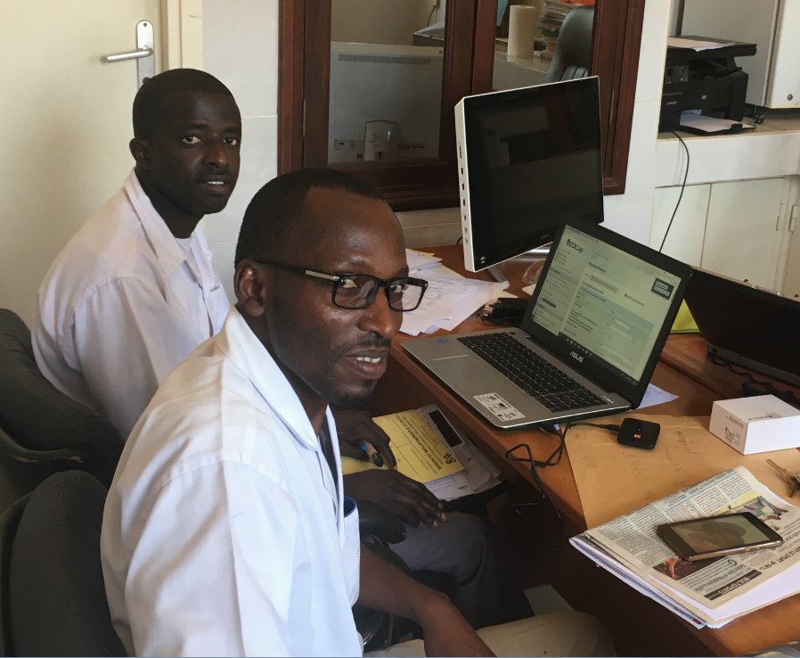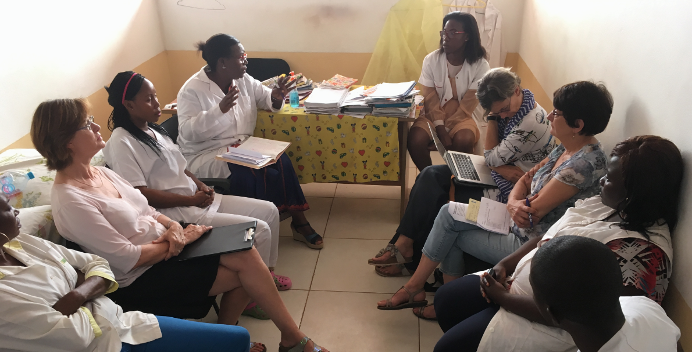
From left: research assistants at the Dantec hospital in Dakar, team discussion about the register in the foundation Chantal Biya in Yaoundé.
The GFAOP with almost 20 years of experience wishes to collect data on cancer incidence, treatment and outcome in participating units, to help evaluate the feasibility and efficacy of treatments. It is hoped that this data will in turn help identify: material, human resources and staff training needs locally as well as for the GFAOP. Ultimately it is hoped that this data will be used in the development of local and national cancer plans in the participating countries. Results from the registries, which have over 2,554 cases in the database so far, will be presented in Kyoto at the SIOP Congress. Keep an eye out for the future of this register which is a very bold attempt at providing data for studies locally and internationally.
The 13th SIOP Africa Continental Meeting is due to be held in Cairo from 6th – 9th March 2019 under the leadership of Prof Elhamy Rifky, chair of the local organizing committee. It promises to be a very stimulating and unique meeting. The theme is ‘Joining hands toward cure of children with cancer in Africa’. Physicians and other participants from Africa and the Middle East will have the opportunity to meet world renowned experts in Paediatric Oncology, to network and exchange experiences. A rich social programme is also promised, experiencing the land of the pharaohs and pyramids. Registration and abstract submission is now open. More details can be obtained from the website http://siop-africa2019.com/ We look forward to seeing many of you in Cairo.

