SIOP EUROPE UPDATE
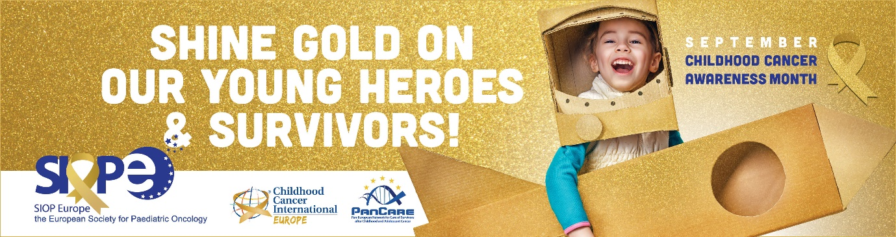
Childhood Cancer Awareness Month: Shine Gold on Our Young Heroes & Survivors
During September, we honour the children and young people battling cancer, the families who care for them, the healthcare professionals and their caregivers, the survivors, the children who lost their lives, and the scientists dedicated to beating childhood cancer.
This year’s campaign intended to reach out to a broad audience with easily accessible information on the stark reality of childhood cancer – the number one cause of mortality by disease in children older than 1 year in Europe.
We put a lot of effort into this year’s campaign, not least because of the challenges we are facing within the context of the COVID-19 pandemic. It is even more important that we highlight the challenges that we are facing and urge all of the various stakeholders to continue their work for a brighter future for children and adolescents with cancer.
This is the reason why SIOP Europe joined forces with Childhood Cancer International – Europe (representing parents/patients) and PanCare (a network of childhood cancer survivors and professionals working in the field) to support the Childhood Cancer Awareness Month this September.
The lighting of the European Parliament building in Brussels for the first time (from 1st to 6th September) brought unprecedented visibility to the persistent burden of childhood cancer and it is an important signal from the European Parliament that the youngest citizens will not be left behind.
And this is championed by Hon. MEP Ewa Kopacz (Vice President of the European Parliament in charge of Children’s Rights) with a statement of support by David Sassoli (President of the European Parliament).
Beyond Brussels, another eight cities in Belgium and other cities across Europe in the UK, Netherlands, Spain, Italy, Greece, Monaco, Bosnia, Czech Republic, Cyprus, Slovenia and Poland all lit up landmark buildings in gold.
We also had tremendous support from numerous Members of the European Parliament who wore the gold ribbon and organised special events.
SIOP Europe, CCI Europe and PanCare were furthermore delighted to partner with the MEPs Against Cancer (MAC) interest group of the European Parliament in a special webinar solely focused on paediatric cancer needs that took place on 8th of September. Having such a strong support from MEPs as our childhood cancer champions means a great deal to the community.
We also received messages of support at the highest level from the European Commission: Ursula von der Leyen (President of the European Commission) and Stella Kyriakides (European Commissioner for Health & Food Safety) have both provided tremendous statements of support.
Our gratitude goes to everyone: all who wore the gold ribbon pin, engaged on social media, supported this year’s Childhood Cancer Awareness Month – you really have made an impact and we will do more together next September!
More information: https://siope.eu/shinegold | Twitter: #ShineGold
Thank you message by Pam Kearns: click here to watch.
Video address by Stella Kyriakides: click here to watch.

ONCOPOLICY
Evaluation of the European Commission on the Legislation for Medicines for Rare Diseases and Children
The European Commission published a comprehensive evaluation of the medicines for rare diseases and children legislation by assessing the strengths and weaknesses of the Orphan and Paediatric Medicine Regulation.
The lack of sufficient investment with slow pace innovation stalled the progress in curing paediatric cancer, which remains to be the first cause of death by disease in children older than one year old in Europe. Neither regulation served the urgent needs of children and adolescents with cancer, leaving them to cope with acute and persisting adverse long-term side effects caused by older medicines.
SIOP Europe and CCI Europe: the European organisations representing childhood cancer professionals and parent and patient groups welcome the recognition in the European Commission report that rare childhood diseases and paediatric cancers specifically have not been sufficiently addressed by the current medicine legislation.
An urgent action is needed for revising the regulatory environment, aligning it with the global arena (e.g. RACE for Children Act) and better tailoring incentives for development of new innovative medicines for children and adolescents with cancer.

How the Pharmaceutical Strategy for Europe can help children and adolescents with cancer
By facilitating and incentivising the regulatory environment with dedicated R&D funding, policymakers can make a big impact on development of new and better anticancer medicines for paediatric population across Europe.
The aim of the EU Pharmaceutical Strategy is to ensure Europe’s supply of safe and affordable medicines to meet patients’ needs and support the European pharmaceutical industry’s innovation efforts.
Our European childhood cancer community is delighted that the outcome of European Commission’s evaluation of Orphan & Paediatric Medicine Regulations is intended to guide future legislative changes and shape the Pharmaceutical Strategy for Europe, which shall also focus on drug shortages.
The new Pharmaceutical Strategy for Europe is an opportunity to make lifesaving differences for young cancer patients by addressing its key pharmaceutical challenges. These include:
- The poor progress made regarding high-risk paediatric tumours due to lack of access to targeted innovation;
- Major inequalities in access to essential medicines across Europe;
- Inadequate access to innovative therapies for children and adolescents with cancer.
We welcome the European Commission’s recognition of the need to evaluate the regulatory framework and its implementation more closely. SIOP Europe has implemented a comprehensive stakeholder mobilisation effort to ensure that paediatric cancer community views are well represented as the new Pharmaceutical Strategy for Europe evolves.
The Pharmaceutical Strategy for Europe is a unique opportunity to address these major unmet needs in paediatric cancer and we encourage the Commission to seize this chance to make a pivotal change for our youngest citizens.
Read the full article in The Parliament Magazine (2 October 2020).
Further information here.

SIOP Europe & The European Parliament Group Webinar: Ways Forward for Childhood Cancer Policy
On 8 September 2020, SIOP Europe, CCI Europe and PanCare were delighted to partner with the MEPs Against Cancer (MAC) interest group of the European Parliament in a webinar entitled: ‘How can the EU4Health and Horizon Europe programmes improve access to diagnosis, treatment and care for paediatric cancer patients?’
The MAC Group virtually met with the childhood cancer community to mark Childhood Cancer Awareness Month and look at how EU policy and funding programmes, specifically the #EU4Health and #CancerMission can accelerate the fight against childhood cancer.
Pam Kearns (SIOPE President) presented 'Paediatric Cancers in EU4Health Programme - Where to invest?'
Pam Kearns: "The facts are there. There is a huge amount of work that still has to be done to improve the lives of these young people. It must be re-emphasised that childhood cancer is not just a mini version of adult cancers. They are cancers that affect a heterogeneous population. The impact on children is different from the impact on teenagers and on young people. And of course, they carry that impact across into survivorship. Each individual cancer (over 100 different sub-types) is rare. It falls into the concept of rare diseases. And each individual cancer is even rarer. So, each problem we have to find a solution for is not just about one cancer but addressing all these individual cancers and how they impact different age groups."
4 key paediatric cancer recommendations for EU4Health Programme:
- Address unequal access to the best available multi-disciplinary care (up to 20% difference in children's survival rates across Europe)
- Address lack of therapeutic innovation since most systemic treatment agents are old and originally developed for adults (only 9 new medicines in the last decade in contrast to over 150 for adult cancers)
- Deliver solutions for under-served survivors (almost 500,000 paediatric cancer survivors in Europe and growing)
- Empower vulnerable families (importance of parental involvement throughout the disease)
Watch the entire event on YouTube: https://youtu.be/2YVUeMe8Ayk

EVENTS
SIOP Europe 2021 Annual Meeting
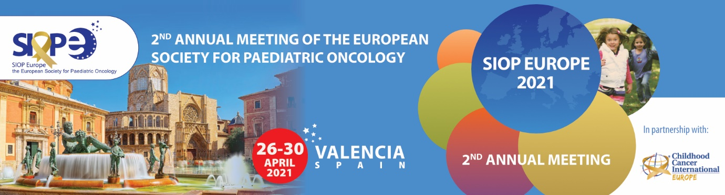
New dates: 26-30 April 2021 (Valencia, Spain)
The Annual Meeting will be held in partnership with CCI Europe, who will be holding their 11th CCI Europe Conference. This ensures the representation and participation of childhood cancer parents and survivors and provides exceptional possibilities for collaboration across all stakeholders within the paediatric oncology community.
More information: www.siopeurope.eu | Twitter: #SIOPEurope21

ESO – SIOPE Masterclass in Paediatric Oncology
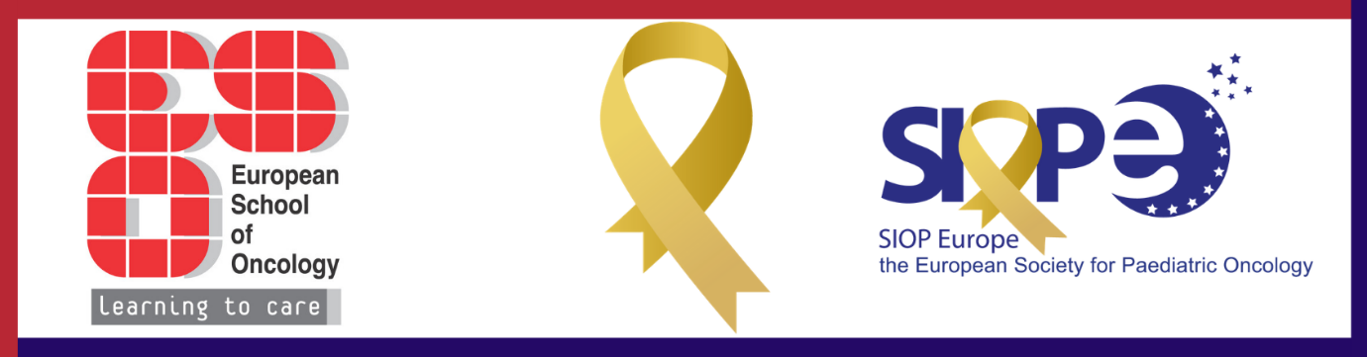
8th edition ESO – SIOPE Europe Masterclass in Paediatric Oncology
New dates: 27 November - 3 December 2020 (Bucharest, Romania)
This CME accredited clinically oriented educational program has been designed for advanced paediatric oncologists, who wish to improve their skills in clinical management of common childhood tumours and leukaemia and lymphoma. It is designed to offer a unique learning experience, providing practice-oriented training and the teaching sessions will focus on the application of the most recent research findings to clinical practice.
More information here.
EDUCATION
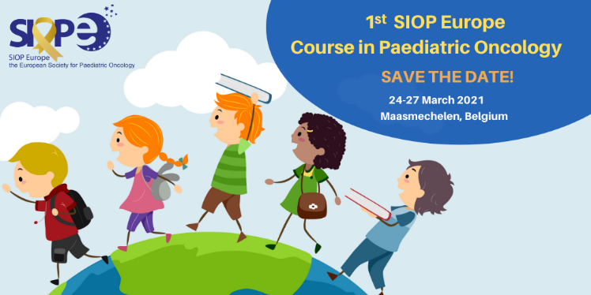
NEW: SIOP Europe Course in Paediatric Oncology

The first module of the SIOP Europe Course in Paediatric Oncology will take place 24-28 March 2021 in Maasmechelen, Belgium.
This new initiative is designed to support young and promising paediatric oncologists in developing their careers in paediatric oncology. The course will cover clinical aspects of childhood cancer, clinical research methods, research collaborations, statistical analysis, presentation skills and leadership. Real-life cases and situations will be discussed, as well as patient management and how to perform clinical studies.
More information here.

SIOP Europe: www.siope.eu
Twitter: @SIOPEurope

