SIOP Board Meeting - Paris, France
Friday 05 February 2016, 08:30 – 17:30
DRAFT MINUTES

Participants: Giorgio Perilongo – SIOP President, Gregory Reaman – SIOP Treasurer, Paul Rogers – SIOP Secretary General , François Doz – Chair of the Scientific Committee, Eric Bouffet – SIOP President-Elect, Susanne Wollaert – SIOP Secretariat, Tchiaska Jeanneret – SIOP Secretariat, Perry Gil-Ran – Kenes International, Camilla Presto Ben-Tov – Kenes International
Joining by Skype:
Gabriele Calaminus (SIOP Advocacy Chair), Julia Challinor (PODC Co-Chair), Ramandeep Arora (PODC Co-Chair), Michael Capra (Dublin 2016 LOC Chair), Stephen Hunger (SC chair elect)

Contents
1. Welcome & Communication 4
1.1 Communication 4
1.2 Concord 4
1.3 UICC 2016 Word Cancer Congress SIOP Symposia 4
1.4 SIOP History 4
3. SIOP Elections 4
3.1 Secretary Elect 4
3.2 SC nominations 6
4. Finances & Contracts 6
4.1 Brief update on the financial status 6
4.2 Tax exempt status 7
4.3 Any pending issue on the contract with Kenes 7
4.4 Fundraising activity 8
4.5 Wilms Tumour funding 2016 9
4.6 Membership Fee 9
5. Annual & Continental SIOP Meetings 10
5.1 Cape Town 2015 10
Preliminary report 10
CME Survey 10
Marketing Budget 11
SIOP Asia congress 2016 Moscow 12
Washington 2017 13
6. Handbook 13
7. SIOP Committee Reports 13
7.1 Advocacy General 13
7.2 Global Village Stakeholder Meeting 14
7.3 PODC 14
7.4 Website and communication 16
7.5 Request from Ronnie Barr on Essential Medicines 16
8. Objective and Goals - Status report 2016-2018 Objective & Goal 17
8.1 St Baldrick’s 17
St Baldrick’s Symposium 2016 17
St Baldrick and CCI (Dublin 2016) 17
Washington 2017 17
8.2 Dublin 2016 meeting 17
8.3 Other relationships 19
9. Brainstorming Meeting Paris June 16. – 17. 2016 19

1. Welcome & Communication

1.1 Communication
Giorgio Perilongo welcomed everyone and especially welcome Tchiaska Jeanneret as new secretariat team member to the board. The board has not received any farewell communication from Lorraine yet and would
Action:
- Susanne Wollaert to remind Lorraine de Montmollin to send a farewell email to the board

1.2 Concord
The endorsement request by Dr Audrey Bonaventure for the Concord programme has been approved.

1.3 UICC 2016 Word Cancer Congress SIOP Symposia
The UICC World Cancer Congress will take place in Paris, from October 31st to November 3rd, 2016 and SIOP has been asked to submit a symposium which has been done.
P Rogers reported that the SIOP symposium submitted had four speakers and SIOP has been requested to combine this with the ALIAM/GFAOP session. This means the symposium needs to be increase to six speakers over ninety minutes. SIOP was asked to contact their convener to merge the sessions but no response has been received yet.
The question is, if we want to be exclusive SIOP? E Bouffet added that SIOP was selected and that the session will be led by us 80% and might need to make a compromise this time since it is the only symposium related to paediatric oncology during the entire event.
Decision:
The board approved of sharing the symposium slot with other stakeholders but the topics need to be more aligned.
Action:
- Eric to get in touch with Sumit Gupta in order to find out more
- Susanne to give Eric the contact details of UICC event coordinator

1.4 SIOP History
G Perilongo reported that Dr D’Angio and his team have already done a wonderful job and SIOP will have all the details of the SIOP history on the website once the file is complete (exact timeline tbc).
Action:
- E Bouffet to interview Maude Brunat
- Eric Bouffet to contact Dr D’Angio and all to think about the 50 year anniversary of SIOP in Kyoto and maybe get an industry sponsor as well
- S Wollaert add up meetings to page once the history

3. SIOP Elections

3.1 Secretary Elect
Susanne Wollaert showed the board the current overview of nominations received for the Secretary Elect and Scientific Committee Members:
- Dr Marry M. van den Heuvel-Eibrink (The Netherlands)
- Dr Yunmei Liang (China)
- Dr Scott Howard (USA)
- Dr David Walker (UK)
- Prof Alan Davidson (South Africa)
She also reported that Dr Green (USA) informed the secretariat that he would like to retract his nomination to run for the secretary position and that Dr Liang has missed to provide a SIOP member to second her nomination.
E Bouffet commented that the board should not be completely formed by North Americans, and F Doz added that members however still should be able to choose. G Reaman also said that these nominations came in and we should let members vote. P Rogers stated that the nominating committee is the board of directors. S Wollaert added that the members will be asked to vote either way and the nominating committee is merely there to make sure all candidates are appropriate and fulfil the criteria.
Decision:
The board agreed that Dr Liang should be removed since she did not manage to have another member second her which means we have four candidates now. These four candidates will be out forward to election now. P Roger, as secretary general will step down by Washington and the new secretary will be in the office as of then. The timeframe from now until then can be used by the secretary elect to shadow P Rogers. G Perilongo will stay on the board for another year after Dublin as past president and entirely step down in Washington as well. F Doz to leave board in Dublin and S Hunger to take over completely.
Action:
- S Wollaert to share CV, motivation letters with board of directors and inform about decision to move forward with online election (with all SIOP members eligible to vote online after)

3.2 SC nominations
Susanne Wollaert presented the final nominations for the SC member election to the board.
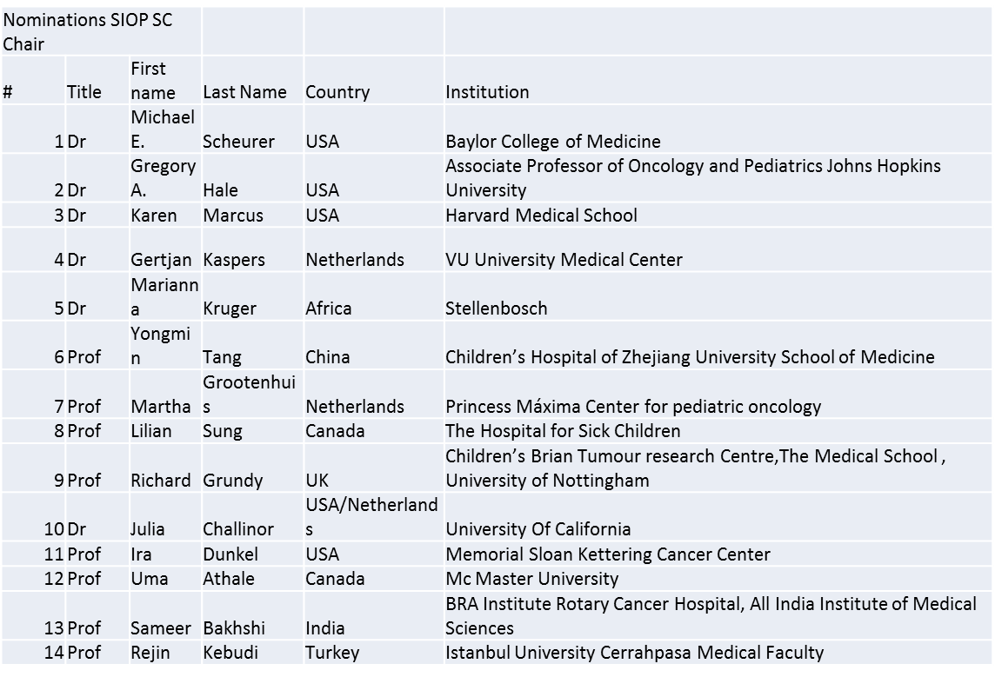
Decision:
The board agreed that there are too many people on this list and we need to get their CVs and decide on who to put forward. From the above 14 nominees the nomination committee need to selected 6.
CV should match what the SC does and what would be their main criteria which is involvement in research and running groups and societies. The question was raised if SIOP wants one PPO and one PODC members. It was decided that only two paediatric oncologist should be chosen.
Action:
- S Wollaert to arrange private voting
- S Wollaert to advice extended committee (meaning board of directors) that we have 14 nominations and we need to bring this down to 6. Each person will need to pick their top six
- S Wollaert to write note to members about delay, plus update membership zone on website and set for end of May

4. Finances & Contracts

4.1 Brief update on the financial status
G Reaman reported that the profit from the London meeting 2012 has finally been received due to a delay with the UK VAT returns. GP inquired where the money will go to. GR replied that the funds have been transferred to the general accounts at UBS in Switzerland.

G Reaman also emphasized the fact again that SIOP needs to be more cautious now on how to spend the money. P Gil Ran added that the congress profits will be much better, but G Reaman stated that the society will always need to budget with the guaranteed profit of EUR 100,000. He also mentioned that SIOP has placed reserves in a restricted account to run the operations and society. He added that the society also need to start fundraising internally and externally since we now have a legitimate objective. P Gil Ran added that, the ILS team (industry liaison team) rejected the fundraising activity in the past for the society since you need staff and also a reason to do so (infrastructure and strategy). P Rogers agreed that the advocacy should need to do fundraising and ask for the reports. There are many meetings in many important countries and we as aboard have to be a bit more directive to advocacy and what they are doing.

4.2 Tax exempt status
Susanne Wollaert explained that in order for SIOP to apply for tax exemption in Switzerland, SIOP needs a Swiss citizen or resident on the board. Hans Peter Wagner has been approached and will need to check with his lawyers before agreeing to this. E Bouffet added that he will obtain Swiss citizenship as well and could be the back-up for Dr Wagner in case.
Reasons to accelerate the process for the tax exemption:
- Since SIOP is now included in the Geneva Commercial Register it will receive tax declarations to be completed.
- Without formally having the tax exemption its profits might be taxable.
- Since obtaining the exemption can take quite some time it would be preferable to speed up this process.
- But, before requesting the exemption it is highly preferable to ensure that the statutes are in full conformity with the exemption and, further, a Swiss national, or Swiss resident, must be included in the commercial register (with either single or joint signing powers). I am already in touch with Prof Wagner and he is willing to do so if certain criteria are met. He will need to check with his lawyer and tax consultant first and will get back to us on this matter.

Changes required to Statutes:
- Just to be safe add a note in the first article that SIOP is an association according to the Swiss CC Articles 60 etc.
- On dissolution any remaining funds to go to an association that also has the tax exemption

Decision:
Changes to statutes and online ballot has been approved.

Also, S Wollaert and Greg Reaman are currently looking into the US tax status as well since Wiley (PBC publisher) withheld the US VAT from the royalties and educational grant paid to SIOP every year. There might be an option to recuperate that money as well.
Action:
- S Wollaert to follow-up on the Swiss tax exempt and US tax status and inform the board accordingly
- S Wollaert to set-up online vote for Changes of Statutes when ready

4.3 Any pending issue on the contract with Kenes
P Gil Ran reported that that the current Kenes contract can be stopped with a note after 120 days after the end of the previous congress and that any changes that we make today will take effect as of 2019. P Gil Ran agreed that certain items on the current contract are not 100% clear, for example is meant by period. G Reaman stated the period seems to refer to 3 years, but this needs to be clarified. He also suggested that the contract be renewed for another year after each congress. As of 3 congresses, there is a commitment for one year and a notice of 30 days after the meeting.
P Rogers asked if that links SIOP to the same budget and E Bouffet added that the real cost of abstract handling and secretariat support needs to be explained better and also if the board thinks it is a fair deal. P Gil Ran replied that we are partners and are sharing the profit.
P Gil Ran also explained to EB that the AM contract with Kenes is valid up to 2018 and if the board would like to make any changes, Kenes need to be notified by 2017. G Perilongo added that they are not planning to change anything, but it is important for the board to know these timelines.
Decision:
The current PCO contract should be amended and term of each contract will be of 3 years. Current addendum only allows for one time and SIOP needs one year notice.
Action:
- Dan Rivlin and Perry Gil Ran to check timelines since it binds SIOP for a long time to the PCO
- Perry Gil Ran to clarify the PCO contract with SIOP by a clear breakdown and more detail
- Kenes International needs to clarify the contract and abstract handling and this should be listed under general admin charges
- Addendum needs to combine terms and conditions
- S Wollaert, G Reaman and P Gil Ran to work on this together and bring final version to June meeting

4.4 Fundraising activity
S Wollaert shared the fundraising proposal from Isabel Mortara with the board prior to the meeting. The feedback was as follows:
Overall area of fundraising needs and possibilities:
- Advocacy: global (globally advocating for children with cancer) and primary directed at low and middle income countries
- funds for just the PODC as well for the annual congress
- travel grants for example and YI
- 3 main themes PODC, YIs and Advocacy

Action for the board and KAW:
- Eric Bouffet, Giorgio Perilongo and Gregory Reaman to write one pager of what SIOPs wants to achieve and for what SIOP would like to receive funds
- Set the areas and strategy with Isabel Mortara
- Board meeting June meeting: first idea and concrete action to lay down with future development plan
- Followed by call for projects; Set the objective; how we can do this and does involve small group?
- Isabel Mortara to act under the strategic consulting agreement
- we need to establish the culture within our organisation and is a collective responsibility
- SIOP to do this on their own and not include parents or any other partners
Action:
- add advocacy to this partnership agreement; global and primary directed at low and middle income countries
- funds for just the PODC as well for the annual congress; travel grants for example and YI; globally advocating for children with cancer;

4.5 Wilms Tumour funding 2016
The board discussed if the Wilms Tumour project should receive funding for 2016 again.
G Reaman remembered that the project and support was initially set for three years with EUR 20,000 paid directly by SIOP each year.
Decision:
The board decided to continue to support this activity for 2016.
Action:
- S Wollaert to check the archives on the duration of the project
- S Wollaert to arrange for wire transfer

4.6 Membership Fee
The board discussed the pending proposal to remove Upper Middle Income countries (UMICs) from the discounted membership rate for developing countries (currently EUR 80 per year).
Decision:
The board decided to hold off of on changing the UMICs status and instead to increase the overall fee overall by next few years.
The question was raised, how many members SIOP Europe has? It is estimated to be around 1500 individuals. Reasons for SIOPE to be so much bigger than SIOP are for example:
- access to clinical trials and EU and commission
- strategic plan with seven pillars
E Bouffet asked what the link to SIOP is. GP explained that the current president is part of continental board and reports back to SIOP Executive board regularly. S Wollaert added that there are also marketing collaborations with them. G Reaman explained that SIOP Europe is like the COG of Europe and that it is not a question of approval and control but how can SIOP involve SIOPE better with our advocacy. F Doz added that SIOP Europe is also part of ECCO, rare diseases and cancers and is more focused on science and disparity in Europe with closed meetings on rare diseases.
Vision of Giorgio Perilongo is to have a virtual community and he raised the question how this can be embraced. S Wollaert suggested an opt-in – membership option for national society to become member of the international society which is SIOP.
E Bouffet also added that SIOP should encourage more French to be part of SIOP.
Organisational membership would also be an option and even an institutional one, such as COGS can become a SIOP member? Other organisations need to be included as well.
E Bouffet stated that Lindsay Frazier (SIOP Cont President North America) has already asked how COG and SIOP can collaborate. P Rogers added that there needs to be a dedicated discussion on membership strategy. S Wollaert explained that this initiative will need to have dedicated meeting. P Gil Ran stated that we need think out of the box and have strategy meeting. Actually, membership, fundraising etc. needs all to be brought under one umbrella.
Decision:
Board will dedicate one day in Paris with Louise Gorringe (as suggested by S Wollaert) on discussing the membership strategy (June 16) (one day out of the 2 day meeting, Thur 16 – Fri 17)
Action:
- E Bouffet to inform Lindsay Frazier that this needs to happen under the SIOP umbrella and addressed to the board directly
- S Wollaert share ISN strategy meeting items with the board
- Perry to invite Dan Rivlin to June meeting
- S Wollaert to prepare meeting very well with Louise Gorringe and Isabel Mortara

5. Annual & Continental SIOP Meetings

5.1 Cape Town 2015

Preliminary report
P Gil Ran explained that the Cape Town congress was very successful and SIOP will receive EUR 120,000 instead of only 100,000. Despite the scheduling conflict with COGs, the great result showed that SIOP is actually a very strong brand. It has been added that the level of science will need to be increased and one should encourage the continental meetings to improve the training.
G Gil Ran went over the final result and budget with the board that was shared previously. One point was the high price for e-posters. He stated that to rent 600 poster boards would also costly and ones need to look at that versus the rental for the halls to display these posters. It was agreed that there is a need to find better system with the posters. What do we actually want to achieve? If it is networking and interaction, just the terminals will not do that.
Action:
- P Gil Ran & F Doz to work together to set up a better system and have authors at the terminal
- P Gil Ran to make posters available before, during and after the meeting to create buzz
- Action: F Doz to send a proposal to Perry how to improve this
- Congress team to market this better and communicate to all (check ASCO site for example)

CME Survey
Poster and abstracts have received the worst feedback and action need to be taken to improve this as per the above.
Action:
GP to send a thank you note to Alan Davidson and the LOC

Marketing Budget
Camilla Presto Ben-Tov has been invited to explain the marketing budget items and where the money is going since is not clear to the board. She started with presenting the Kenes Marketing services and the budget line items which she will explain one by one.
Kenes Marketing is comprised of:
- Onsite Technology
- Research, Strategy and Planning
- Branding and visual concept design
- Congress website
- Online/offline promotion
- Social media
- SEO and online advertising
- Email marketing and database management
Budget overview:
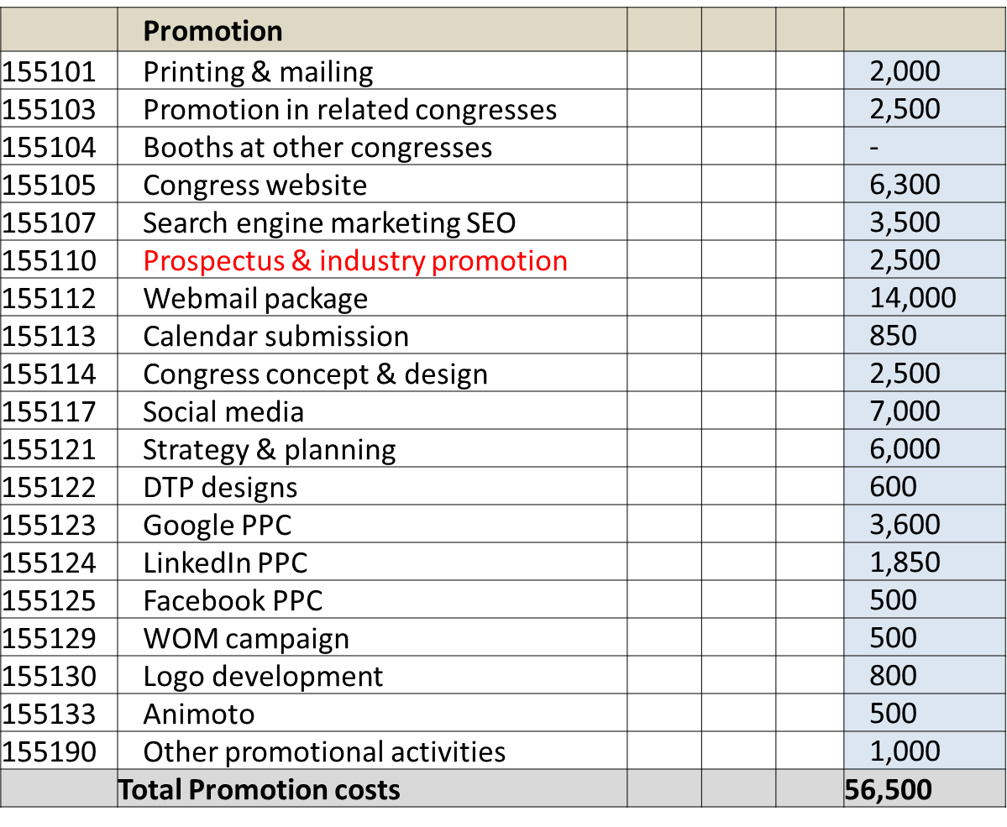
She explained the cost for the Concept design and that with the new society guidelines we will include those into the congress guidelines as well. For SIOP 2017 Washington we will have combined branding. The Strategy planning is big chunk in the budget since there is a large team of people to work on research and it needs to be done every year. Why a congress website for every meeting?
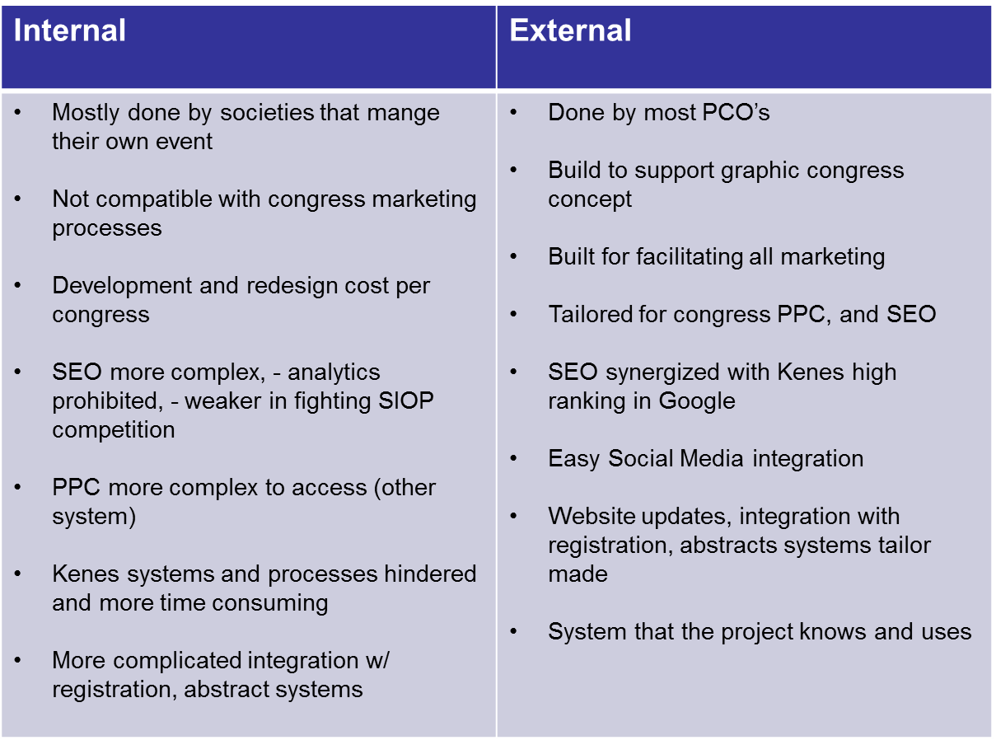
The board understood the necessity of the two websites, but nevertheless, P Rogers emphasized that the linkage between the society and congress websites needs to be better.
In order for Social media to work, the society needs a long-term society and congress social media marketing strategy. What is the 14,000 EUR spent on in the email campaign? One person is writing the content, Kenes marketing launches, monitors and measures. The database is the most expensive item on the budget.
Kenes Database Make-up:
- Records of past participants and abstract submitters from the event's history (15-20%)
- Any relevant opt-in contacts received by Kenes, in related fields (5%)
- Contacts of published authors, collected using a customized query on a database of articles published in high-quality, peer-reviewed scientific journals in the last four years, sourced from a reputable aggregator (70-80%)
Database Reach
Our data consistently exhibits equal or above industry standard performance in our mass mailings with the average blast delivering a 21% 'Open' rate and a 3% 'Click-through' rate.
Some of SIOP 2015 mailers peaked at 26.5% for 'Open's and over 5% for Clicks (attached)

P Rogers asked if we know what these 25,000 professionals do and C Presto Ben-Tov replied that she can share the details from the list with the board. Kenes marketing needs to do a proper analysis of the society members and see how this fits the database.
Decision:
GP was not aware of how much work was behind this marketing budget and added that the world is changing and SIOP needs to be more professional. There are many unexploited synergies and we need to bring them to our membership to benefit from SIOP. But all agreed that we can certainly agree on cost saving. As of 2017 the logo will not be extra charged anymore.
Action:
- Get regular reporting from ILS to the board and plan earlier and better; Dublin sponsorship should have been finished in December 2015 already
- S Wollaert to look into registering the logo and brand
- Camilla to share the details about the congress database that is purchased
- Camilla to send database conversion list of 2015; meaning how many people of the database went to the congress in South Africa
- KI to improve linkage society and congress website
- Kenes marketing to not charge for 2017 logo anymore
- S Wollaert to survey the committee and membership about the new website and ask Yuri to compile this information
- E Bouffet to get in touch with Klinta Stela for sponsorship ideas

SIOP Asia congress 2016 Moscow
Susanne Wollaert explained that she is still looking for the final cost of the proposed booth at SIOP Asia congress.

Decision:
To go for it after final cost has been established and to check for a possible print add with Hillary Gordon.
Action:
- to get Eric and PG promo material for Dublin 2016 for their SLAOP 2016 visit if there is nothing already (see with H Gordon)

Washington 2017
-meeting with Jeff Dome and Greg in Washington
- start on visual for Washington and we need to have this ready by Dublin 2016 booth
- start a dialogue with ASPHO, COGs and Lindsay Frazier
Action: reach out to ASPHO and increase younger people to attend the meeting

6. Handbook
P Gil Ran reported that the following feedback has been received:
- IPSO
- PODC
- LOC chairmen suggestions
F Doz added that we should have a handbook with principle and appendix with processes. All scholarships need to be included in the same part of the handbook to avoid confusion.

7. SIOP Committee Reports

7.1 Advocacy General
Gabriele Calaminus was called in to the meeting to report on the latest SIOP Advocacy activities.
She reported that the WHO workshop organisations is moving forward and the Ghana workshop has been a success and an important step for the global work plan. The NGO status will enable SIOP to be direct voting member in WHO initiatives and also facilitate to approach and work together with WHO in their global programme.
The next workshop is planned for Myanmar and Ethiopia with special interest of WHO to go there. Cherian Vargese will facilitate the contact and WHO. The Fiji workshop is planned with a long standing twinning project and Julia Challinor will meet the Fiji WHO representative to agree on the Programme in February in Geneva. The Advocacy team will report further on this. The Myanmar workshop attracts important organisations like St Jude and WCC. The workshop financed by St Jude. The Kazakhstan workshop (led by Dr Henzle) has the ministry of health involved and is in planning for June 2016.
The application for WHO status needs to be filled online and preferably ready by July 01 (final deadline July 31).
GP asked where the funding is coming from. GC answered it is mainly from other organisations and national funding bodies and the costs vary. During the 18th January 2016, the 10,000 EUR SIOP set aside for this initiative in the light of the SIOP WHO donor agreement was mentioned by Dr Chestnov. GC proposed to the board to use this money for the workshops (e.g. 500 – 1000 EUR per workshop and to support the LOC).
Decision:
The board approved the request of GC to use the 10,000 EUR to support some of the workshops and it is considered to be part of the NGO application costs. It is not in addition to anything else.
GC continued her report to the board that her team is now in second phase with WHO and the steering committee. And they need to show a plan and ability to work with them. To move forward we need someone to physically attend the WHO 2 days a month in Geneva for fixed appointments with WHO etc. she reported that CCI covers Ruth Hoffman’s travel and Julia will be covered by her SIOP salary and Dr Chestnov agreed to pay her airfare. The SIOP Advocacy representative can work 10 days a year in the WHO Geneva offices and Susanne can attend the meetings as well when they are bigger and more important. There is also a close collaboration with PODC.

7.2 Global Village Stakeholder Meeting
The proposal for the Global Village Stakeholder Meeting has been sent by the whole group which includes group Advocacy, CCI and PODC to the board. The event is embedded in the PODC and CCI programme during the SIOP 2016 Dublin meeting. F Doz asked if it is during the educational day. GC answered yes, and there is the need for a half day on day three. Is partly in the morning and partly in the afternoon. F Doz added that he thinks it is a good idea but now we have more speakers than usually since it is 90 minutes and only 3 speakers are covered
Action:
- Advocacy to send SC summary for next week’s TC
- S Wollaert to plan payments with advocacy team for workshop organisers

7.3 PODC
The PODC co-chairs have been called in to discuss their recent requests to the board on the following matters:
- PODC request: We suggest that like the IPSO, PROS and Nursing Committee a PODC representative (one of the two current PODC co-Chairs) be assigned to the Scientific Committee. SIOP Board reply: There are two positions open for election to the SC for which PODC can propose a candidate for that election. Nominations close on the 20th January.
- PODC request: Currently, the following groups have Keynote Lectures - IPSO, PROS, Nursing, PPO and the following have symposia - IPSO, PROS. We request that PODC be given one keynote lecture and one symposia so PODC has a larger input for the programme, increased visibility within the programme, and PODC speakers can receive funding support - something which we have struggled to identify for a group which is most deserving. SIOP board reply: This is up to the SC to decide. However PODC can always submit proposals to the SC for topics for both Keynote lectures and Symposium
F Doz stated that PODC members have the option and can stand for election like everyone else. Members of the SC are either as pediatric oncologist or as nurses, IPSO and PROS representatives. PODC members who are SIOP members can apply for any of these positions, as physician or nurse. F Doz added that in the past the SC was very large and too many representatives involved. This added a large cost to SIOP budget as well. He recommends that at least 2 PODC members are to be assigned to the SPAC (we believe that the most recent 2 PODC co-Chairs who have left this position be assigned and are rotated out in sequence as current PODC co-chairs leave office).
F Doz stated as well that that the SPAC and PODC working group members should also be SIOP members and should be more pushed to become a member of the society. The quality of science will remain the most important criteria for abstract selection. Keynote ideas for 2017 for example are put forward from SPAC, SC and LOC end of May and final decision taken during Dublin 2016. IPSO, PROS, Nurse and CCI are standard symposium. PODC is not a discipline per se like surgery or radiotherapy bit PODC issues can be the topic of keynotes, symposia or MTE: selection will be made by SC after SPAC, LOC and SC propositions. The link of PODC with the advocacy symposium is also important, to be arranged between Gabi and PODC co-chairs. P Rogers added that the linkage to advocacy is strong and that the PODC can fall under the Advocacy symposium which is part of the 10 regular symposia.
- PODC request: It is our understanding that the LOC must raise a minimum of EUR20K each year for Nursing and PODC scholarships. We believe that for PODC attendees, EUR 1000 is inadequate to ensure attendance as it is unlikely that it would even cover airfare, much less accommodation even if shared. Therefore, we recommend that the scholarship be a more realistic EUR 1500 as it has been in the past. That would ensure that minimally, Nursing receives 5 scholarships and PODC 8. We understand that the Irish LOC has already raised EUR30K to date. If so, and if 5 are designated for Nursing that would leave approximately 15 for PODC at EUR1500/each, correct? SIOP Board reply: To be further discussed by the LOC and board However the scholarships are not meant to cover all costs and it is preferable to fund many to some degree for scholarships then limit to a few at full cost. A consideration to discuss is that the amount is dependent of the distance to be traveled, e.g. more for those traveling Asia to Europe than Asia to Asia congress sites.
S Wollaert explained that the Cape Town 2015 meeting was an exception since the bidding guidelines back in the day did not stipulate the need for the LOC to guarantee funding for the bid to cover scholarships at EUR 30,000.
P Gil Ran mentioned that this depends on the LOC. Minimum figure is 30k EUR since the new bidding guidelines and Dublin 2016 LOC has around 30k guaranteed. But it also depends on delegates as well. Currently there are 20 scholarships included also nurses.
- PODC request: We recommend that the age limit for a PODC scholarship be removed. There are many key stakeholders in LMIC who are above 45 but who are critical to the promotion and execution of improved childhood cancer care in their countries. Age is irrelevant; scientific rigor of the abstracts submitted and pertinence of topic for PODC presentation audiences should be the most important criteria. SIOP board reply: We are trying to promote more involvement by YI from LIC/MIC and see this restriction as a tool to encourage that. Upper age of 45 is quite lenient.
Decision: The PODC co-chairs requested once more that the age limit should be removed. The board will not change the age limit however. A compromise has been made to state that “age is not an absolute limit, but younger people will be considered”. Additionally, the board has decided to set the scholarships at 1000 EUR plus free registration to the congress, plus free membership for one year with the expectation to continue his membership from the recipient. For the selection process, it has been decided that once PODC place their selection, the secretariat is to share this with the board and LOC chair for final okay.
5. PODC request: There is no separate registration rate for LMIC attendees, which is sorely needed. We realize that this has been the case at least from 2013 onwards. Therefore, we recommend that LIMC/PODC attendees be charged EUR200 to attend. Since most nurses in LIC earn $120/month and many physicians earn $300/month this rate is still a challenge, but much easier to meet than even EUR315 that the residents and fellows pay from HIC. SIOP board reply: There is no precedent to do this, looking back at registration to 2007. It is important to note that SIOPs income is derived from membership fees and congress attendance. LIC & MIC members do have reduced membership fees which entitles them to reduced congress fees for members. We need to ensure that the SIOP congress makes a profit for SIOP sustainability. Do understand the concern and suggest PODC be actively involved in also seeking additional funding for scholarships to attend the SIOP congress.
Current SIOP members from LIC and LMI countries can benefit from the reduced congress registration fee. We also had local fee for South Africa. You can sponsors and donate a membership.
6. PODC Scholarships for Working Group or Task Force Chairs: PODC request: PODC proposes to provide two scholarships to support travel and accommodation to assist two PODC Working Group or Task Force co-chairs from LMIC (potential pool is 18 – 10 Working Groups and 4 Task Forces) to attend the SIOP Annual Congress. The successful applicants must have his/her abstract accepted for oral presentation at the SIOP Annual Congress. Funding and support for the travel and accommodation would be generated by the PODC member community. However, the PODC requests SIOP to grant these two scholarship awardees free registration. SIOP board reply: For discussion
P Rogers explained to the co-chairs that they will need to share future activities and objectives. SIOP would like the PODC working groups to also report regularly and especially on how all of this does link with the advocacy.
Action:
- S Wollaert to update the scholarship rules and put email and website together. To share with the board for final approval
- Susanne to assist Julia Challinor with donations
- Perry Gil Ran to make sure the handbook summarises all scholarships and awards

7.4 Website and communication
All agreed that the new website needs to be continuously populated since the website is major tool for communication.
Action:
- Add to June Strategy meeting - website and special interest group, other professionals (pharmacists, nutrionist etc.) and to encourage people with special interests
- to ask Yuri Quintana to put together a website survey for the communication committee and also set one up for membership (ask Camilla for feedback as well)
- to look into communication strategy (with Camilla) and how it can come all together
- ask PODC working groups to send their reports for SIOP newsletter

7.5 Request from Ronnie Barr on Essential Medicines
The question was raised if CCI, PODC and other different groups should be involved.
Decision: Board agreed to support his request.
Action:
- R Barr to contact continental president and others
- P Roger to get back to Ronnie Barr

8. Objective and Goals - Status report 2016-2018 Objective & Goal

8.1 St Baldrick’s
P Rogers stated that he never received a reply from Kathleen Ruddy after he replied to them in an email on December 17, 2015.
Action:
- P Rogers to get back to them and also get more info about the head shaving and where head shaving money comes from

St Baldrick’s Symposium 2016
The official name should be the “St.-Baldrick Foundation SIOP 2016 Symposium: Precision medicine: integrating genomic treatment selection into clinical trials and patient care”. SIOP will receive EUR 12,000 from them and P Gil Ran reported that this way, congress budget will save money on this.
Action:
- Perry Gil Ran to rename to the symposium in the official congress programme
- Perry to get in touch with Becky Weaver (SBF) about free booth, insert in congress bag and small head-shaving event

St Baldrick and CCI (Dublin 2016)
Action:
- Giorgio to ask CCI about their SIOP 2016 St Baldrick involvement or joint activities
Washington 2017
G Reaman reported that has been a problem with Children’s National Hospital in Washington and St Baldrick Foundation in regards to a head-shaving event the hospital organised back in the day under Mike Coppes. St Baldrick believes that they own all head shaving events and do not like competition. Hence, the Children’s National Hospital in Washington fell out of favour with SBF. The question should really be the relation with SBF and the Washington meeting will be a major decision factor.
Action:
- P Gil Ran to check with Jeff Dome on K Ruddy for SIOP 2017 in Washington
Stephen Hunger (SC Chair Elect) and Michael Capra (LOC 2016) joined the meeting via telephone conference.

8.2 Dublin 2016 meeting
M Capra reported that for SIOP Dublin 2016 is all on track and that the issues with the IPSO symposia have been solved as well. He stated that he is working closely with Perry and Raquel and all works very well and nothing to report. The SC programme is completed with minor amendment of symposium. F Doz added that they are still expecting some answers from speakers but we are in good shape.
P Gil Ran stated that we are now 2 months towards the abstract submission deadline on April 5 which will give first indication in regards to delegate numbers etc. Raquel had a site visit with Michael Capra and they allocated halls and rooms. But he added that he needs an estimate of F Doz in terms of hall allocation etc.
Action:
- P Gil Ran to ask F Doz about his session attendance estimate for SIOP 2016 to allocate the right hall size
P Gil Ran briefly reported on the sponsorship status of the meeting. H stated that 90,000 EUR in sponsorship and exhibition are signed so far. The social events are also agreed plus performances (opening and networking dinner). The Presidential dinner will be held on day 1 and not -2. We therefore need to start later due to the e-poster presentation. Also, there will be no fun run this year.
GP asked if there will be any issue in regards to educational day. M Capra replied that all is on track and up and running. CCLG is keen to sponsor the education day component to the region of EUR 10’000 and he wanted to know SIOP can we accommodate that.
Scholarships: EUR 30’000 but final amount still depends on delegate number (currently based on 2k delegates)
GP asked M Capra if he has been contacted by St Baldrick’s or some common event with the parents. M Capra replied that here has been a discussion about the symposium but nothing else.
F Doz pointed out that the SBF event for 2017 will most likely be much larger. S Hunger has nothing to add and has no further information either.
F Doz asked when the award will be decided on. S Hunger replied that he just nominated someone today for North America.
Action:
- ask Stephen Hunger to attend June board meeting
- G Reaman to call K Ruddy and ask about head shaver event and long term plans with SIOP
- S Wollaert to send Greg the bullet points of the discussion to call K Ruddy
Young Investigators
F Doz briefly reported on the YI activities for SIOP 2016 in Dublin. Peter Newburger will explain how to write a paper and they also secured funding for their networking event from the Texas Children Hospital again. P Gil Ran added that they have 3 parallel sessions, but need sponsor for lunch as well. P Roger mentioned the lunch issue and we need to be careful about complaints etc.
F Doz added that the YI group is here to stay and they are growing.
Action:

- S Wollaert to add “how to promote to young members” to June agenda
- Klinta Stala to check if Texas Children Hospital can be used for small luncheon on education day
- Newsletter date is fine for March and can be sent out my S Wollaert

8.3 Other relationships
IPSO
G P reported on the TC he had with the IPSO board early February 2016. S Shochat said that objectives and goals have been set for the society and that IPSO would like to be part for the new ones of SIOP as both societies need to move into same direction.
PROS
Akira will do some PROS activities post congress in Kyoto 2018. Should also not hurt PROS programme within the conference. SIOP will only share membership details with PROS for their congress registration.
PPS letter
P Roger explained that this comes to down to special interest groups and should fall under pathology discipline group of SIOP.
The same goes for the neuro surgeons.
Action:
- GP to get back to them and start the conversation with them
ISPN
They always ask for their session last minute and that creates issues.F Doz added that it is certainly important and give positive answer to ISPN. P Rogers added that SIOP should reply to them with the same answers as PPS. SIOP wants to be inclusive and solve issues with them.

9. Brainstorming Meeting Paris June 16. – 17. 2016
Who will be involved?
- Only exec board (plus S Hunger, plus both elects President and Secretary)
- Advocacy – Gabriele
- YI – to invite Reineke Schoot
- PODC – Julia Challinor
- SIOP Europe rep – Martin Schrappe
Action:
- S Wollaert to already think about the SIOP Dublin 2016 meetings and with which partners
(Cut down meetings, e.g. combine IPSO & PROS)
- Extended board
- Giorgio and Eric to have chat in Lima SLAOP
- P Roger to attend SIOP Asia 2016 meeting in Moscow
The meeting ended at 17:30

