PODC SIOP Newsletter Spring 2019
Dear friends,
Our first Quarterly 2019 PODC meeting took place Feb 11 2019. All the WG and TF presented. The Agenda included:
1. Current Structure of the PODC: WGs and TFs
2. A new PODC co-chair for 2020
3. The Lyon Programme
4. The Rubrik for Scholarships
5. SIOP Ped Oncology Service Mapping – Africa and the World!
6. Continental Outreach
7. WHO Global Initiative for Childhood Cancer

New chairs for PFS Engagement (Alta Bence-South Africa), Psychosocial (Nuria Rossell-El Salvador) and Nursing (Liz Sniderman/Yuliana Hanaratri-USA/Indonesia) were announced. Also, Alan Davidson will be stepping down in Lyon and a call for nominations was done (Sandra has received none yet).
Lyon promises to be exciting. PODC will have a Nutrition symposium, an Advocacy symposium in the main SIOP meeting, Supportive care symposium and YI-led symposium on Education day (D-1). Lyon will not have a D+3 workshop/symposium, and the BEST of PODC and the Continents will take place on D-1.

Due to an increase in donations at Kyoto, the scholarships and membership donations are expected to increase and Suzanne Wollaert is helping coordinate them all.

The SIOP Global Pediatric Oncology Mapping Survey has been launched in Africa (https://siop-online.org/globalmapping/) with excellent accrual and hoping to get answers form most centers. Some changes were made to the content; and after these, we expect to a report soon
Kyoto PODC 2018 (I want to wait if Karina Viani answers our call to a summary)
The SIOP PODC members attending Kyoto had a varied array of new contributions and insightful issues faced by members of L&LMIC. But the announcement that had the most impact was the new World Health Organization (WHO) Childhood Cancer Initiative. The initiative was announced at the Third Global High-Level Meeting on Noncommunicable Diseases (NCD), calling for urgent action with the aim of reaching at least a 60% survival rate for children with cancer by 2030.
On September 2018, the WHO, with the support of 10 countries, recognized that 300,000 children (ages 0-19 years) are diagnosed with cancer in resource-restrain countries each year. Despite the high cure rate in HIC, this success has NOT translated into cure for children in LMIC. These children have a 4 times higher chance of death due to abandonment of treatment, high cost, late diagnosis and lack of specialized training.
Key facts:
- Cancer is a leading cause of death for children and adolescents around the world and approximately 300,000 children aged 0 to 19 years old are diagnosed with cancer each year. [1]
- The most common categories of childhood cancers include leukemias, brain cancers, lymphomas and solid tumors, such as neuroblastoma and Wilms tumor. [1-2]
- In high-income countries more than 80% of children with cancer are cured, but in many low- and middle-income countries (LMICs) only about 20% are cured. [2-3]
- Childhood cancer generally cannot be prevented or screened.
- Improving outcomes for children with cancer requires early and accurate diagnosis followed by effective treatment.
- Most childhood cancers can be cured with generic medicines and other forms of treatments including surgery and radiotherapy. Treatment of childhood cancer can be cost-effective in all income settings. [2]
- Avoidable deaths from childhood cancers in LMICs result from lack of diagnosis, misdiagnosis or delayed diagnosis, obstacles to accessing care, abandonment of treatment, death from toxicity, and higher rates of relapse.
- Childhood cancer data systems are needed to drive continuous improvements in the quality of care, and to drive policy decisions.
With strong advocacy from SIOP, IARC, IAEA, UICC, WCC and St Jude, this initiative will bring a comprehensive and united approach to childhood cancer. This WHO Global Initiative involves the development of a WHO technical package to help assess, scale up capacities within the National Health Systems, define site appropriate interventions, costing and outcomes measures. Andre Ilbawi (Medical Officer) for Cancer Control Group at WHO, assembled a group of consultants to help formulate and design the Modules and instruments. Consultants from each of the PODC Working groups and Task Forces are involved, as the most knowledgeable and “on the ground” experts, to help design the instruments that are appropriate and sustainable for a high-quality childhood cancer program. Five working groups were formed:
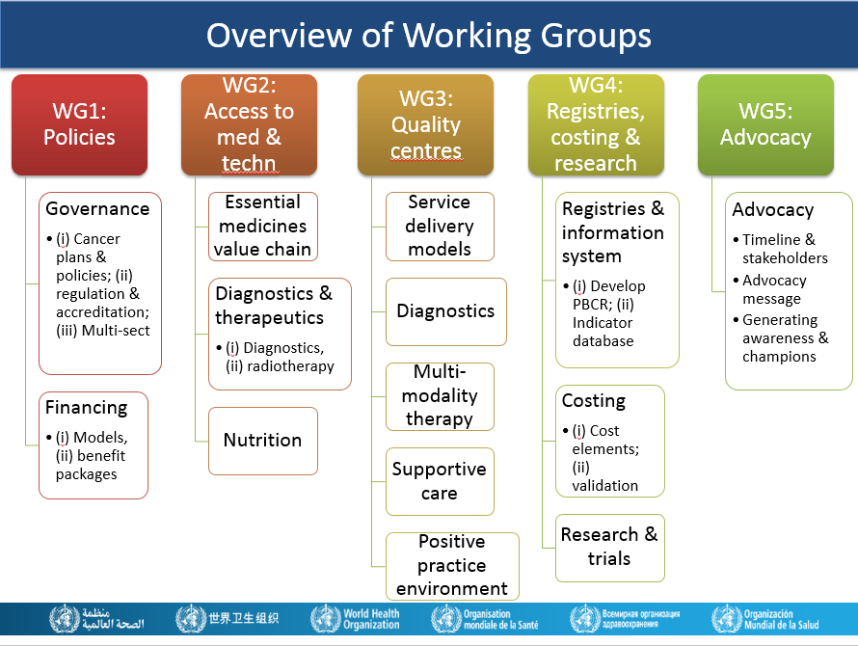
Each subgroup meets once a month, advancing into the necessary: assessments, implementation modules and progress evaluation instruments. For example: one of the big necessities and problems in resource-restricted countries is the procurement of quality and inexpensive chemotherapy, biologic response modifiers and supportive drugs (antimicrobials, pressors, etc). The model for the Essential Medicines Value chain delineates the process, supported by legislation, regulation, governance and monitoring. This process should guarantee the quality and accessibility of medications. Below is the Med Chain for acquisition of quality medications.
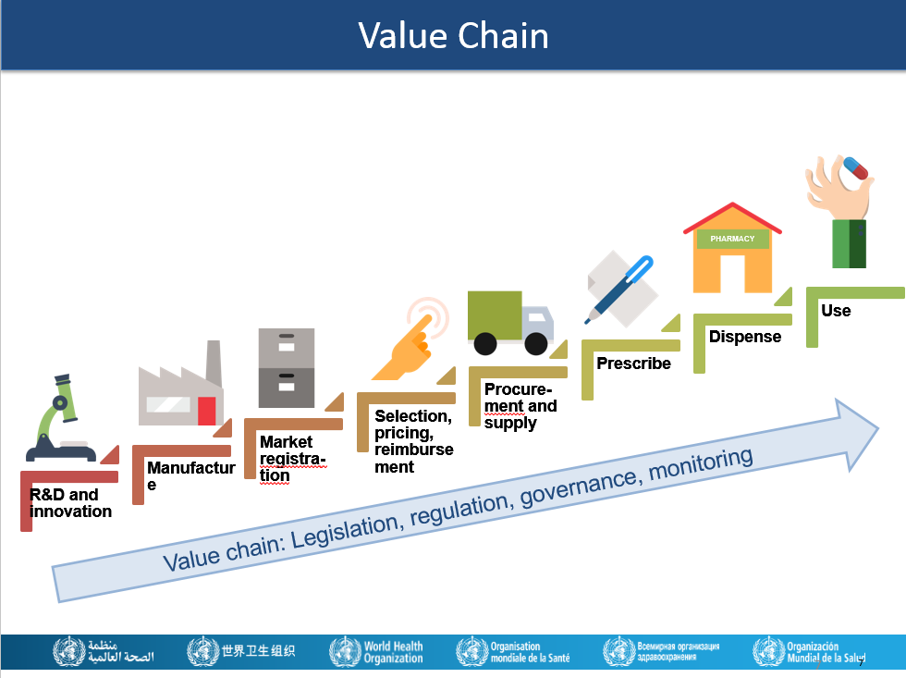
These exercises are providing WHO the expertise to provide leadership and technical assistance to support the governments to:
- Increase capacity of countries to deliver best practices in childhood cancer care
- Prioritize childhood cancer and increase available funding at the national and global levels
- Increase political commitment for childhood cancer diagnosis and treatment;
- Support governments to develop high-quality cancer centers and regional satellites to ensure early and accurate diagnosis and effective treatment for children with cancer;
- Develop standards and tools to guide the planning and implementation of interventions for early diagnosis, treatment and palliative and survivorship care inclusive of the needs of childhood cancers;
- Improve access to affordable and essential medicines and technologies;
- Support governments to safeguard families of children with cancer from financial ruin and social isolation as a result of cancer care.
The dream of providing a dignified and comprehensive approach for children with cancer in resource-constrained countries is coming true; thanks to the unrelenting effort of so many physicians, nurses, psychologists, pathologists, radiation therapists, radiologists… who believe that all children have a right to health and care.
We hope to have a more complete picture of the modules put together during the coming months by SIOP Lyon.
Alan Davidson and Sandra Luna-Fineman

Nutrition Working Group Update Spring 2019
The SIOP PODC Nutrition Working Group (WG) has established a global infrastructure, in partnership with the International Initiative in Pediatrics and Nutrition at Columbia University Irving Medical Center in New York, to advance nutritional science in pediatric oncology. This report is focused on activities in low and middle income countries (LMICs) during January - March 2019. In the WG stream dealing with the challenges in LMICs there are 151 members in 31 countries, Highlights of the group’s activities include:
- Nutritional Education & Capacity Building. Countries presently involved in training and capacity building are: Brazil, Cameroon, Honduras, Guatemala, India, Nicaragua, and South Africa. This year we have reached out to Bangladesh, Nepal, the Philippines, Sri Lanka, and the Middle Eastern and Mediterranean countries (POEM group) by involving them in educational workshops. Three such events have been held in 2019; in Chennai, India (January 18-19, 2019), Yerevan – Armenia (Feb 8, 2019) and at SIOP Africa (March 9, 2019). Educational webinars are also held regularly on cure4kids.
- Research projects on nutrition are underway in Brazil, Guatemala, Honduras, Nicaragua, India, South Africa and Cameroon through support of IIPAN at Columbia University Irving Medical Center. Several additional sites in Asia and Africa will be joining this global initiative advancing nutritional research. The Dana Farber Global Program has established a capacity-building program in Myanmar with research endeavors underway. The International Atomic Energy Agency is also launching research projects aimed at improving cancer care through nutrition.
- Recent publications from the group include
i) Hesseling PB, Tamannai M, Ladas E et al. Burkitt lymphoma- Nutritional support during induction treatment: Effect on anthropometric parameters and morbidity of treatment. SA Journal of Oncology. October 22, 2018.
ii) Villanueva G, Blanco J, Rivas S et al. Nutritional status at diagnosis of cancer in children and adolescents in Guatemala and its relationship to socio-economic disadvantage. A retrospective cohort study. Pediatric Blood and Cancer. 2019 Feb 7, e 27647.
(iii) Schoeman J, Ladas EJ, Rogers PC et al. Unmet needs in nutritional care in African paediatric oncology units. Trop Pediatr. 2018.
- The group is providing mentors for two PhD candidates among its members (Karina Viani in Brazil and Judy Schoeman in South Africa)
The group has trained nearly 5000 clinicians in LMICs in nutritional assessment, intervention and research methodology. We would be delighted to have more physicians, dietitians and nurses join the group which can be done on cure4kids (SIOP PODC nutrition group).
Submitted on behalf of the Working Group LMIC team
Amita Trehan and Karina Viani

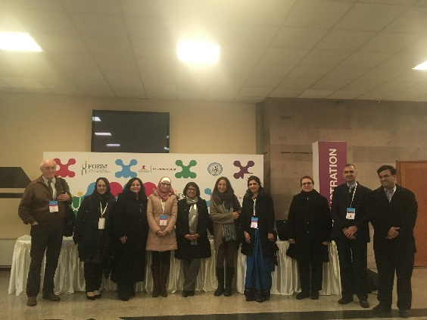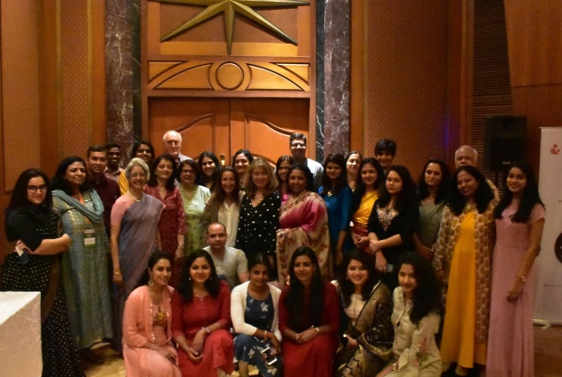
Meeting at Yerevan, Armenia February 2019 Meeting at Chennai, India January 2019

PODC Patient, Family, Stakeholder and Engagement Task Force
The PODC Patient, Family, and Stakeholder Engagement Task Force is currently conducting a qualitative research study across low- and middle-income countries (LMIC) “Patient, Family and Survivor Engagement in Paediatric Cancer Care in Low- and Middle-Income Countries”.
Despite the presence of numerous models and studies of patient and family engagement, there is minimal research that captures how children and adolescents with cancer, the survivors and their parents/families, in LMIC, view their engagement and related experiences in childhood cancer treatment and medical care.
We are completing a literature review on patient engagement in pediatric hem/oncology care in low- and middle-income countries and will be submitted for publication and shared with Task Force members and interested stakeholders when finished.
This study is specifically interested in exploring and understanding the expectations, experiences and dynamics related to engagement during childhood cancer treatment and care in LMIC (e.g., involvement in communication/explanation of diagnosis to the child/teen, symptom management and/or pain management options, information and education on the disease and its treatment).
The following countries are currently involved, while others are considering participation: El Salvador, Peru, India, Ethiopia, Greece (for Albanian children treated in Greece), South Africa, and Morocco. Continental leaders, Marcela Zubieta (Latin America), Efrosini Kritikos (Eastern Europe), Carmen Auste (Asia) and Alta Bence (Africa) are all members of Childhood Cancer International (as well as our Task Force) and are providing crucial links to local support for the researchers during data collection, if needed, from parent support organizations.
Submitted on behalf of the PFSE Task Force group
Carmen Auste and Alta Bence

