Greetings from the SIOP Nursing Committee
SIOP 2019 Recap
The SIOP Congress in Lyon was attended by over 200 nurses from across 42 countries, representing diverse cultures, roles and work environments. Paediatric oncology nurses attending SIOP frequently observe that despite their varied backgrounds, they experience many common challenges and benefit greatly from sharing their difficulties and accomplishments.
The pre-congress educational day was well attended, and featured joint sessions with Supportive Care, Young Investigators, PODC and Childhood Cancer International. An exciting highlight of the congress was the keynote presentation by Dr. Sara Day on “International Baseline Standards for Paediatric Oncology: An Interdisciplinary Approach to Achieving Equity in Care Delivery”, attended by almost 500 clinicians. The SIOP Nursing Committee is committed to proposing a nurse keynote speaker each year, and is thrilled to share that Dr. Marilyn Hockenberry will present on management of symptom clusters in children with cancer at SIOP Ottawa in 2020.
The 2019 SIOP Nursing Lifetime Achievement Award was presented Julia Challinor, RN PhD, whose career exemplifies excellence in paediatric oncology nursing. As noted by her PODC colleagues, “Julia is a constant presence at SIOP, always there to challenge, engage, debate and listen.” She is a passionate advocate for paediatric oncology nurses in LMIC and has made significant contributions to the specialty of paediatric oncology.
Nominations for the 3rd annual Nursing Lifetime Achievement award are open and find out more here.

SIOP PODC Nursing Updates:
The SIOP PODC Nursing group was pleased to present recognition awards for their service over the past year to Rachel Hollis (UK; in appreciation for her work with POINTE and to develop the Sub-Saharan Nursing Network), Glenn Mbah (Cameroon; in appreciation for his work to create the International Pediatric Oncology Nurses Day posters), and Neil Ranasinghe (UK; Friend of Nursing award in appreciation for his work to develop and launch the nursing page on POINTE).
Initiatives for PODC Nursing 2020 include:
- Continue joint educational meetings with other PODC groups (supportive care, nutrition, palliative)
- Increase social media presence to help connect nurses globally
- Promote 2020 WHO Year of the Nurse
- Establish regional online meetings to increase regional engagement and connections

Nursing Engagement in the WHO Global Initiative for Childhood Cancer
In 2019, current and former SIOP Nursing Committee members participated in WHO Global Initiative for Childhood Cancer workgroups, and represented nursing at the target country workshops. In May, Pernilla Perget represented SIOP nursing at the 2nd National Workshop on the Cancer Control Programme in Myanmar, followed by Liz Sniderman (PODC Nursing Co-chair) at the National Stakeholder Workshop in Manila, Philippines, Courtney Sullivan at the 1st National Workshop in Tashkent, Uzbekistan and Enyo Bosumprah at the 2nd National Stakeholder Workshop on Childhood Cancer in Accra, Ghana. Courtney shared that several nursing priorities were discussed during the Tashkent meeting including specialized education programs, standards and materials. Nursing priorities based on the SIOP Baseline Nursing Standards were presented, highlighting the need to address high nurse-patient workloads and the importance of chemotherapy/biotherapy education and clinical nursing practice standards.
In Ghana, nursing was strongly represented by nurse leaders from Korle Bu Teaching Hospital (KBTH) and Komfo Anokye Teaching Hospitals (KATH), including Enyo Bosumprah (KBTH, SIOP Nursing Committee member). Nursing leadership representatives from the Ghana College of Nurses and Midwives also were present. Nurses participated in all working groups and pledged to take “SMART” actions to support children and adolescents with cancer and their families over the next year.
Looking Forward: SIOP Ottawa 2020
The SIOP Nursing Committee excitedly anticipates 2020 as the WHO designated “Year of the Nurse and Midwife”, and look forward to another robust nursing program in Ottawa. We will work closely with Naomi Thick, nurse leader on the Ottawa Local Organizing Committee, to develop a robust programme, offering innovative presentations focused on nursing education, research, clinical care and advocacy.
We hope that SIOP 2019 left you feeling energized and enriched by new knowledge and discovery. With 2020 elections coming up, all nurses are highly encouraged to become voting members, strengthening the voice of nursing as SIOP moves into the next decade.
Happy Holidays to all, and we look forward to seeing you in Ottawa!

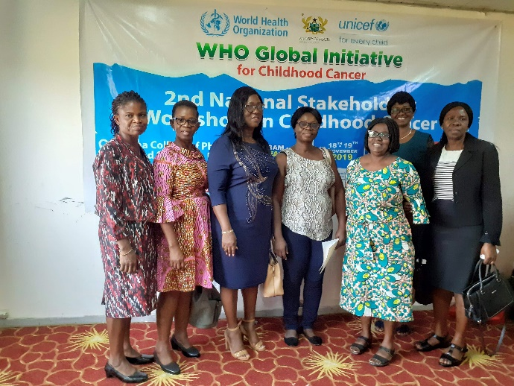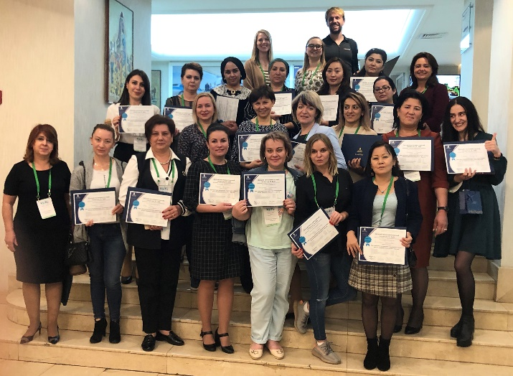
Nursing representatives at the WHO National Workshops in Accra, Ghana and Tashkent, Uzbekistan.

