PODC SIOP Business Meeting
Lyon Oct 22, 2019
Alan Davidson and Sandra Luna-Fineman
Co-Chairs

Sandra Luna-Fineman presented brief overview of activities and projects of SIOP PODC. She briefly shared the highlights of PODC related scientific content in SIOP2019 Congress

General Announcements and PODC slides
- As of 2019, the co-chairs of PODC belong and participate of the SIOP Board.

Lyon SIOP meeting
Education Day (Wed Oct 23)
8:15-9:45: Best of PODC – free papers
10:15-11:45: Joint YI/Nursing/PODC session – mentorship
13:45-15:15: Best of Continents- Free Papers
15:45-17:15: Supportive Care Symposium: Chemotherapy adverse effects
17:30-18:30: WHO Global Childhood Cancer Initiative (summary and discussion)

Other Scientific Sessions with relevance to LMIC/ PODC:
(Thursday Oct 24)
8:40-9:10 The Burden of Childhood Cancer Worldwide and IARC
9:10-9:40 Movie: «How I Live» - Dana Farber
13:00-13:45 SIOP Global Mapping – My Child Matters funding
17:00-18:30 SIOP Award Session

Other (Fri Oct 25)
10:40-12:10 MCM Sy: Advancing Nutritional Education LMIC
12:20-14:15 SIOP Annual Business Meeting

Other (Sat Oct 26)
9:40-10:10 International Baseline Standards for Ped Onc Nursing

- Review of Continental meetings (Africa, Asia, Latin America)
  - Uncertainty if what continent the Caribbean fa

Winners of PODC scholarships
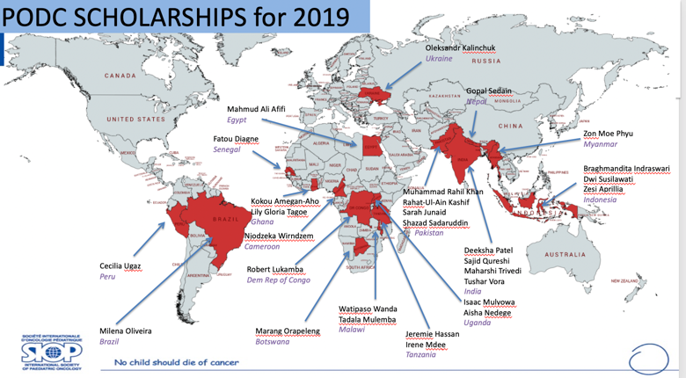

What is new for Working Groups and Task force leadership
2 new Task Forces suggested: AYA, Pharmacy

New co-Chairs:
PODC SIOP: Alan Davidson (South Africa) steps down: new Muhammad Saghir Khan (Pakistan) starts
Patient, Family and Stakeholder Engagement Task Force: Carl Queiros (Greece) steps down and new Alta Bence (South Africa)
Psychosocial Task Force: Nicole Schneider (USA) joins Nuria Rossell (El Salvador)
Nursing WG: Lisa Morrisey (USA) step down; new Liz Sniderman (USA) & Yuliana Hanaratri (Indonesia)
Palliative Care: Meaghan Weaver (USA) steps down; new Justin Baker (USA)
Adapted therapy regimens: Tricia Alcasabas (Philippines) steps down; new Raya Saab (Lebanon)
Education and Training: Jennifer Geel steps down: new Elianeth Kiteni
Other co-chairs stepping down soon!
2019
  - Kevin Schwartz – Twinning (HIC)
  - Amita Trehan – Nutrition (LMIC)
  - Stacey Marjerrison – Integrative (HIC)
2020
  - Sandra Luna-Fineman – PODC (HIC)
  - Mike Sullivan – ATR (HIC)
  - Marisol Bustamante – Palliative (LMIC)
  - Gregov Tamamian – Supportive (LMIC)
  - Neil Ranasinghe- Edu and Train (HIC)
  - Parth Metha – Essential drugs (HIC)
  - Nihad Salifud – Twinning (LMIC)
  - Karina Viani – Nutrition (UMIC)
  - Carmen Auste – PFSE group (LMIC)

Global Childhood Cancer Initiative (Andre Ilbawi and Catherine Lam)
- Co-chairs and multiple co-chairs and PODC members participated in more than 50 meetings with WHO to give discuss the necessary components of the Global Initiative.
- After summaries of the 5 working groups: Policies, Access to Medications and Technology, Quality Centers, Registries, Costing and Research, and Advocacy, initial and central issued picked and Technical Packages being built.
- 5-10 countries already started process with help of WHO/PAHO and other grous
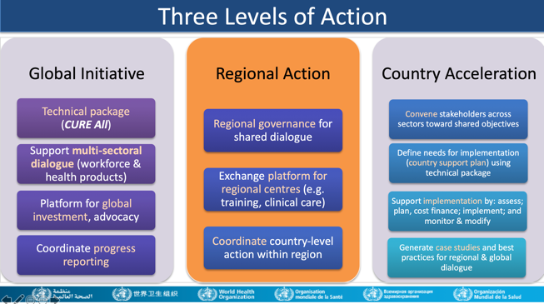
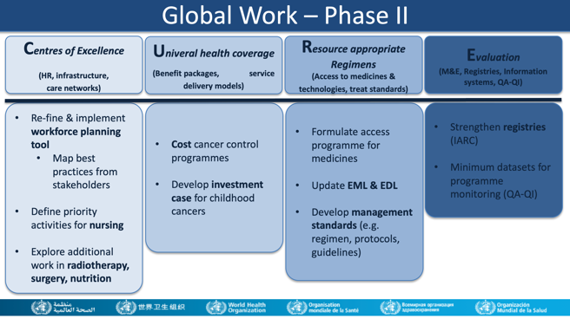

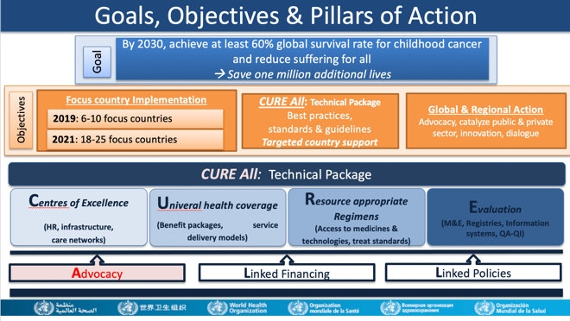

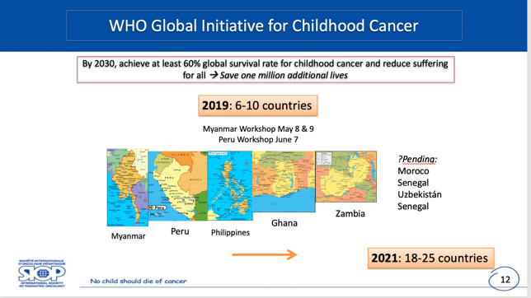

Brief Annual reports of Working Groups and Task Forces:

- Patient and Family Engagement Study – a Qualitative study (Julia Challinor)
- New co-chair: Alta Bence
- Study group met at Lyon, France before SIOP x 4 days
- discussed the first round of findings on interviews from Greece, Georgia, Ghana, South Africa, Ethiopia, Morocco, India, Philippines
- harmonization and analysis of Data

- Palliative Care
- New co-chair: Justin Baker
- ongoing online teaching
- publications listed

- Twinning (Kevin Schwartz)
- new documents available on the POINTE website:
  - Twinning guide, evidence-based
  - Templates for evaluation of site and MOU for twinning institutions
  - Proposal for a symposium in SIOP 2020

- Psychosocial Task force (Nuria Rossell)
- New co-chair Nicole Schneider
- New survey designed and approved:
    - Pilot survey during Lyon Meeting
    - Questions: how long will it take to collect; how long to analyzed. Answered to be determined
    - Jenn Geel suggested to learn from experience of already conducted surveys as well

- Supportive Care (Muhammad Saghir Khan presented)
- Online Education Meetings through C4K
- Creation of updated repository on cancerpointe
- Pending: Immunization Survey Manuscript

- Adapted therapy regimens (Mike Sullivan)
- New co-chair: Raya Saab
- Pending: HL, germ cell, craniopharyngioma, CNS germ cell, and rhabdomyosarcoma
- AML (published in PBC in December 2020)
- Tom Gross announced 2 supplements (word max 4500) on PBC
- New Wilms, update ALL, new Bone tumor
- Intend to align with WHO GICC 6 tumors (Burkitt, ALL, Wilms, retinoblastoma, low-grade glioma, Hodgkin lymphoma)

- Nutrition
- Multiple educational talks, including Nutrition in PICU
- Research initiatives: Brazil, Guatemala, South Africa, India and AHOPCA
- Multiple publications: algorithms, research and guidelines

- Essential Medicines (Parth Mehta)
- New WHO Essential drugs for Children out (2019)
- Next: add anti-emetics, hemophilia drugs, new drugs (melphalan, topotecan)
- need more Advocacy
- Drug forecasting/access research (Boardroom in Lyon)
- Vincristine shortage: First World, welcome to the real World
- Collaboration with CanKids to procure drugs for all children in India
- Participating in Global Initiative
- Lancet Commission paper in editing phase

- Education and Training (Jennifer Geel)
- New co-chair: Elianeth Kiteni
- Posting multiple talks, PROS
- New page for nursing
- Running Global Mapping survey (shared brief results)
- New initiative for early detection of childhood cancer
  - Will provide education and training
  - Technology transfer and implementation
  - Leadership in early detection
  - Telemedicine and teaching through OncoPeds (Chantada) through a new grant by My Child Matters

- Africa/PODC Wilms Collaborative
- EFS: 49.9%, OS 57.9%

End of treatment | Baseline | After 2 years | After 4 years |  | Aim
Alive, NED | 52% | 66% | 69% | P=0.002
Abandonment | 23% | 14% | 12% | P=0.0009 | <10%
Death during treatment | 21% | 13% | 15% | P=0.14 | <10%
(Estimated) 2 year EFS | Est 35% | Est 50% | 50%
- SUCCOUR: Supportive care ongoing

- Traditional and Complementary Medicine
- Africa study: presented at SIOP Africa 2019
- Submitted article to PBC on Nutritional supplements: Supplements, antioxidants, probiotics, immuno-nutrition, Ketogenic diet, cannabinoids etc.

- PROS LMIC
- Collaborating with Global Initiative
- Teaching courses in SIOP Africa: Cairo and Abu Dabi
- XRT palliative in works
- New project looking at remote contouring and planning for LIC/LMIC sites for Paediatric brain tumours

- Abandonment of Treatment (Nuria Rossell)
- New focus on effective intervention for prevention and control of abandonment (PRACTICAL)
  - development of technical/practical materials based on local experiences, over development of “new” academic projects
- New teaching tool being design
- Multiple committees to help as must be multidisciplinary
  - Core groups: 2 chairs by continent
- Abandonment as a quality issue

Global Mapping (Jenn Geel)
- Africa launched in Kyoto 2019
- Almost all countries participated – 700 responses
- Snowball methodology: SIOP, Continental meeting
- All service lines per Framework paper
  - Average #/country 120 (45-300)
  - Only 3 countries have full Flowcytometry
  - Imaging almost complete
  - Full time nursing: only 0-21% centers
  - Nutrition is assessed in most
  - Legacy of war and colonization…
- Will have an interactive map soon
- More analysis and will publish 2010

Meeting was adjourned at 5:30pm

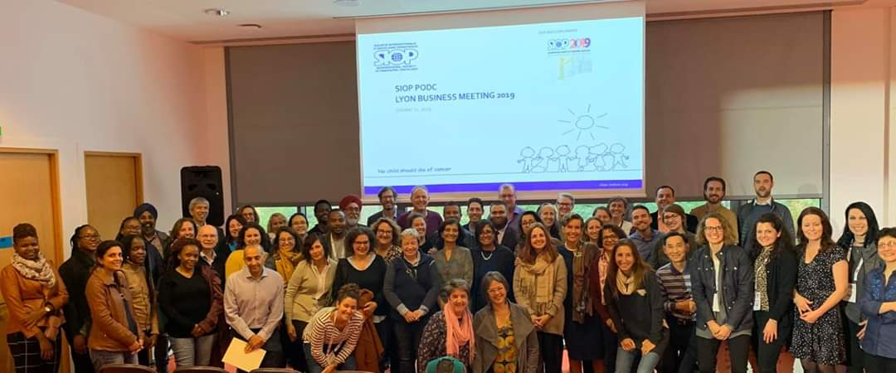

A memorable Group Photo after SIOP PODC Business Meeting- Photo Credit: cancerpointe team

