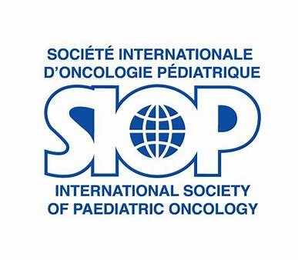

ADVOCACY UPDATE FEBRUARY - MARCH 2021

INTERNATIONAL CHILDHOOD CANCER DAY (ICCD)

SIOP launched the ICCD 2021 campaign on 15 February through a prominent message on the SIOP website on behalf of Kathy Pritchard-Jones and SIOP Patron HRH Princess Dina Mired of Jordan (LINK). The message highlighted all SIOP initiatives to celebrate ICCD2021, summarized underneath.
-----------------------------------------------------------------------------------------------------------------------------------------

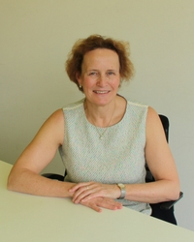
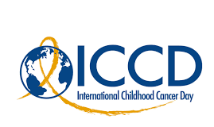
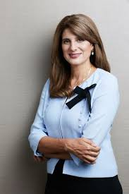

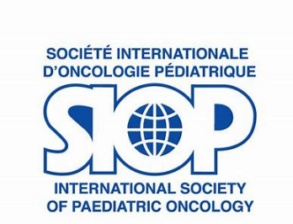

SIOP-CCI Joint advocacy campaign

SIOP and CCI joined forces to work on a global campaign for ICCD with the first 3-year framework confirmed for 2021-2023.

- 2021 ICCD Topic: #throughourhands - focus on the children and adolescents with cancer
- 2022 ICCD Topic: #throughyourhands - focus on the healthcare team
- 2023 ICCD Topic: #throughtheirhands - focus on families and caregivers

To coordinate the effort, monthly conf calls took place between SIOP and CCI, with the participation of both Presidents and nominated Campaign Committee members from the two societies.

CCI took the lead in the development of the online platform and advocacy toolkit with contributions from SIOP, as well as the translation of the material. SIOP took the lead writing the press release of the campaign and the coordination of the monthly calls.

The campaign is hosted on an interactive online platform where participants can post Messages of Hope and receive a symbolic certificate recognizing their contribution. It also features an interactive Tree of Life with child handprints as leaves. Participants can indicate the approximate survival rate in their country, which fills part of the leaves/handprints with color.

The joint SIOP and CCI ‘Tree of Life’ campaign was launched on ICCD, 15 February, and will last until end of March 2021.

The SIOP Secretariat disseminated the opportunity widely to members encouraging to inform and involve children coming to their centres.
-------------------------------------------------------------------------------------------------------------------------------------
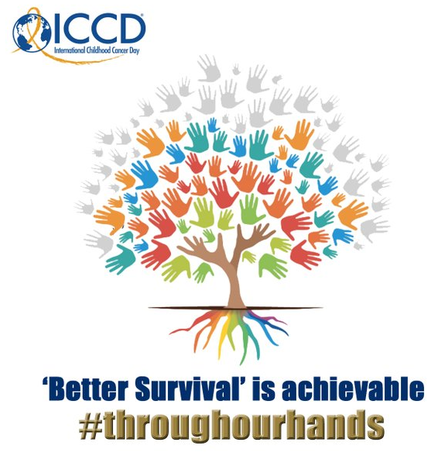
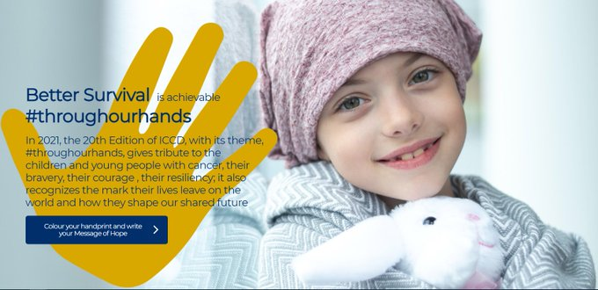

-------------------------------------------------------------------------------------------------------------------------------------

Campaign deliverables and achievements:
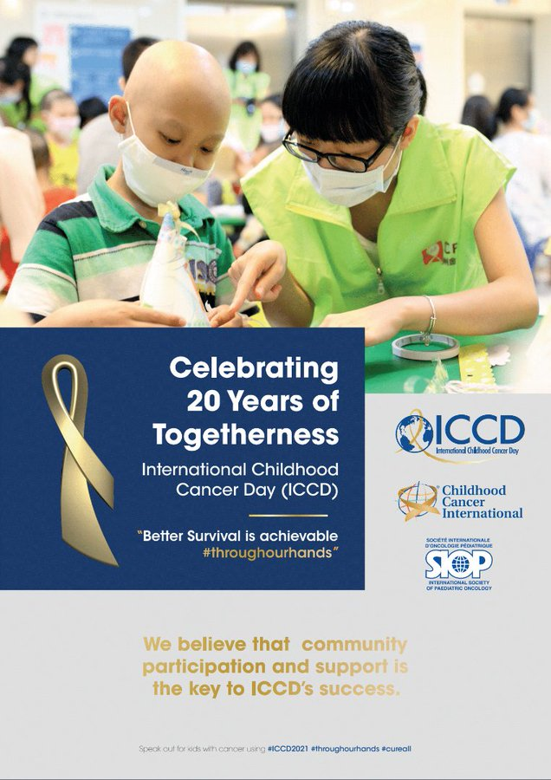

- Joint ICCD Advocacy Toolkit (EN – CHI – FR – ES): LINK

- Joint ICCD Press Release (EN – AR – BG – EL – IDN – RU): LINK

- ICCD Campaign Messages of Hope:
https://internationalchildhoodcancerday.org/
- Wide social media reach and online engagement
e.g. retweets more than doubled compared to ICCD2020!

Up to 15 March there were 1189 participants from 64 countries in the Tree of Life campaign for handprints and message of hope. There are many moving messages. You may want to get inspired by these meaningful messages at: https://www.iccd.care/en-us/viewglobal

Thank you for your support & spreading the word!

NEXT YEAR: FOCUS ON HEALTH PROFESSIONALS ThroughTheirHands

The threat of the COVID-19 pandemic on reversing global life-saving gains in the survival of childhood cancer: a call for collaborative action
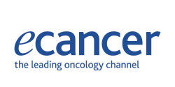
In October 2021, SIOP co-signed a letter to the WHO Director-General offering cooperation to maintain access to childhood cancer services during the Covid pandemic.

To foster the visibility of this important topic, SIOP led in writing a collaborative policy paper entitled ‘The threat of the COVID-19 pandemic on reversing global life-saving gains in the survival of childhood cancer: a call for collaborative action’ for ecancermedicine journal (LINK). The piece was co-authored with IPSO, PROS, WCC, CCI, St Jude Global, UICC and WHPCA.

The paper was published on ICCD, 15 February and was accompanied by a video interview with Kathy Pritchard-Jones (LINK) to build engagement and visibility. The piece puts forward specific recommendations to address a variety of collateral consequences of COVID in the field of childhood cancer and can be used to advocate on these issues in a variety of settings.

We thank all the SIOP Board members for their contribution to the paper and encourage its wide dissemination to governments and other stakeholders.
----------------------------------------------------------------------------------------------------------------------------------------

Keeping the commitment to the youngest cancer patients during COVID-19: blog post on UICC website
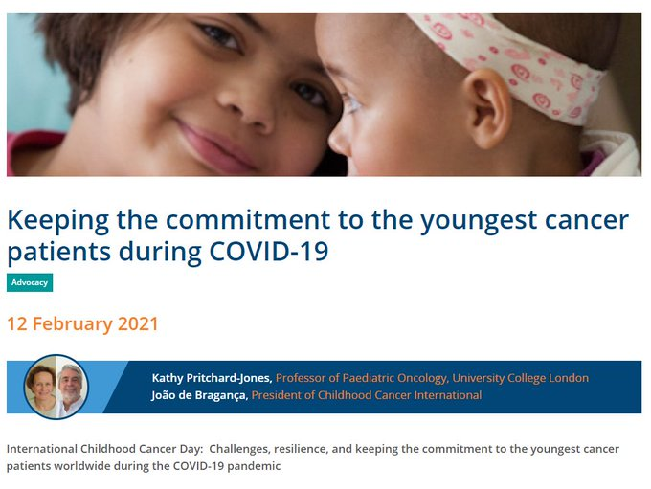
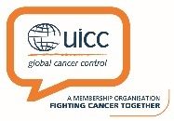
Following the UICC World Cancer Day campaign on Covid and cancer, SIOP built on the momentum by highlighting childhood cancers on UICC platforms for ICCD. From 12 to 16 February, the UICC blog was headlined by SIOP Kathy Pritchard-Jones and CCI Joao de Braganca with a resonant piece on the pandemic’s consequences in the pediatric cancer sector, urging stakeholders not to forget young cancer patients in Covid mitigation efforts. READ IT HERE.

Impact of COVID on child health is high on the agenda towards the WHA May – June 2021
------------------------------------------------------------------------------------------------------------------------------------------

WHO GLOBAL INITIATIVE FOR CHILDHOOD CANCER (GICC)

Launch of the GICC Technical Package, 15 February 2021
The GICC Technical Package is a key deliverable of the initiative, conceived as a resource for governments to facilitate contextualized implementation of the CureAll Framework.

The Technical Package was formally launched on 15 February 2021 in a high-level webinar with the participation of WHO Director-General. SIOP was actively involved; President Kathy Pritchard-Jones and SIOP Patron Princess Dina Mired delivered messages as invited speakers.

The GICC Technical Package (Pamphlet: LINK) consists of the following elements:
- Assessment tool
- Investment case
- Knowledge Action Portal,
- Results Framework with indicators
Prior to the launch, SIOP contributed to the Technical Package development through the GICC Working Groups and regular contact with the WHO cancer team. For example, SIOP reviewed and provided comments to the Assessment Tool looking to align with the SIOP Global Mapping Survey. In addition, SIOP fed into the Knowledge Action Portal (KAP) repository, designed to foster exchange between professionals/ civil society and government programme managers. SIOP also provided inputs into regional mapping of stakeholders to pave the way for the Technical Package implementation.
Thank you once more for sending information on initiatives for the KAP and regional mapping! The implementation of the Technical Package will be rolled out in the coming months. Pilot training sessions are already foreseen at the WHO regional level (see below).

GICC Regional initiatives

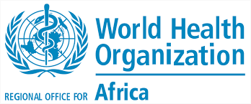
WHO AFRO Webinar to Commemorate International Childhood Cancer Day in the COVID-19 Context (Tue 15 February 2021)

SIOP speakers: Lorna Awo Renner

Key messages:

- Need for integrated approach for GICC implementation. Zambia and Ghana are using the GICC to strengthen their overall health systems and broader programmes including on NCDs and child and adolescent health. It is about moving away from silos towards increased coverage of health services, particularly at the primary health level.
- Health systems strengthening for UHC is a key instrument to achieve the GICC target.
- Need to further grow partnerships including with civil society, the private sector, and academia.
- Development agencies should also be involved
- Urgent need for more local government ownership and engagement
------------------------------------------------------------------------------------------------------------------------------------------

WHO EMRO Region:
- Virtual consultation meeting on the Global Initiative on Childhood Cancer (25-26 Jan. 2021)
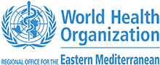
- Dialogue with experts to CureAll children with cancer (25 February 2021)
SIOP speakers: Rashmi Dalvi, Laila Hessissen

Follow-up actions:

- Call for proposals: A call for proposals for projects addressing the barriers to childhood cancer care in EMRO member states will be sent out by the 15th of March. The deadline for submission of the proposals is 30th April (6 weeks later).
  - Around 150K $ seed funding.
  - Open call to all countries in the region to get involved, rather than focusing on those where the government/health ministry has already volunteered

- Demonstration of the CureAll technical package: mid-March

- Situation analysis: Reach out to Member State MOH focal points for a more comprehensive analysis of the child cancer situation to provide baseline data for planning.

- Regional Governance: Following completed partner mapping, meeting with partners and MOH focal points to refine the mapping and discuss the findings will be called in the following weeks.
The same meeting will discuss the most appropriate regional governance structure and to call for expression of interest to be part of the regional alliance.
GICC picking up speed with mobilisation foreseen at the regional and local levels to implement the Technical Package and projects. We look forward to our close collaboration on these next steps!

