2023 – 2025 Nursing Award Project

NAME OF PROJECT_________________________________________ DATE___________________
PROJECT LEADER__________________________________________
Please fill in the project timeline below:
Please describe the project step by step for each specific objective and mark with “X” the appropriate box when the action will take place.
Activities implementation timeline for each SMART GOAL
 | 2023 |  |  |  |  |  | 2024
 | July | Aug. | Sept. | Oct. | Nov. | Dec. | Jan. | Feb. | Mar. | Apr. | May | June
Smart Goal 1
1. action
2. action
3. action
4. action
Smart Goal 2
1. action
2. action
3. action
4. action
Smart Goal 3
1. action
2. action
3. action
4. action
Smart Goal 4
1. action
2. action
3. action
4. action
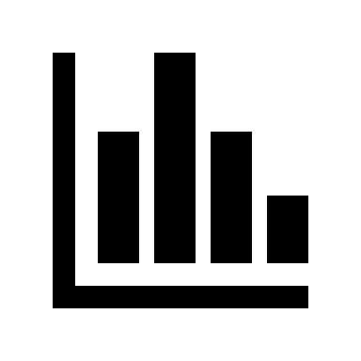
Intermediate report Year 1 report

Activities implementation timeline for each SMART GOAL
 | 2024 |  |  |  |  |  | 2025
 | July | Aug. | Sept. | Oct. | Nov. | Dec. | Jan. | Feb. | Mar. | Apr. | May | June
Smart Goal 1
1. action
2. action
3. action
4. action
Smart Goal 2
1. action
2. action
3. action
4. action
Smart Goal 3
1. action
2. action
3. action
4. action
Smart Goal 4
1. action
2. action
3. action
4. action
Year 2 report

Activities implementation timeline for each SMART GOAL
 | 2025 |  |  |  |  |  | 2026
 | July | Aug. | Sept. | Oct. | Nov. | Dec. | Jan. | Feb. | Mar. | Apr. | May | June
Smart Goal 1
1. action
2. action
3. action
4. action
Smart Goal 2
1. action
2. action
3. action
4. action
Smart Goal 3
1. action
2. action
3. action
4. action
Smart Goal 4
1. action
2. action
3. action
4. action
Final report

