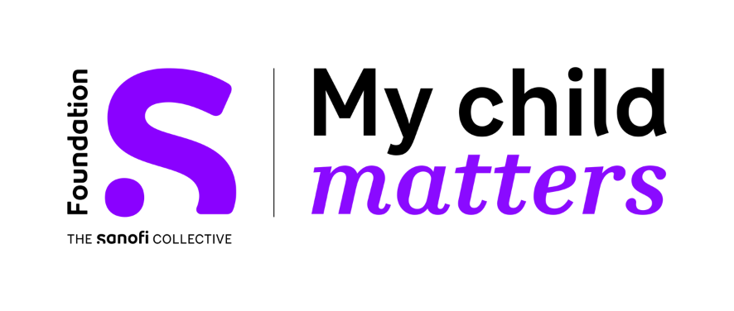

My Child Matters 2023-2025 Nursing Awards

SMART Goal Guidance

Overall guidance for SMART Goals
- S = Specific
  - What will you do or accomplish?
  - What actions will you take?
  - Be sure to briefly address
    - Who will do the work?
    - What will each person do?
    - When each task will be done
      - be general, you will be more specific in the timeline later
    - Where will the work take place?
    - Which obstacles or requirements do you anticipate you will encounter or need to accomplish this project?
    - Why are you doing this project?
- M = Measurable
  - What data will you collect to measure your goal?
    - Measurement methods can be both quantitative (productivity results, money saved or earned, etc.) and qualitative (client testimonials, surveys, etc.).
- A = Achievable
  - Is your goal doable? Explain why.
  - Do you have the necessary skills and resources? Explain your skills and resources.
- R = Relevant
  - How does your goal align with broader goals, such as the World Health Organization Global Initiative for Childhood Cancer (find out more here) or the Foundation S – Sanofi Collective My Child Matters Awards (find out more here) ? Explain how your project aligns.
  - Why is the result of this goal important?
- T = Time-Bound
  - What is the overall time frame for accomplishing your goal?

Questions & queries?
Kindly email the SIOP Office at info@siop-online.org

