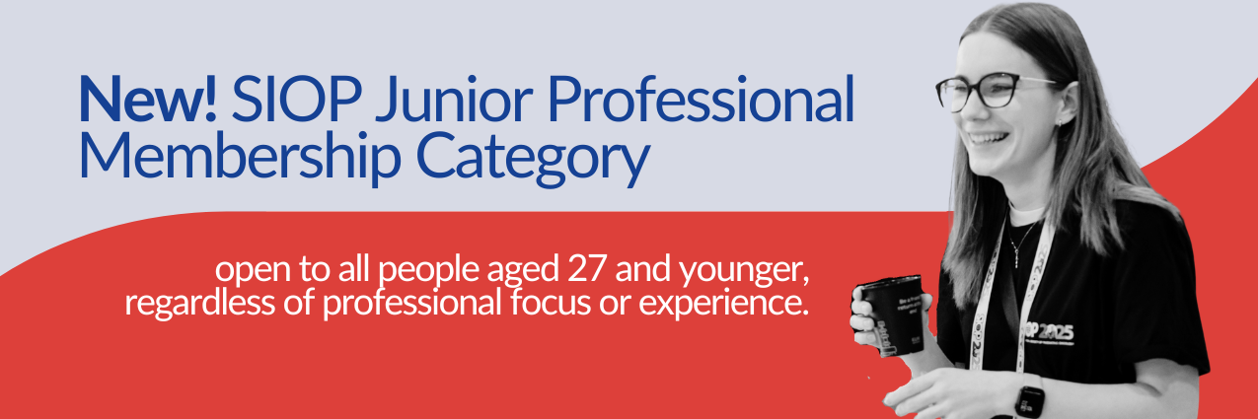

Newsletter Copy
New: SIOP Junior Professional Membership (for people aged 27 & under)
SIOP has launched a new Junior Professional Membership category to support the next generation of paediatric oncology professionals worldwide.
If you are 27 years old or younger, you are eligible to join at a significantly reduced rate.
Annual Fees
- HIC: €20 (1 year) | €40 (2 years)
- UMIC: €15 (1 year) | €30 (2 years)
- LIC/LMIC: €8 (1 year) | €16 (2 years)
Members benefit from:
- Free access to the SIOP Knowledge Centre (CME-accredited modules & Congress sessions)
- Free subscription to Paediatric Blood & Cancer or European Journal of Oncology Nursing
- Reduced Congress registration fees
- Eligibility for scholarships and awards
- Access to SIOP CONNECT for global networking
- Opportunities for leadership and professional development
Extra saving: Use promo code SAVE5NOW for 5% off 2-year memberships.
For 3+ year memberships, contact: membership@siop-online.org
We encourage members to share this opportunity with students, trainees and early-career colleagues in their institutions.
Join the global community advancing education, research and care in childhood cancer.

Email Text
Subject: New Reduced-Rate SIOP Membership for Professionals 27 & Under
Dear [Name],
We are pleased to announce a new Junior Professional Membership category from SIOP, designed to make global education and networking more accessible to early-career professionals.
If you are 27 years old or younger, you can now join SIOP at a reduced rate starting from €8 per year (country category dependent).
As a Junior Professional member, you will gain access to:
- CME-accredited learning modules via the SIOP Knowledge Centre
- Scientific sessions from past Congresses
- Free journal subscription
- Scholarships and awards eligibility
- Reduced Congress registration fees
- International networking via SIOP CONNECT
- Leadership and professional development opportunities
When purchasing a 2-year membership, use promo code SAVE5NOW to receive 5% discount.
We would be grateful if you could also share this opportunity with eligible colleagues, trainees and students within your institution.
Join us in advancing paediatric oncology education and collaboration worldwide.
Kind regards,
[Name]
[Title]

Social Media Post
New Junior Professional Membership (for people 27 & under)
Join SIOP and access: Global education & CME modules, international networking, scholarships & awards, reduced congress fees, free journal subscription!
Memberships start from €8 per year (country category dependent).Use code SAVE5NOW for 5% off 2-year memberships.
Help us spread the word to students, trainees and early-career colleagues: https://siop-online.org/news/junior-professional-membership/
#SIOP #PaediatricOncology #EarlyCareer #MedicalEducation #GlobalHealth

